2024 Spring Education Conference

Friday, March 22, 2024
Saturday, March 23, 2024

BOTH ONSITE AND VIRTUAL REGISTRATION OPTIONS AVAILABLE

West Baton Rouge Convention Center
2750 North Westport Drive
Port Allen, Louisiana

For Registration Assistance, Call or Text Cindy Bishop (225) 933-5435

Registration Links
childcarelouisiana.org/events
Childcarelouisiana.org/join

Select from one of our four Lagniappe Membership Bundles for early learning centers.

We also have a membership category for Family Day Homes and Corporate Sponsors.
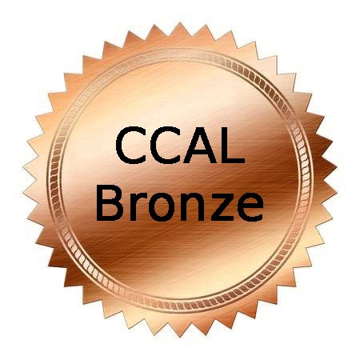 |  | 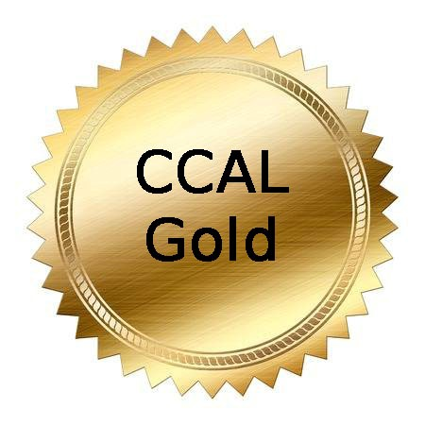 | 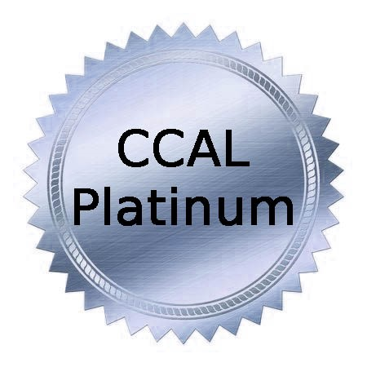
$160/year  Includes CCAL Membership for up to ten (10) staff members. Each bundle member will receive the CCAL newsletters and a CCAL membership card. | $200/year  Includes CCAL Membership for up to twelve (12) staff members. Each bundle member will receive the CCAL newsletters and a CCAL membership card. | $280/year  Includes CCAL Membership for up to fifteen (15) staff members. Each bundle member will receive the CCAL newsletters and a CCAL membership card. | $400/year  Includes CCAL Membership for an unlimited number of staff members. Each bundle member will receive the CCAL newsletters and a CCAL membership card.

Register at www.childcarelouisiana.org/events
Renew at www.childcarelouisiana.org
Join at www.childcarelouisiana.org/join-us
Spring Education Conference
Friday, March 22, 2024

7:40 AM Onsite Check-in
8:55 AM Welcoming Remarks – Tafta Miller, President
9:00 AM Keynote Presentation – Mr. Ty Clark “The Child Care Whisperer”
10:00 – 10:30 AM Break (Visit Exhibitors, Networking)
10:30 AM – 12 Noon Concurrent Sessions
For Owners, Directors and Assistant Directors | For Teachers and Support Staff
Louisiana Department of Education Updates  Introductory Remarks - Karen Powell, Deputy Assistant Superintendent, Early Childhood Strategy  - Moderator: Shelia Campbell  - EdLink Update – Robert Klein  - Child Care Assistance Program – Melinda George  - Licensing Updates (Bulletin 137) –Andrea Burl  - Child Care Criminal Background Checks – Kayla Batiste | Teachers Roundtable Discussion  Pamela Marshall, Shiloh Gardens Academy  Jennifer Stevenson, The Garden of Knowledge  Stacey Byes-Byarse, It Takes A Village Academy  - Effective Teaching Strategies  - Classroom Management Techniques  - Latest Research in Early Childhood Development

12:00 PM – 1:15 PM
- Lunch and Corporate Sponsor Recognition - Cindy Bishop
- Door Prize Giveaways – Tara Emery and Tafta Miller

Friday, March 22, 2024 Afternoon Breakout Sessions 1:15 – 4:15 PM

Plantation Room  Cultivating a Dynamic Leadership Culture  Ty Clark  “The Child Care Whisperer”  Target  Audience: Owners and Directors and Assistant Directors  Onsite and Virtual | Allendale Room  Medication Administration  Dianna Constant  Agenda for Children  Counts as a Health and Safety Class as Required by the Louisiana Department of Health  Target Audience: Directors and/or Teachers  Onsite and Virtual | Cinclaire Room  The Economics of Quality Childcare: yes, Virginia It Is Possible to Be Profitable and Provide Quality Care  Kathy Petchel  Hinge Advisors  Target Audience:  Owners, Directors, and Assistant Directors  Onsite Only | Choctaw Room  Recognizing Developmental  Delays in Young Children  Dr. Dionne Nichols-Condoll  Target Audience: Directors, Assistant Directors, and Teachers  Onsite Only | Poplar Grove  Four Ways to Support Your Teachers in Having a Winning School Year  Dr. DeShannon  Burrell, Dominque Byrd and  Sharon McNeely  Target Audience:  Owners, Directors, Assistant Directors  Onsite Only

Friday, March 22, 2024 Afternoon Breakout Sessions 1:00 – 4:00 PM

Cultivating a Dynamic Leadership – Ty Clark “The Childcare Whisperer”

Dynamic leaders recognize the unique strengths, needs, and aspirations of each team member. They provide
individualized support, mentoring, and coaching, acknowledging that different individuals may require different types of guidance.

Intellectual Stimulation:
These leaders stimulate creativity and innovation by encouraging critical thinking and problem-solving. They challenge the status quo, promoting a culture of continuous improvement and learning within the organization.

Emotional Intelligence:
Dynamic leaders possess high levels of emotional intelligence. They are attuned to the emotions of themselves and others, fostering positive relationships and creating a supportive work environment. This emotional intelligence allows them to navigate complex interpersonal dynamics effectively.

Risk-Taking and Innovation:
Dynamic leaders are willing to take calculated risks and embrace innovation. They encourage their team to explore new ideas and approaches, creating a culture where experimentation and learning from failures are valued.

Ethical and Moral Leadership:
Integrity and ethical behavior are fundamental to dynamic leadership. These leaders operate with a strong moral compass, making decisions that prioritize the well-being of their team and the organization.

Collaborative Leadership:
Dynamic leaders understand the importance of collaboration. They build strong, cohesive teams by promoting open communication, active listening, and a collective sense of purpose. Collaboration is seen as essential for achieving transformative goals.

Continuous Learning and Adaptability:
These leaders recognize that change is constant, and they promote a culture of continuous learning and adaptability. They lead by example, demonstrating a commitment to personal and professional growth.

Medication Administration presented by Dianna Constant, Agenda for Children
Target Audience: Owners, Directors, and Teachers

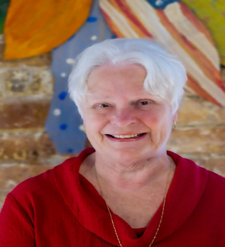
This three-hour breakout session provides staff training on how to properly administer medication to children in early learning centers. Participants will learn the state’s policies and procedures to follow to implement a clear guiding principle for medical administration. Upon completion of this training session, participants will receive a certificate to demonstrate compliance with the Louisiana Department of Health. Dianna Constant has been part of Agenda for Children’s team since 1990. She has over forty years of experience in early childhood education. She spent twenty years directing and operating her own childcare center and has more than two decades of experience as a trainer and technical assistance advisor for early childhood programs. She serves on the board of United Way of St. Charles and is actively involved with the Parish Networks in New Orleans and Houma supporting interaction improvements in Early Child Care Center and has served on the Child Care Health Care Consultant board since 2000. Dianna holds a bachelor’s degree in Sociology/Youth and Family Services from Nichols State University. Certifications include Certified Reliable CLASS Observer (Infant, Toddler, Pre-K), CLASS Affiliate Trainer (Pre K), Inter-Rater Reliable in GOLD by Teaching Strategies, Child Care Health Consultant, Louisiana Pathways Trainer Level II. Dianna is a lifelong resident of Thibodaux, Louisiana.

Four Ways to Support Your Teachers in Having a Winning School Year

Dr. DeShannon Burrell, Dominque Byrd and Sharon McNeely

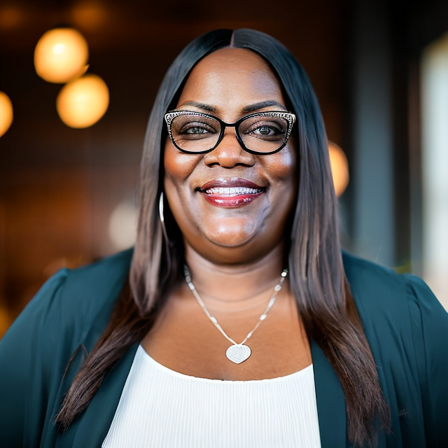
This session will identify why childcare teachers need support. We will discuss 4 key ways to give them support and even include a bonus! Get ready for a winning school year. Dr. DeShannon L. Burrell is a native of Baton Rouge, Louisiana. She holds a master’s degree in psychology and her Doctorate in Naturopathic Health. She has thirty years of experience in the childcare field. Within this field, she has worked as childcare staff, director, administrator, and trainer. She has a love for training, equipping, and propelling childcare staff, children and families into their divine destiny. She is owner of Elite Caregiver Training Institute, executive director of Louisiana Human Care Connection, Inc., and Performance Coach with Childcare Millionaire’s Association. She is also a state trainer for Northwestern State University Louisiana Pathways Career Development System helping to improve quality childcare in Louisiana.
Recognizing Developmental Delays in Young Children - Dr. Dionne Nichols-Condoll
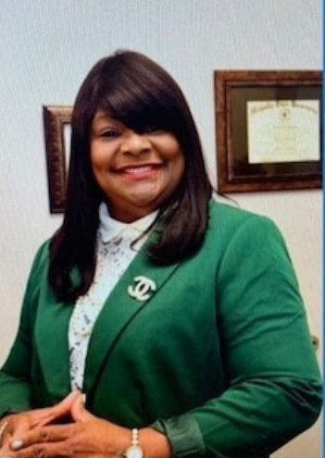
This presentation will provide the definition and overview of “developmental delay” along with explaining the different types of developmental delays in young children. This presentation will also include sharing the difference between a disability versus a delay in young children and the administration of assessment tools, strategies, resources, and materials to ensure adequate services working with young children with developmental delays. After completion of this course, participants will have a better understanding of the term “developmental delay” and various identified types of developmental delays in young children. We will cover the following topics:

- To provide insight into the term “developmental delay” in young children.
- To share the difference between a disability and a delay.
- To use assessment tools, strategies, resources, and materials in early childhood education classrooms.

Dr. Dionne Nichols-Condoll is an educator with over 20 years of experience in early childhood, elementary, secondary, and higher education. She holds a Bachelor of Arts degree in Elementary Education, a Master of Arts degree in Teaching in Urban Schools both from Southern University at New Orleans and a Master of Arts degree in Administration and Supervision from Nicholls State University, Thibodaux, Louisiana. In addition, she has earned her doctorate degree in Educational Leadership and Administration from Capella University, Minneapolis, Minnesota. Dr. Nichols serves as Chief Academic Officer of Good Shepherd Schools and serves as a professor at Northwestern State University serving practitioners who are enrolled in Early Childhood Education and Teaching Grades 1-5 programs. She is an Independent Educational Consultant for Early Childhood and Special Education. She is a proud member of the Alpha Kappa Alpha Sorority; Inc. Dr. Nichols has written several children’s books that depict minority characters that all children can relate to. She is committed to the idea of life-long learning and believes that education is the key to success in life for both children and adults. She is the proud mother of her only daughter Shantrice and grandmother to her 7-year-old granddaughter Saige.

Saturday, March 23, 2024 Breakout Sessions
8:00 – 11:00 AM  Ready Set Eat  Food Safety  Dianna Constant  Agenda for Children  Three Clock Hours  Counts as a health and safety class  Onsite or Virtual | Plantation Room  8:00 – 10:00 AM  Teaching that Transforms Hearts and Minds of Teachers  Ty Clark “The Child Care Whisperer”  Onsite and Virtual | 8:00 – 10:00 AM  The ABC-123’s of Changing Challenging Behavior  Rebecca Freedman  FirstDayLearning  Onsite Only | 8:00 – 10:00 AM  Saying What You Mean: Effective Communications to Avoid Conflict  Karen Stevens, M.A., LPC-S, NCC – Early Childhood Mental Health Consultant  Onsite Only | 8:00 – 10:00 AM  Greauxing Healthy:  Exploring Indoor and Outdoor Play  Katherine Spring PhD  Kristen Domangue  Pennington Biomedical Center  Onsite Only
 | 10:15 – 12:15 PM  Recognizing Developmental Delays in Young Children  Dr. Dionne Nichols-Condoll  Target Audience:  Early Childhood Educators and Directors  Onsite Only | 10:15 – 12:15 PM  The Left Brain of Quality: Leadership and Logistics  Niki Da’Jon MBA  Target Audience: Directors, Owners and Teachers  Onsite Only | 10:15 – 12:15 PM  The Four Generations in the Workplace and How to Successfully Support Each One  Kathy Petchel  Hinge Advisors  Onsite Only  Target Audience:  Owners, Directors and Assistant Directors | 10:15 – 12:15 PM  Cooking up a Successful Recipe for Concept Development  Annette Bazile  Onsite Only
1:15 – 3:15 PM  Teachers’ Roundtable Discussion  Jennifer Stevenson, Garden of Knowledge  Pamela Marshall,  Shiloh Gardens Academy  Stacey-Byes Byarse, It Takes A Village Academy  Target Audience:  Teachers and Floaters Only  Onsite Only | 1:15 – 3:15 PM  The ABC-123’s of Changing Challenging Behavior  Rebecca Freedman  FirstDayLearning  Onsite Only | 1:15 – 3:15 PM  The Left Brain of Quality: Leadership and Logistics  Niki Da’Jon, MBA  Onsite Only | 1:15 – 3:15 PM  Kathy Petchel  Hinge Advisors  Onsite Only | 1:15 – 3:15 PM  Voices from the Field: Insights from Early Childhood  Educators  Katy Dyson  LSU Early Childhood Education  Onsite Only

Teaching that Transforms the Hearts and Minds of Teachers – Mr. Ty Clark “The Childcare Whisperer”
Transformative teaching refers to an approach to education that goes beyond traditional methods, aiming to create a profound and lasting impact on students' knowledge, skills, attitudes, and values. This teaching style is not just about
delivering information; it seeks to empower students, foster critical thinking, and promote personal and social growth. These are the three key topics:

Critical Thinking: Transformative teaching encourages students to question, analyze, and evaluate information critically. It goes beyond rote memorization and promotes a deeper understanding of concepts.

Active Learning: This approach often involves interactive and participatory activities, such as discussions, group projects, and hands-on experiences. Students are actively engaged in the learning process, which enhances their
understanding and retention of the material.

Reflection: Transformative teaching encourages students to reflect on their learning experiences. This reflection helps them connect new knowledge to their existing understanding and personal experiences, making the learning
more meaningful.

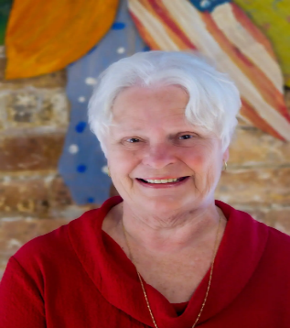
Ready Set Eat Food Safety - Dianne Constant, Agenda for Children
Ready Set Eat Food Safety is a session on how children grow and develop. This is an interactive session that includes information on handling children with special needs. After completion of this three-hour training class, participants will be able to:
- Define the grasping status
- Describe a positive and supportive learning environment for feeding children
- Be able to discuss how language and feeding are related.
- CLASS language is used.

This class meets the Louisiana Department of Health food safety requirement.

The ABC-123’s of Changing Challenging Behavior - Rebecca Freedman, FirstDay Learning
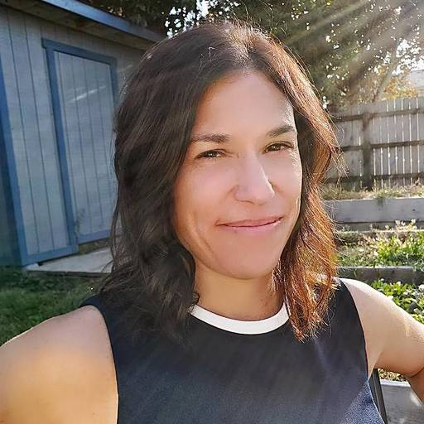
This two-hour workshop takes a deep dive into the writing and implementation of behavior change plans. Participants will be trained on FirstDay Learning’s ABC-123 plan for effective prevention and responses to challenging behavior. Educators will be given the time and guidance to understand the 6 steps in a behavior change program and create a plan that works for their specific needs. Session goals include:
● Create simple behavior change plans for children that are struggling in their classrooms
● Learn strategies on how to communicate behavior plans to colleagues and families
● Understand the steps and strategies needed in understanding, documenting and replacing challenging behavior

Saying What You Mean: Effective Communication Strategies for Avoiding Conflict
Karen M. Stevens, M.A., LPC-S, NCC – Early Childhood Mental Health Consultant
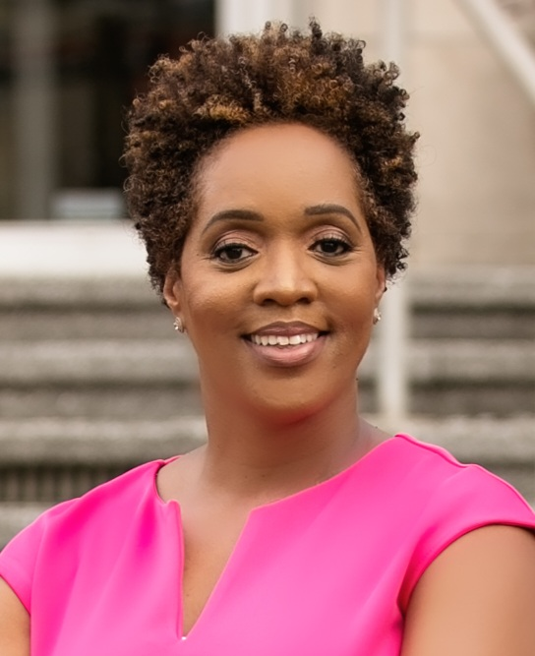
We are often moving from one task to the next. Communicating daily with multiple sources, text messages, telephone calls, emails, video, letters, and face to face can present challenges and even chaos. If you’ve ever said, “that’s not what I meant”, this workshop is for you. This workshop will provide effective communication strategies and conflict. Karen M. Stevens is a Licensed Professional Counselor and a National Certified Counselor who has worked with children and families for over 15 years. Currently, she serves as an Early Childhood Mental Health Consultant with Tulane University’s TIKES Program Region 2 and a Louisiana Pathways Trainer. Her passion for the early childhood field is shown throughout her work and collaborations in centers. If she has visited your center before, you’re sure to remember her joy for children, and vibrant personality. Karen is passionate about supporting children, families, and providers to be their best self. Karen studied at Southern University A&M where she received her bachelor’s in science in Child Development and a master’s degree in Mental Health Counseling.

Greauxing Healthy: Exploring Indoor and Outdoor Play
Katherine Spring PhD and Kristen Domangue, Pennington Biomedical Center
The Greaux Healthy Indoor and Outdoor Play trainings will illuminate the profound impact of play on the physical and mental development of preschool-age children. Join us as we explore the numerous benefits of physical activity, unravel different types of engaging activities, and delve into evidence-based best practices for integrating play into Early Childhood Education (ECE) centers. Packed with actionable tips, helpful resources, and effective strategies, this session is your gateway to creating vibrant indoor and outdoor play environments.
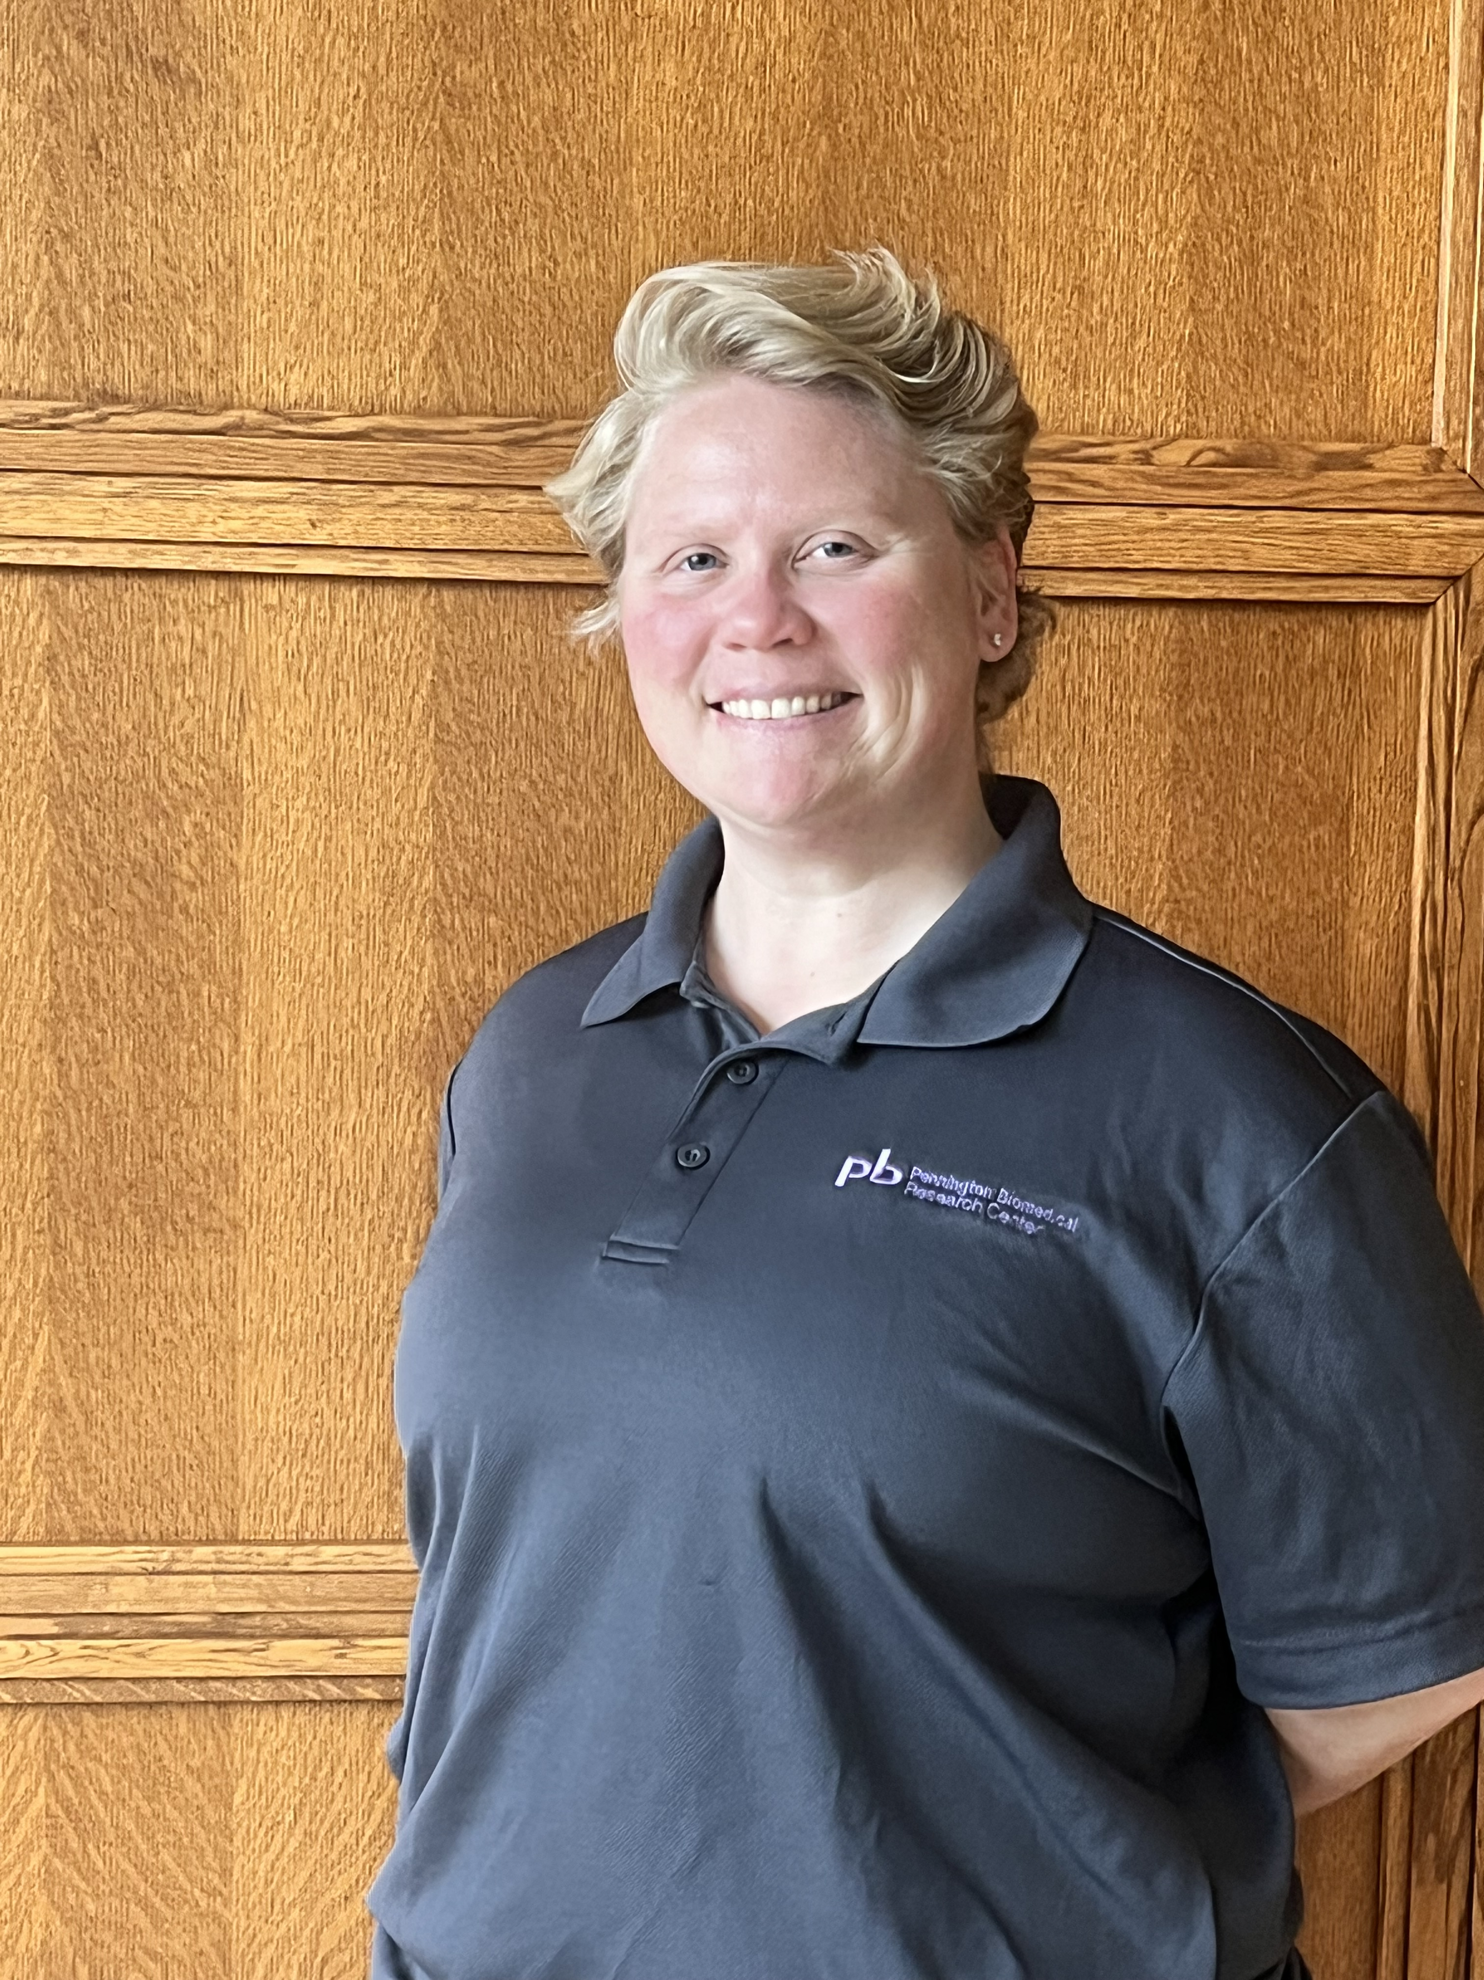
Greaux Healthy is an initiative committed to addressing the critical issue of childhood obesity, a health concern for which Louisiana currently ranks 3rd in the nation. Today’s children are facing challenges and confronting diseases that they never have before, including diabetes, high blood pressure, and, ultimately, shortened life expectancies, but we have the tools to help. With a foundation built upon 35 years of comprehensive research conducted by Pennington Biomedical, a globally recognized authority in obesity research, Greaux Healthy has carefully developed evidence-based tools, products, and resources. We understand the critical role of early childhood in shaping lifelong habits and preferences and place a special emphasis on developing resources that help educators positively impact children’s health and wellbeing from their very earliest ages. Together, we can create a future where healthy children become healthy adults and diminish the looming threat of obesity.

Kristin Domangue currently serves as a Project Manager for the Greaux Healthy initiative at Pennington Biomedical where she aids in developing and implementing professional development trainings tailored for early childhood education center teachers and directors.
Her expertise also includes hands-on work with children in ECE centers for various research studies which has provided her with valuable insights into the unique challenges and opportunities within these environments.

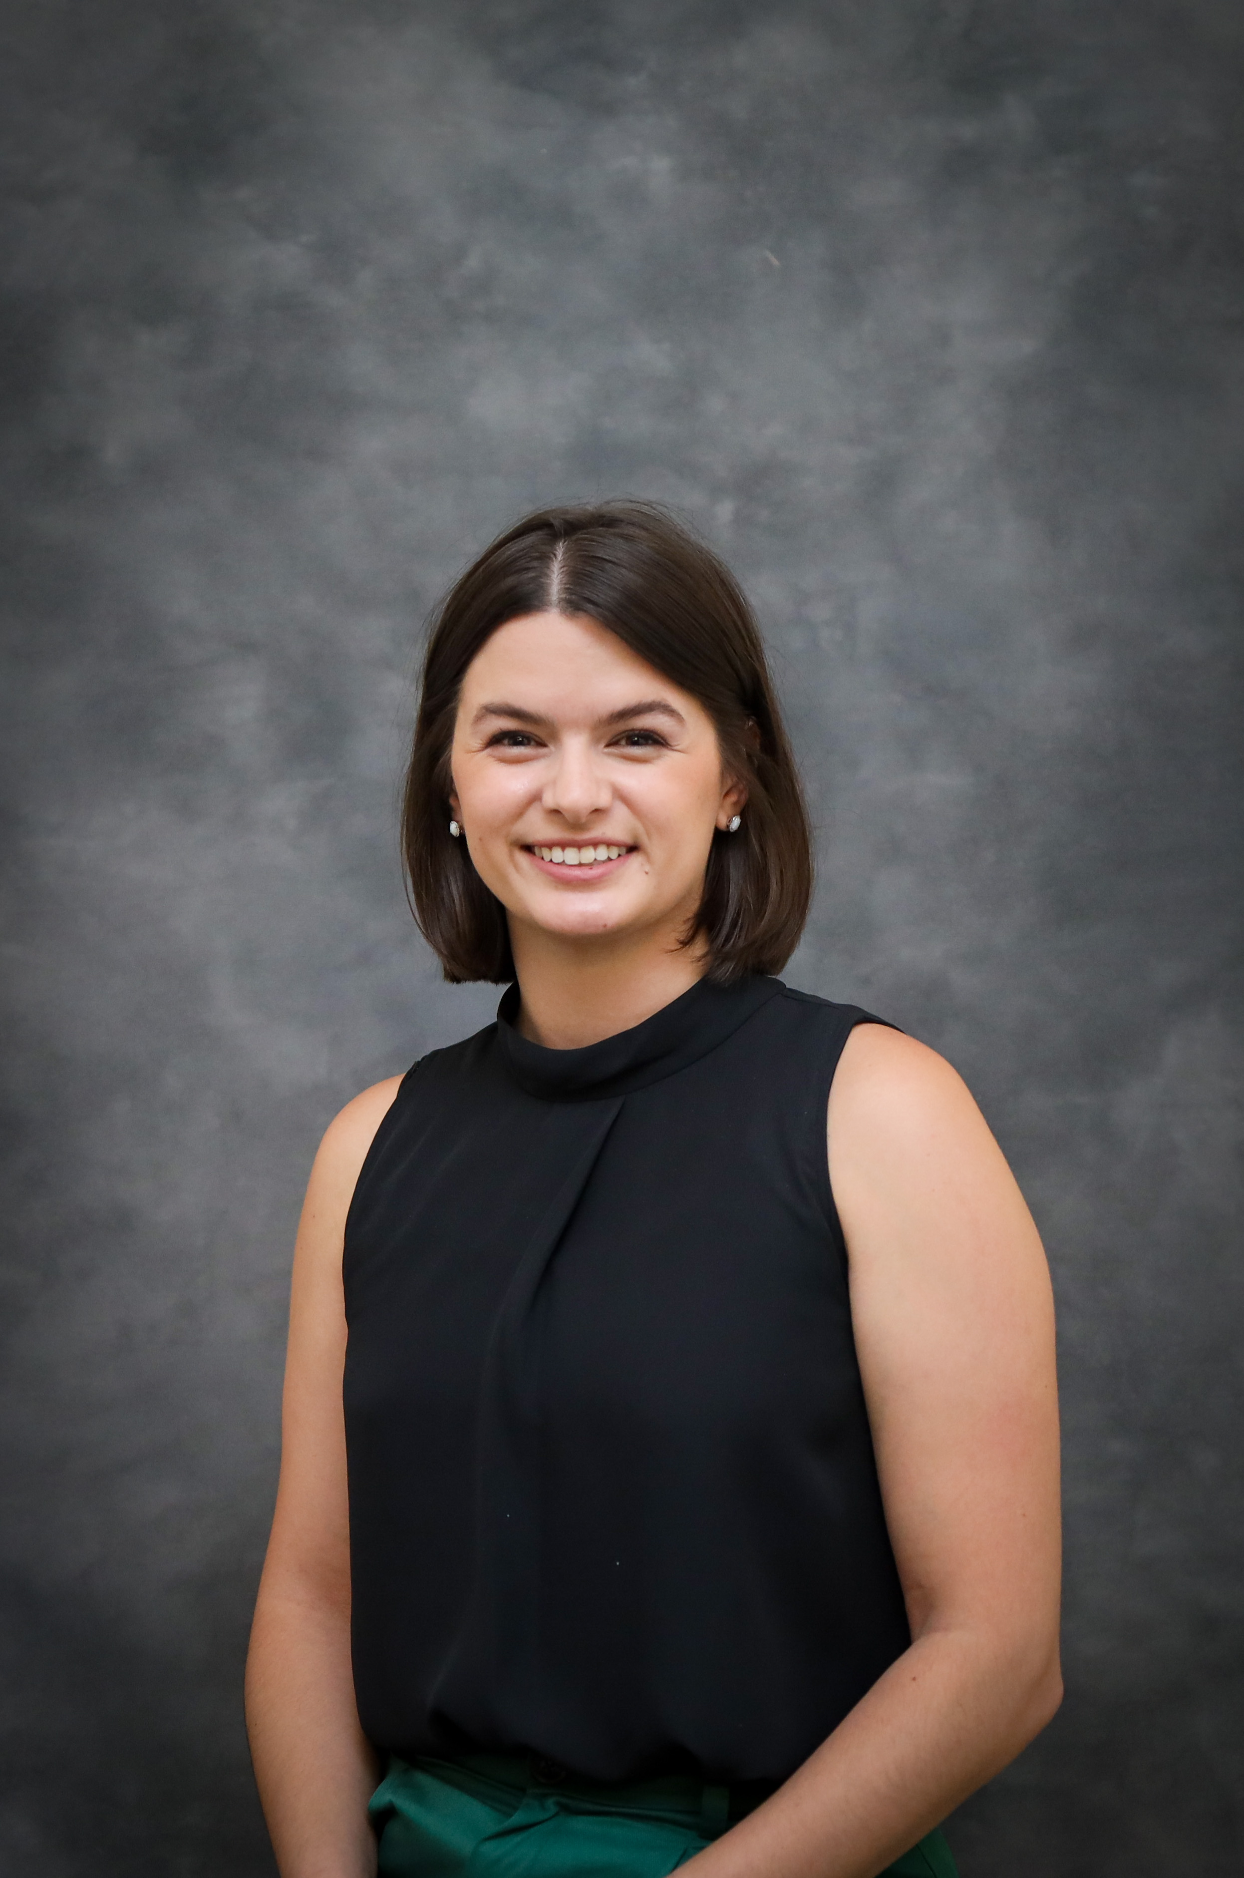
Katherine Spring, PhD is a postdoctoral researcher in the Pediatric Obesity Health Behavior Laboratory at Pennington Biomedical. Dr. Spring comes from a family of educators and is intimately aware of how childcare providers and educators serve as essential role models for children. Her research has primarily focused on the effects of physical activity and play on young children's physical, behavioral, and learning outcomes. Dr. Spring is especially interested in school-based approaches that incorporate movement into learning objectives.

Recognizing Developmental Delays in Young Children – Dr. Dionne Nichols-Condoll
This presentation will provide the definition and overview of “developmental delay” along with explaining the different types of developmental delays in young children. This presentation will also include sharing the difference between a disability versus a delay in young children and the administration of assessment tools, strategies, resources and materials to ensure adequate services working with young children with developmental delays. Class objectives include:

- To provide insight into the term “developmental delay” in young children.
- To share the difference between a disability and a delay.
- To use assessment tools, strategies, resources and materials into the early childhood education classrooms.

The Left Brain of Quality: Leadership and Logistics – Niki Da’Jon, MBA
Target Audience: Directors and Owners and Teachers
Revitalize your early childhood education programs with our dynamic training session on leadership and business logistics. This session delves into critical, yet often neglected, aspects of business management and operations vital for maintaining a high-quality educational environment. Participants will gain essential tools and insights that will empower them to enhance their leadership capabilities, streamline program operations and ultimately deliver a higher quality program, ensuring a well-rounded and impactful educational experience for young learners. Niki Da’Jon, with an MBA in Entrepreneurship and a BS in Business Administration, has a diverse background in early childhood education (ECE) and business. Starting as an office assistant in a 3- star ECE program and advancing to executive director within five years, she now leads a BESE approved CDA/Ancillary program focusing on ECE training and development and owns a private educational business consulting firm. With 9 years in ECE and expertise in small business development, they are a CLASS Observer, certified in Infant/Toddler and Preschool-3rd, a Trainer of Trainers, and a Louisiana certified trainer for 7 years. Her experience includes delivering training for child care resource and referral agencies and participating in leadership programs, blending business acumen with educational methodologies to effectively guide educators. This diverse experience uniquely qualifies Niki to guide educators in enhancing leadership and operational skills.
Cooking up a Successful Recipe for Concept Development – Annette Bazile
Target Audience: Early Childhood Educators
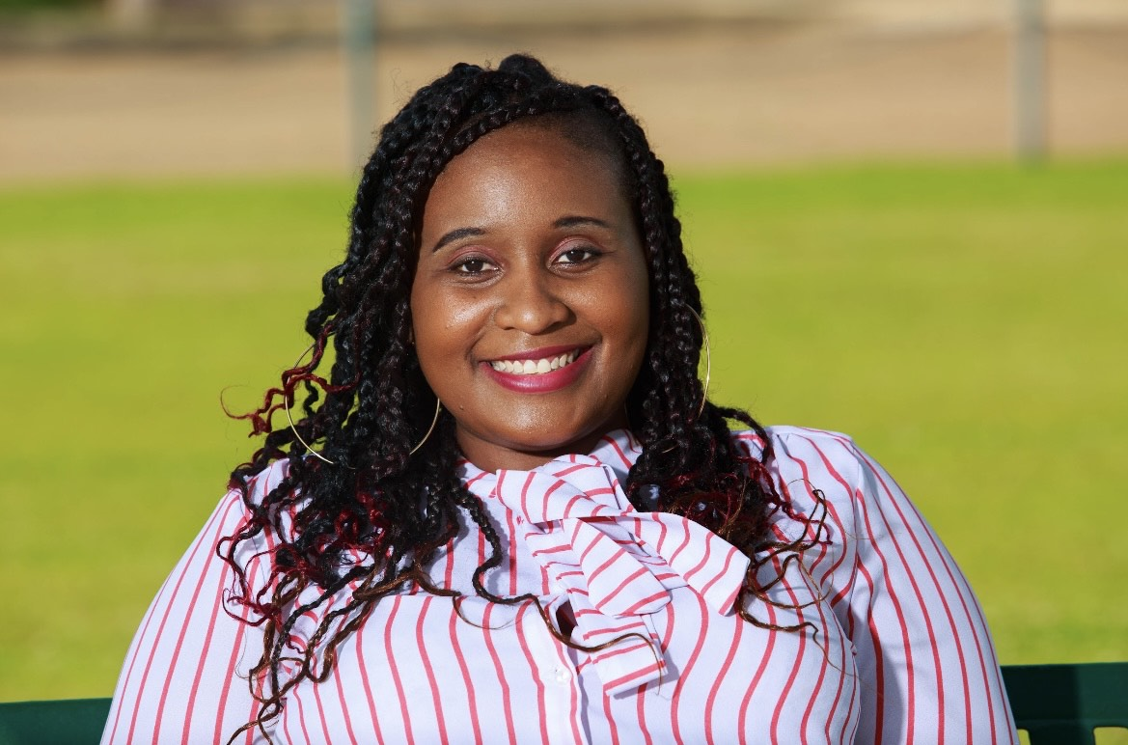
This training will teach educators how to add flavor to concept development in the classroom. Louisiana is known for its cooking techniques and flavors. It is time to add that same spice to development in the classroom. This two-hour workshop emphasizes a student center approach and provides training on concept development to create an atmosphere for children to develop an understanding of complex concepts. Annette Bazile has a Doctoral degree in Theology of Psychology. She is a MMCI trainer, Train the Trainer, Class Observer, and TSG reliable. She is the mother of two wonderful supportive daughters. She is a youth leader of her church and a community advocate for children. She is the owner of It Takes A Village Learning Center and has been working in childcare for the past 12 years. I am a certified Pathways trainer. “I love sharing the knowledge I’ve gained right out my educational journey. Sharing is caring and I care a great deal about children and their educational experiences because shapes life around the key elements they need to succeed” says Ms. Bazile.

Teacher’s Roundtable Discussion
Jennifer Stevenson, Pamela Marshall and Stacey Byes-Byarse
Target Audience: Teachers and Floaters
Teacher’s Roundtable Discussion is a dynamic forum for educators to collaboratively explore and share innovative practices, challenges, and insights related to early childhood education. This interactive session fosters a sense of community among teachers, creating a space where they can engage in open dialogue about effective teaching strategies, classroom management techniques, and the latest research in early childhood development. Participants exchange practical tips, success stories, and valuable resources, enhancing their professional development. The roundtable format encourages peer-to-peer learning, allowing teachers to address common concerns and find collective solutions. Overall, the Teachers Roundtable Discussion serves as a platform for educators to connect, learn from each other, and contribute to the continuous improvement of early childhood education practices.
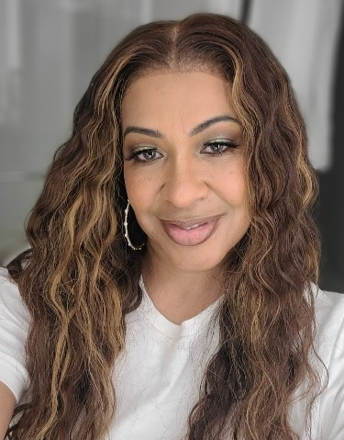
Pamela Marshall is the proud owner and Executive Director of Shiloh Gardens Academy in New Orleans. She recently opened her second location – Shiloh Gardens Academy & Early Learning Center. Pamela holds a Bachelor of Arts Degree in Organizational Management with a concentration in Early Childhood Education and minor in Psychology. She has over 20 years of experience in the childcare profession as an FCC Director working with diverse families. Additionally, she is a CLASS Observer. She is a strong advocate for early childhood education and has a strong passion for educating young children, empowering others to tap into their full potential, and using her platform to bring about change in the childcare profession. Pamela is a native New Orleanian. Pamela serves on the Child Care Association of Louisiana Board of Directors representing Orleans Parish.

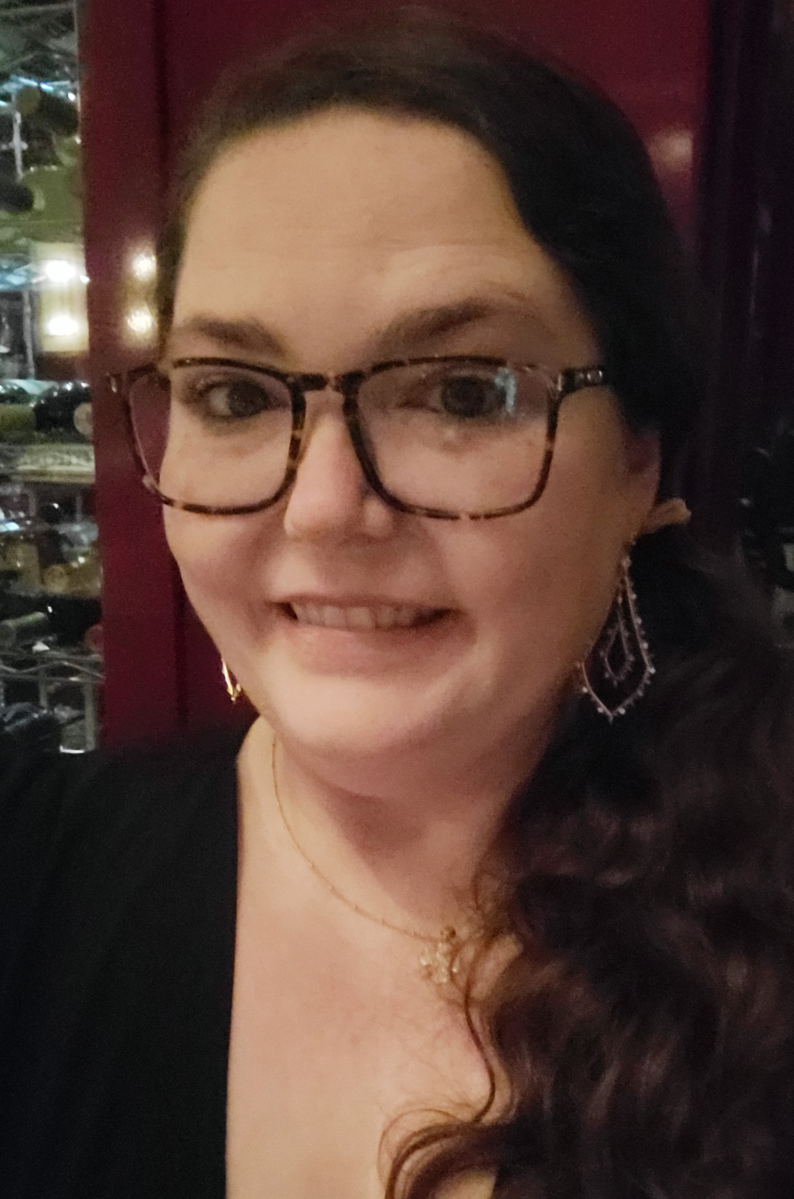
Jennifer Stevenson has over ten years’ experience in early childhood education, starting as a teacher and working her way up. She is the owner of The Garden of Knowledge, a new premiere preschool located in Bogalusa. "Mrs. Jen", as she is affectionately called, carries on a family legacy in education. She is a graduate of West Jefferson High School and holds a CDYC (Care and Development of Young Children) Degree from Delgado Community College. Jen is also a graduate of the prestigious Louisiana Early Learners Academy; a program backed by Harvard University's Saul Zentz Early Education Initiative and the Louisiana Department of Education and was recognized as one of LDOE’s Inaugural Top 5 Leaders of the Year in Louisiana Early Childhood Education in 2022. Jennifer serves on the Board of Directors of the Child Care Association of Louisiana representing the Northshore region of New Orleans.

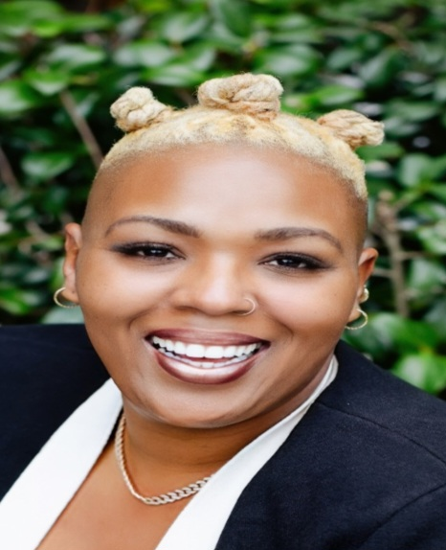
Stacey Byes-Byarse has been in the Early learning field for over 19 years. After working every job in childcare, she established It Takes a Village Academy in 2014 and began servicing Orleans Parish community families. In 2020, It Takes a Village Academy acquired its second location, servicing families of the Jefferson Parish community. Since opening her two early learning centers, Stacey has built an environment of trusted and supportive team members who embrace the mission and vision to uplift each family in every aspect of life. Stacey and It Takes a Village Academy has been a voice and an outspoken and effective advocate for children, families, early childhood teachers, and support staff. In 2021, Stacey was elected to the Board of Directors for the Child Care Association of Louisiana and started her Coaching and Consulting business, Talk with Ms. Stacey B., as a certified Happiness Coach. In 2022, Stacey became a certified Early Learning Trainer to foster further the growth and development of Childcare Owners, Directors, and Team members in the childcare industry.

Voices from the Field: Insights from Early Childhood Educators – Katy Dyson
Target Audience: Early Childhood Educators/directors (toddler/young toddler)
An insightful presentation where invaluable experiences and perspectives from early childhood educators and caregivers bridge the gap between theory and practice. These firsthand accounts describe real-world application of developmentally appropriate research-based approaches. Attendees will gain a deeper understanding of the intricate nuances involved in implementing methodologies such as facilitating centers. These approaches, strategically designed to enhance the quality of early childhood education, are aimed at not only fostering optimal child development but also at elevating CLASS scores, providing a comprehensive view of the effectiveness of these methodologies.
Katy Dyson is an Early Childhood Education PhD student at LSU. During this time, she has worked with the Point Coupee Early Childhood Coalition (PCECC) as an instructional coach. In this role, Katy collaborates with early childhood teachers, caregivers, and directors to provide both group and personalized training focused on effective interactions as related to the CLASS tool. Katy strives not only to enhance the educational experience for young learners, but also to empower and support early childhood professionals.

CCAL Gatsby Gala
Murder Mystery Dinner
Friday, March 22, 2024
West Baton Rouge Conference Center
6:00 – 9:00 PM
Register separately for the Social Event
http://childcarelouisiana.org/events
$50 to participate as a character in the Gatsby Murder Mystery Dinner
$40 to be an observer (non-participant in the Murder Mystery)

West Baton Rouge Conference Center

2750 N Westport Drive

Port Allen, Louisiana

CONFERENCE REGISTRATION RATES
Register at www.childcarelouisiana.org/events

Early Bird Registration Rates Regular Registration Rates (March 1st – March 22)

Onsite Friday $100 $125
Onsite Saturday $75 $100
Corporate Sponsors $375 $400
Virtual Friday $100 $125
Virtual Saturday $100 $125
Friday Social $50 to register as a character in the Murder Mystery Dinner
$40 to register as an observer in the Murder Mystery Dinner
Non-Member $250
For non-members, call or text Cindy Bishop at 225 933 5435 for special promotion rates.
Please Include your name, center or affiliation and email address please
For registration assistance, call Cindy Bishop at 225 933 5435 or email cindy.bishop@checkmate-strategies.com and David.roberson@checkmate-strategies.com

DISCOUNT HOTEL RATES AVAILABLE THROUGH CCAL HOTEL ROOM BLOCKS

CCAL has a discount room block secured with the Hampton Inn and Suites in Port Allen for discount hotel rooms at the rate of $99 plus tax per night for Thursday, March 21st and/or Friday March 22nd.
To book a room, call the hotel directly at 225 389-6655 and ask for a reservation under the CCAL Room Block to get the discounted hotel room rate. The hotel rate includes breakfast.
CCAL has a discount room block secured with the LaQuinta Inn and Suites, 2720 N. Westport Drive in Port Allen. The discount room rate is $99 plus tax per night for Thursday, March 21st or Friday, March 22nd. To book a hotel room, call 225 831 3253 or book online at Wyndham.com and use discount code CGCCAG. The hotel rate includes breakfast.

