2019 SPRING EDUCATION CONFERENCE
PRE-REGISTRATION PACKET

All Sessions have been linked to CLASS (Classroom Assessment Scoring System) which is a tool used to measure teacher effectiveness as well as TS GOLD (Teaching Strategies GOLD) a child assessment tool used to measure and improve school readiness for young children!

Friday, March 29, 2019

Saturday, March 30, 2019

WEST BATON ROUGE CONFERENCE CENTER
2750 NORTH WESTPORT DRIVE
PORT ALLEN, LOUISIANA

For more information, contact Cindy Bishop, Executive Director cindy.bishop@checkmate-strategies.com (225) 933-5435

Your center must be a CCAL Member to attend the conference!
Contact CCAL to find out how to join today or visit our website

CCAL Annual Membership Dues are based on licensure capacity

Small Center Medium Center Large Center
1 - 99 100 - 199 200 or more

Renew or Join CCAL today at www.childcarelouisiana.org

Friday, March 29, 2019
GENERAL SESSION – PLANTATION ROOM
WEST BATON ROUGE CONFERENCE CENTER

7:45AM Registration Check-in and Continental Breakfast
Networking and Visit with Sponsors / Vendors
8:55 AM Welcoming Remarks– Olivette Temple, President
9:00 AM KEYNOTE PRESENTATION

“EARLY BRAIN DEVELOPMENT: TIME TO ACT...AND SHARE”
Stewart T. Gordon, MD, Chief Medical Officer, Louisiana Health Care Connections

The presentation will provide an overview of human brain anatomy & development during the first 5 years of life. Economics of early childhood will be explored. Early childhood experience relevance will be explained and a further case for investing in Early Childhood will be reiterated.

10:00 AM Louisiana Department of Education Updates
- Introductions – Lisa Brochard
- Child Care Assistance Program - Melinda George
- Licensing/Bulletin 137 – Shelia Campbell
- Child Care Criminal Background Checks – Valerie Black, JD

- Adult and Child Nutrition Food Program – Linda Lambert
- Ancillary Teaching Certificates and April Roundtables – Nasha Patel
- Early Leadership Training - Emmy O’Dwyer
11 AM – 12 Noon Lead Agency Panel Discussion - Gina Carter Merkel, Facilitator
- Tara Baudean, Early Childhood Coordinator, St. Tammany Parish Schools
- Amy Clancy, Director of Community Networks, Children’s Coalition of Northeast Louisiana
- Cassandra Cole, Supervisor of Early Childhood, City of Natchitoches Early Childhood Education and Development Program
- Carmen Brabham, Early Childhood Coordinator, Tangipahoa Parish School System
- Amy Metoyer, Early Childhood Coordinator, City of Natchitoches Early Childhood Education and Development Program
Gina Merkel Carter will facilitate this robust one -hour confab with the lead agency network panelists. Expect an interactive discussion on challenges and opportunities for early learning centers and ways in which early learning centers and Lead Agencies can collaborate!
12 NOON Networking Lunch with Door Prizes and Sponsor Recognition

1:30 – 4:30 Afternoon Breakout Sessions

Friday, March 29, 2019

FRIDAY AFTERNOON BREAKOUT SESSIONS

All Sessions have been linked to CLASS (Classroom Assessment Scoring System) a tool used to measure teacher effectiveness as well as TS GOLD (Teaching Strategies GOLD) a child assessment tool used to measure and improve children’s readiness for school!

SESSION A  1:30 – 4:30 PM  Medication  Administration (Good for 2 years)  Dianna Constant  Agenda for Children | SESSION B  1:30 – 4:30 PM  Business Management:  HR and  Labor Laws  Bob Lansing  Central Academy Early Learning Center  Jim Rieger, Wage and Hour Division,  US Department of Labor | SESSION C  1:30 – 4:30 PM  The ABC’s of Behavior Using Assistive Technology  Melva Pania-Stephens  Josh Miller | SESSION D  1:30 – 4:30 PM  Using CLASS to  Its’ Fullest Potential  Niki Da’Jon | SESSION E  1:30 – 4:30 PM  Professionalism  in the Workplace  Dr. DeShannon  Quiett | SESSION F  1:30 – 4:30 PM  Adapting Books: Access for All  Kristie Sheffield  Theresa Robinson

FRIDAY AFTERNOON BREAKOUT SESSIONS – FRIDAY, MARCH 29, 2019

SESSION A: Medication Administration – Dianna Constant, Agenda for Children
Administration of Medications to Children in Child Care Facilities provides a mechanism for administering medication to children in child care facilities. This policy specifically establishes the procedures to follow in order to institute a clear guiding principle on administration of medications for child care facilities.
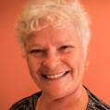
Dianna Constant is the Region IV Agenda for Children/Child Care Resources Coordinator. She holds a Bachelor of Arts Sociology and Youth and Family Services. She is also an Office of Public Health, Maternal and Child Welfare Child Care Health Consultant and a consultant with University of Montana Rural Institute on Disabilities – Child Care Plus Team; Consultant with Utah State University Ski - High Institute on Children with Disabilities and a statewide trainer on Inclusive Ideologies. Dianna may be reached by email at dconstant@agendaforchildren.org

SESSION B: Business Management – HR and Labor Laws

Bob Lansing, Central Academy Early Learning Center

Jim Rieger, U.S. Department of Labor - Wage and Hour Division
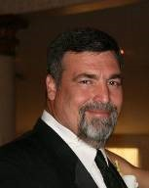
Don’t bury your head in the sand when dealing when dealing with Federal and State Laws, because it can come back to bite you. This session will discuss many HR topics including the hiring/firing process, job descriptions, employment application, employee manuals, etc. through the filter of state and federal laws. Some of these laws will include the Affordable Care Act, Americans with Disabilities Act, Immigration Policies, and the Fair Labor Standards Act just to name a few. Join us delve into these unpopular, but essential topics. Bob Lansing has a Bachelor’s of Science degree in Electrical and Computer Engineering from LSU and a Masters of Arts from New Orleans Baptist Seminary with an emphasis in Administration. He spent 10 years working for the Department of Defense, US Air Force. For the past 23 years, he has been the owner/director of Central Academy Early Learning Center, a four star center in Baton Rouge. Bob Lansing has been married for 37 years to Robin. They have 5 children and 3 grandchildren. Bob Lansing can be reached via email at bob@centralelc.com

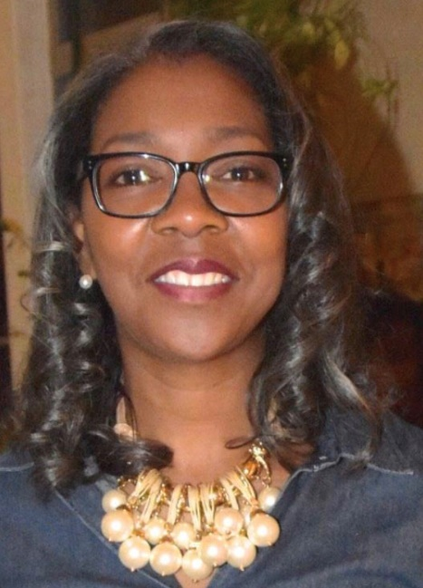
SESSION C: The ABC’s of Behavior Using Assistive Technology Melva Pania Stephens and Josh Miller
All behaviors are a form of communication. Children usually have logic behind the behavior they exhibit. Some behaviors can be to seek sensory needs, escape a task, and seek attention or a tangible need. In this session, you will learn ways to incorporate positive behavioral support strategies using Assistive Technology in the Early Childhood Classroom to increase classroom effectiveness ad decrease misbehavior. Strategies for addressing clear behavior expectations while being proactive and redirecting misbehaviors will be discussed. Melva Pania-Stephens is an Assistive Technology Facilitator who works with LATI (Louisiana Assistive Technology Initiative) to provide training and support to several school districts in the state of Louisiana. Melva believes that all students, regardless of their disability, can learn when they are afforded an opportunity. She has worked in Iberville Parish for the past 28 years serving as both a Speech-Language Pathologist and as the teacher for the medically fragile students with significant disabilities (Cerebral Palsy, Seizure Disorders, Cortical Blindness, Autism and Oppositional Defiant Disorder. Melva has attended numerous conferences and trainings to increase her knowledge in the area of student behavior. Melva holds a Bachelor’s Degree in Communication Disorders from Southern University and A&M College, Baton Rouge, Louisiana. Melva can be reached at melvapania@ipsb.education Josh Miller is an Assistive Technology Facilitator with the Louisiana Assistive Technology Initiative for the Southeast region. He attended Louisiana State University where he received a degree in Mass Communications. He was formerly Program Director at the Louisiana Assistive Technology Access Network. He is a certified Assistive Technology Professional (ATP) by RESNA and a Level 2 Google Certified Educator. Josh is an Assistive Technology Facilitator with the Louisiana Assistive Technology Initiative for the Southeast region. He attended Louisiana State University where he received a degree in Mass Communications. He was formerly Program Director at the Louisiana Assistive Technology Access Network. He is a certified Assistive Technology Professional (ATP) by RESNA and a Level 2 Google Certified Educator.

SESSION D: Using CLASS to Its’ Fullest Potential - Niki Da’Jon, MBA
This session will talk about CLASS using a different lens. It will highlight the importance of modeling the CLASS tool as an administrator to your staff in the same way they are to model it to the students. We will unpack the dimensions and evaluate how they provide the framework to facilitate positive and productive interactions and explore practical ways to use this tool to create a more effective learning environment from the front office to the classroom. This training will touch on the how TSG and CLASS are linked and how to integrate documentation into the conversation of CLASS. It will also highlight how the developmental standards are the foundational structure of the CLASS tool. Niki Da’Jon is the Director at SEA Academy in New Orleans, La. She has made many strides in the early childhood field in only 3.5 short years. She is a certified CLASS observer in Infant, Toddler and Pre-k, pathways trainer, experienced MTP coach and contracted trainer. With a passion for coaching, teaching and training and equipped with her Master’s in Business she has a unique perspective of the early childhood educational landscape. She is passionate about the impact that teacher’s commitments make on the lives of the coming generations and fully intends to continue perusing opportunities to make further positive contributions to the field. Niki can be reached at niki@sea2academy.com
SESSION E: Professionalism in the Workplace – DeShannon Quiett, PhD
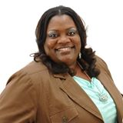
To understand the importance of professionalism in the work place. This session will provide valuable information on strategies for getting cooperation and collaboration to improve relationships within the center.
In this training you will learn ...
  - The Importance of YOU as a Professional
  - The Benefits of a Center that Operates Professionally
  - General Principles of Professionalism in the Workplace
  - Professionalism in the Child Care Setting
  - Strategies to diffuse competition in the Workplace
  - Strategies on improving Cooperation and Collaboration in the Workplace

Dr. DeShannon L. Quiett is a native of Baton Rouge, Louisiana. She holds a Master’s Degree in Psychology and her Doctorate in Naturopathic Health. She has over twenty-five years of experience in the childcare field. Within this field, she has worked as childcare staff, director, administrator and trainer. She has a love for training, equipping and propelling childcare staff, children and families into their divine destiny. She is owner of Head 2 Toe Wellness, LLC and executive director of Louisiana Human Care Connection, Inc. She is also a state trainer for Northwestern State University Louisiana Pathways Career Development System helping to improve quality childcare in Louisiana and a state trainer for Direct Service Workers for the Department of Health and Hospitals. She can be reached at deshannonquiett@yahoo.com
SESSION F: Adapting Books / Access for All – Kristie Sheffield and Theresa Robinson
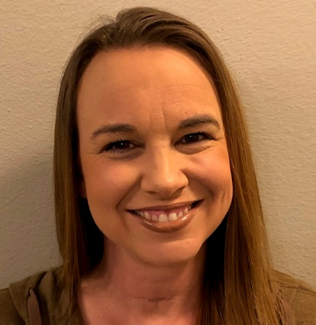
This session will demonstrate methods of adapting books for students with various access and cognitive needs giving them the needed independence of their peers. Allowing all children to access age appropriate reading materials will help to build reading skills in even the earliest phases. Participants will walk away with a self-created example to take back to their center. Kristie Sheffield has a 19-year background in Special and Elementary Education and has been a part of the Louisiana Assistive Technology Initiative (LATI) team for the past 11 years. She currently works in the Northeast Assistive Technology Center servicing all schools and early childhood centers in the Northeast region of the state. She can be reached at kristie@northeastatc.com

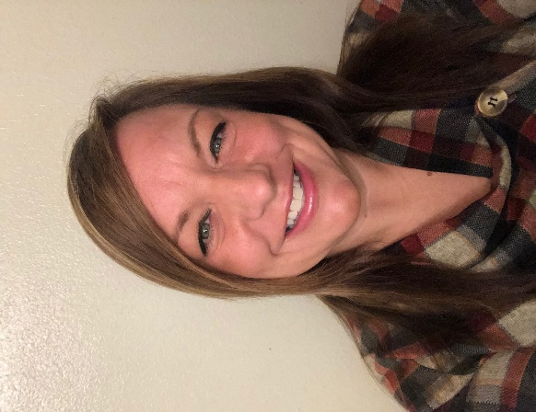
Theresa Robinson holds a Bachelor of Science in Psychology and an alternative teacher certification in Special Education K-12. She has a 12-year background in private/public schools serving in both Texas and Louisiana. She has been a part of the LATI team for 3 years. She currently works in the Northwest Assistive Technology Center servicing all schools and early childhood centers in the Northwest region of the state. She can be reached at theresa.robinson@bossierschools.org

Saturday, March 30, 2019
7:45 – 9 AM Continental Breakfast - Visit Sponsors

SATURDAY MORNING BREAKOUT SESSIONS

SESSION G  9AM – 12 Noon  The ABC’s of Behavior Using Assistive Technology  Melva Pania- Stephens  Josh Miller | SESSION H  9AM – 12 Noon  Ready Set Eat  Qualifies as the Food Safety  Requirement  Dianna Constant | SESSION I  9AM–12 Noon  AdministratorsOwners and Director’s Roundtable  Discussion  Bob Lansing  Jonathan Pearce | SESSION J  9AM – 12 Noon  Communicate for Success  This session is geared for owners, directors and administrators  Dr. Sheika  Square | SESSION K  9AM – 12 Noon  Conscious Discipline: Composure  Suzanne Millerhebert | SESSION L  9AM – 12 Noon  What’s the Flippin’ Point of this Activity?  Gina Carter Merkel | SESSION M  9AM – 12 Noon  How to Organize an Educational and Fun Holiday and Summer Camp Curriculum Plan  Loretta Hall

SATURDAY MARCH 30, 2019 MORNING BREAKOUT SESSIONS

SESSION G: The ABC’s of Behavior Using Assistive Technology
Melva Pania Stephens and Josh Miller
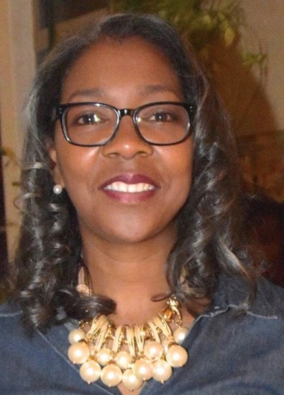
All behaviors are a form of communication. Children usually have logic behind the behavior they exhibit. Some behaviors can be to seek sensory needs, escape a task, and seek attention or a tangible need. In this session, you will learn ways to incorporate positive behavioral support strategies using Assistive Technology in the Early Childhood Classroom to increase classroom effectiveness ad decrease misbehavior. Strategies for addressing clear behavior expectations while being proactive and redirecting misbehaviors will be discussed. Melva Pania-Stephens is an Assistive Technology Facilitator who works with LATI (Louisiana Assistive Technology Initiative) to provide training and support to several school districts in the state of Louisiana. Melva believes that all students, regardless of their disability, can learn when they are afforded an opportunity. She has worked in Iberville Parish for the past 28 years serving as both a Speech-Language Pathologist and as the teacher for the medically fragile students with significant disabilities (Cerebral Palsy, Seizure Disorders, Cortical Blindness, Autism and Oppositional Defiant Disorder. Melva has attended numerous conferences and trainings to increase her knowledge in the area of student behavior. Melva holds a Bachelor’s Degree in Communication Disorders from Southern University and A&M College, Baton Rouge, Louisiana.
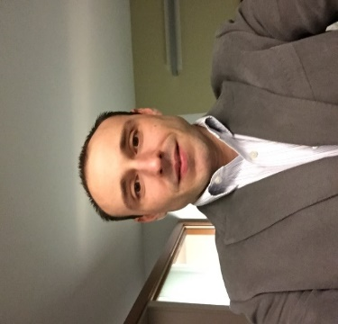
Josh Miller is an Assistive Technology Facilitator with the Louisiana Assistive Technology Initiative for the Southeast region. He attended Louisiana State University where he received a degree in Mass Communications. He was formerly Program Director at the Louisiana Assistive Technology Access Network. He is a certified Assistive Technology Professional (ATP) by RESNA and a Level 2 Google Certified Educator.

SESSION H: Ready Set Eat (Food Safety Class) Dianna Constant, Agenda for Children

Ready, Set Eat is a session on how children grow and develop and fulfills the Board of Health's Food Safety requirement. This is an interactive session that includes children with special needs. Additionally, participants will be able to define the grasping stages, to describe a positive and supportive learning environment for feeding children and will be able to discuss how language and feeding are related. CLASS language is used.

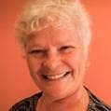
Dianna Constant is the Region IV Agenda for Children/Child Care Resources Coordinator. She holds a Bachelor of Arts Sociology and Youth and Family Services. She is also an Office of Public Health, Maternal and Child Welfare Child Care Health Consultant and a consultant with University of Montana Rural Institute on Disabilities – Child Care Plus Team; Consultant with Utah State University Ski - High Institute on Children with Disabilities and a statewide trainer on Inclusive Ideologies. Dianna may be reached by email at dconstant@agendaforchildren.org

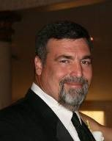
SESSION I: Administrators, Owners and Directors Roundtable Discussion – Bob Lansing & Jonathan Pearce
JONATHAN PEARCE
BOB LANSING
Come join Bob Lansing and Jonathan Pearce in a discussion of the most current topics of the day during our Round Table Discussions. We will facilitate group discussions on such topics as Background Checks, Licensing Inspections, Video Cameras, Workers Compensation, Risk Management, Staffing, Budget Cutting Ideas, and many more. Bring your list of topics and be a part of the discussion. Bob Lansing has a Bachelor’s of Science degree in Electrical and Computer Engineering from LSU and a Masters of Arts from New Orleans Baptist Seminary with an emphasis in Administration. He spent 10 years working for the Department of Defense, US Air Force. For the past 23 years, he has been the owner/director of Central Academy Early Learning Center, a four star center in Baton Rouge. Bob Lansing has been married for 37 years to Robin. They have 5 children and 3 grandchildren. Bob Lansing can be reached via email at bob@centralelc.com

Jonathan Pearce is a native of Lafayette and a graduate from the BI Moody College of Business at the University of Louisiana with a Degree in Business Management and a minor in Psychology. He also earned the National Administrators Credential given by the National Institute of Child Care Management. Jonathan is the President/CEO of Sugar ‘n Spice Preschools and Vacation Station with four locations in Acadiana employing over 100 and serving over 500 students. He is also the President/CEO of Property 1st Management. Jonathan is the current President of the Childcare Association of Louisiana. Jonathan also serves on the Board of Directors for the Youngsville Chamber of Commerce serving as Past President and current Governmental Chair. He and his wife Angelle have been married since 2009 and they are the proud parents of Jon Paul, Andrew and Jeanette. Jonathan is a 2015 Recipient of Acadiana Leadership Top 20 Under 40 award. Jonathan can be reached at jonathan@snsacadiana.com

SESSION J: Communicate with Success – Dr. Sheika Square
Has there ever been a moment where you felt like you could have communicated better with your co-workers, employees, or even management? Dr. Sheika Square, Certified Business Coach and Empowerment Expert, specializes in teaching effective ways to communicate in and out of the workplace. It’s been said time and time again, that communication is the key to success and it’s true. Being able to clearly convey your thoughts, feelings, and suggestions, will allow you to grow personally and, most importantly, professionally. If you’re ready to become a more confident and successful communicator, join Dr. Sheika Square for a candid conversation and training focused on effective communication skills, as well as results-driven approaches to better engage your audience. As an Empowerment Expert and Certified Business Coach, with over 13 years of experience in Leadership, Administration, & Business, Dr. Sheika Square is one of this generations pioneering leaders and captivating speakers. Dr. Square has worked with Dillard University’s DUFIT, the Urban League, Dillard University, BREC, STEM NOLA, Louisiana State University, the University of New Orleans, and more… putting her skills as a leader and educator to use. After over a decade in education, finance, and leadership, Dr. Square launched IIYKO Systems, LLC in an attempt to foster the growth she desperately desires in others. Dr. Sheika Square speaks to groups on topics that offer insight into self and/or organizational maneuvering. Dr. Square can be reached at www.drsheikasquare.com

As an Empowerment Expert and Author, with over 10 years of experience in Leadership, Administration, & Business, Dr. Sheika Square is one of this generations pioneering leaders and captivating speakers. Along with the knowledge to make solutions and resolutions elucidated, Dr. Square’s ability to penetrate her audience and move them to action is unparalleled. Her work as a financial consultant and mentor/leader in the fields of Business and Education adds to her ability to disseminate unique messages. Dr. Square has worked with Dillard University’s DUFIT, the Urban League, Dillard University, BREC, STEM NOLA, Louisiana State University, the University of New Orleans, and more… putting her skills as a leader and educator to use. After over a decade in education, finance, and leadership, Dr. Square launched IIYKO Systems, LLC in an attempt to foster the growth she desperately desires in others. Today, with fascinating and enlightening antidotes, Dr. Sheika Square speaks to groups on topics that offer insight into self and/or organizational maneuvering. Dr. Square can be reached at info@drsheikasquare.com
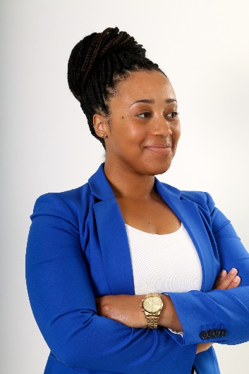

SESSION K: Conscious Discipline: Composure - Suzanne Millerhebert
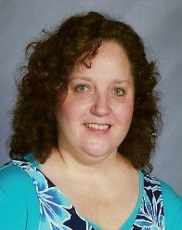
By keeping our composure, we can see confrontations and disagreements as teachable moments. Using the practices in Conscious Discipline, we can teach children to be thoughtful and have internal motivation. This corresponds with CLASS and best practices. Suzanne “Suzea” Millerhebert was born and raised in New Orleans. She received a BS from SLU in Elementary Education, and a M.Ed. from UNO in Curriculum and Instruction majoring in Early Childhood and minoring in Special Education. She has worked with children for 37 years, teaching in New Orleans, Oklahoma City, Biloxi, Houston, and Slidell. Her experience with children ranges from birth to 13 years of age. Her goal is to help teachers do the best job they can so that they and the children they work with can reach or exceed their potential. She can be contacted at the Center for Development and Learning as an Early Childhood Coordinator. She can be reached at millerhebert@gmail.com

SESSION L: What’s the Flipping Point of This Activity? Gina Merkel-Carter
In this session, we will discuss what the potential learning gains are in our curriculum. This class is designed to help teachers facilitate scheduled activities for effective teaching. Gina began her career in the early childcare industry the same way that many of you have. She had a passion for children and wanted to be more involved. She applied to work at a child care center and was hired as a two-year-old teacher and given minimum training and set loose. She was promoted to an Assistant Director, Director, trained as an ERS assessor (Environment Rating Scales) conducted assessments, observed classrooms and now works for ProSolution Training as the lead coach and mentor for one of LDOE's Approved Blended Ancillary CDA program. In addition she provides personalized private coaching and training for centers and teachers. Additional training and certifications include Affiliated Trainer for Infant, Toddler and Pre-K CLASS (Classroom Assessment Scoring System). Train the Trainer for TS GOLD (Teaching strategies GOLD) which is a child assessment tool on child growth and development. Over the years she has attended many classes, trainings, studied under many wise people, learned and unlearned a great deal. She thinks what she has learned the most is that things change and we must also be in a constant state of change. But this basic principle remains constant in guiding her philosophy. Look through the eyes of a child. See what they see. Feel what they feel and be compassionate to it. Gina may be reached by email at wiredforlifegcm@gmail.com

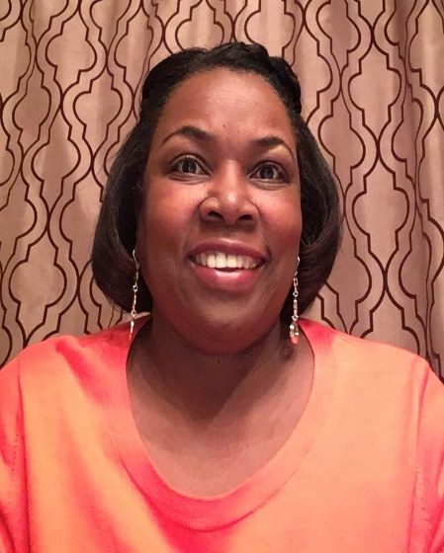
SESSION M: How to Organize an Education and Fun Holiday and Summer Camp Curriculum Plan – Loretta Hall
In this session, we will dive into planning school age holiday camp that provides an a well thought out camp experience that provide safe, educational experience that will stimulate growth both educational and emotional. School age children are often considered a difficult age. This group of children need mentors and invested teacher more than ever before. Join Loretta in a high engaging class that promises to excite teachers in the potential of their camp program. Loretta Hall is employed at Volunteer of America (Partnership in Childcare) as an Educational Coach and Technical Assistant. She is married with 2 children and 2 grandchildren. Loretta is the former owner of Helping Hands Preschool, a childcare center that she operated for ten years. She enjoys shopping and reading in her spare time. Loretta is known in the community of Early Childhood as a person with real life experience with real solutions to real world challenges. She is often found in centers elbows deep in modeling appropriate teacher child interactions.

Saturday March 30, 2019 SATURDAY AFTERNOON BREAKOUT SESSIONS

SESSION N  1 – 4 PM  Conscious Discipline:  Composure  Suzanne Millerherbert | SESSION O  1 – 4 PM  Being the Leader of Your Own Classroom  Dr. Sheika Square | SESSION P  1 – 4 PM  The ABC’s of Behavior Using Assistive Technology  Melva Pania- Stephens  Josh Miller | SESSION Q  1 - 4 PM  Using Hands-On Activities Effectively  Addie Hester | SESSION R  1 – 4 PM  Staying Inspired: The Importance of What We Do to Educate Children  Desiree  Collins | SESSION S  1 – 4 PM  Preparing for your Assessment  Gina Carter Merkel

SESSION N: Conscious Discipline: Composure Suzanne Millerhebert
By keeping our composure, we can see confrontations and disagreements as teachable moments. Using the practices in Conscious Discipline, we can teach children to be thoughtful and have internal motivation. This corresponds with CLASS and best practices. Suzanne “Suzea” Millerhebert was born and raised in New Orleans. She received a BS from SLU in Elementary Education, and a M.Ed. from UNO in Curriculum and Instruction majoring in Early Childhood and minoring in Special Education. She has worked with children for 37 years, teaching in New Orleans, Oklahoma City, Biloxi, Houston, and Slidell. Her experience with children ranges from birth to 13 years of age. Her goal is to help teachers do the best job they can so that they and the children they work with can reach or exceed their potential. She can be contacted at the Center for Development and Learning as an Early Childhood Coordinator. Suzanne can be reached at millerhebert@gmail.com

SESSION O: Being the Leader of Your Own Classroom Dr. Sheika Square
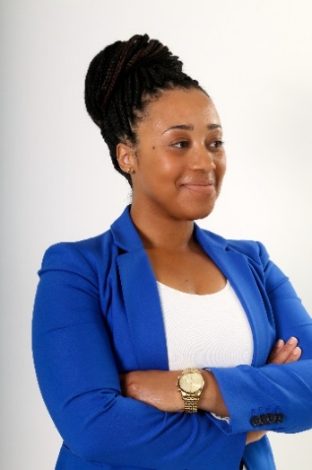
Leaders lead and that means teachers too. This enlightening session will guide classroom leaders with techniques needed to engage with parents, center staff and other members of administration in a productive and results driven way. As an Empowerment Expert and Certified Business Coach, with over 13 years of experience in Leadership, Administration, & Business, Dr. Sheika Square is one of this generations pioneering leaders and captivating speakers. Dr. Square has worked with Dillard University’s DUFIT, the Urban League, Dillard University, BREC, STEM NOLA, Louisiana State University, the University of New Orleans, and more… putting her skills as a leader and educator to use. After over a decade in education, finance, and leadership, Dr. Square launched IIYKO Systems, LLC in an attempt to foster the growth she desperately desires in others. Dr. Sheika Square speaks to groups on topics that offer insight into self and/or organizational maneuvering. Dr. Square can be reached at www.drsheikasquare.com

SESSION P: The ABC’s of Behavior Using Assistive Technology - Melva Pania Stephens and Josh Miller
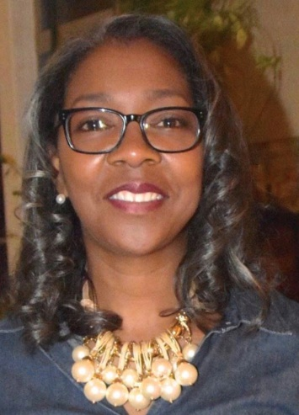
All behaviors are a form of communication. Children usually have logic behind the behavior they exhibit. Some behaviors can be to seek sensory needs, escape a task, and seek attention or a tangible need. In this session, you will learn ways to incorporate positive behavioral support strategies using Assistive Technology in the Early Childhood Classroom to increase classroom effectiveness ad decrease misbehavior. Strategies for addressing clear behavior expectations while being proactive and redirecting misbehaviors will be discussed. Melva Pania-Stephens is an Assistive Technology Facilitator who works with LATI (Louisiana Assistive Technology Initiative) to provide training and support to several school districts in the state of Louisiana. Melva believes that all students, regardless of their disability, can learn when they are afforded an opportunity. She has worked in Iberville Parish for the past 28 years serving as both a Speech-Language Pathologist and as the teacher for the medically fragile students with significant disabilities (Cerebral Palsy, Seizure Disorders, Cortical Blindness, Autism and Oppositional Defiant Disorder. Melva has attended numerous conferences and trainings to increase her knowledge in the area of student behavior. Melva holds a bachelor’s degree in Communication Disorders from Southern University and A&M College, Baton Rouge, Louisiana.

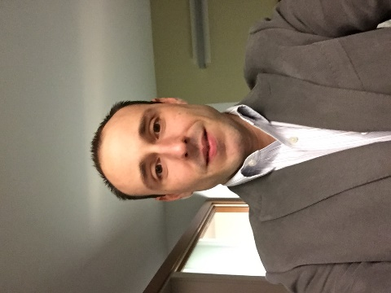
Josh Miller is an Assistive Technology Facilitator with the Louisiana Assistive Technology Initiative for the Southeast region. He attended Louisiana State University where he received a degree in Mass Communications. He was formerly Program Director at the Louisiana Assistive Technology Access Network. He is a certified Assistive Technology Professional (ATP) by RESNA and a Level 2 Google Certified Educator.

SESSION Q: Using Hands-On Activities Effectively Addie Hester
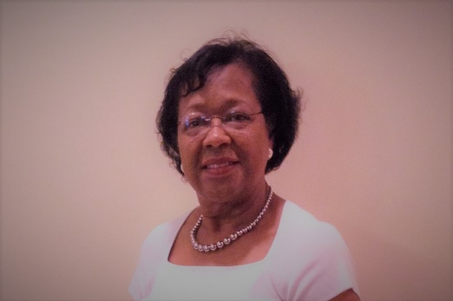
Young children learn best when they are 'doing' and this session is designed to improve the teacher practice of becoming more intentional and effective in increasing young children's vocabulary and language skills while engaging them in hands-on learning activities. Using hands-on activities effectively, teachers have a unique opportunity to stimulate children’s minds and thinking - while at the same time increasing their vocabulary and language skills. This over-arching session goal can be linked to increasing teacher practices which lead to improving CLASS scores. The variety of practical yet effective strategies to be embedded throughout the session can be aligned with the various indicators within the Language Modeling Dimension of CLASS. Addie Hester is a native of Wilson, North Carolina and has lived in Baton Rouge for more than four decades. Her professional career began with obtaining a B.S. Degree in Child Development from North Carolina A & T State University and later earning a Master’s Degree from LSU in Special Education plus 30 additional college credit hours. Over the years, Addie has gained several additional certifications and extensive early childhood knowledge and skills through on-going participation in seminars, webinars and on-line course work. She has also served as an early childhood conference speaker and session presenter for a host of local, regional, and state level early childhood organizations. A noteworthy professional teaching career highlight for her was being honored as the SSD #1 - Statewide Teacher of the Year for 2003-2004. Addie has worked over the years for Volunteers of America - Partnerships in Child Care as a Louisiana Pathways Trainer III and is currently working for the Pointe Coupee Early Childhood Coalition as an Instructional Coach and Trainer. Addie can be reached by email at addie_hester@yahoo.com

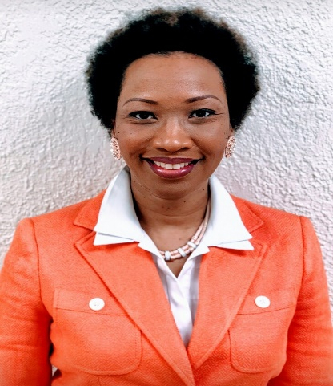
SESSION R: Staying Inspired: The Importance of What We Do to Educate Children - Desiree Collins
In this session Desiree will engage with educators and discuss how to not let the new rules and regulations take away from the joys and passion of Early Childcare. Desiree will dive into the rewarding aspects of working with young children and the life changing effects we have on the future of our society. Desires will re-ignite your early childhood fire. Desiree ran an Early Learning Center where she was the owner and director for 20 years. She is a Instructional Specialist and Louisiana Pathways Trainer, EBR parent Liaison for Triple P as Positive Parent facilitator, Desiree is also an Infant, toddler and Pre-K CLASS Reliable Observer. Desiree earned her Bachelor's degree from Southern University in Psychology. Her favorite place in the classroom is the Library and the Science Center. Desiree is best known for sharing her passion, love and enthusiasm in the early childhood field. Desiree has been married for 25 years. She is a mother of 5 children, and grandmother of 2.

SESSION S: Preparing for Your Assessment - Gina Carter-Merkel

In this session, Gina will review what to expect, how to prepare, and understanding what it takes to improve scores in challenging areas. Key concepts for this class include, but are not limited to:
- Tips on key language
- How to set yourself up for a great assessment
- How to prepare yourself to receive feedback
- Understanding what it takes to improve challenging areas

Gina began her career in the early childcare industry the same way that many of you have. She had a passion for children and wanted to be more involved. She applied to work at a child care center and was hired as a two-year-old teacher and given minimum training and set loose. She was promoted to an Assistant Director, Director, trained as an ERS assessor (Environment Rating Scales) conducted assessments, observed classrooms and now she provides training, assistance, and support to Early Childcare Centers. Additional training and certifications include Affiliated Trainer for Infant, Toddler and Pre-K CLASS (Classroom Assessment Scoring System) tool as well as a reliable observer for the Infant CLASS tool. Train the Trainer for TS GOLD (Teaching strategies GOLD) which is a child assessment tool on child growth and development. Over the years she has attended many classes, trainings, studied under many wise people, learned and unlearned a great deal. She thinks what she has learned the most is that things change and we must also be in a constant state of change. But this basic principle remains constant in guiding her philosophy. Look through the eyes of a child. See what they see. Feel what they feel and be compassionate to it. Gina may be reached by email at wiredforlifegcm@gmail.com

CHILD CARE ASSOCIATION OF LOUISIANA
2019 SPRING EDUCATION CONFERENCE

If your childcare center is a CCAL member, all of your employees are entitled to register. Your center must be a CCAL Member in order to attend our conference.

You can apply for membership online at www.childcarelouisiana.org

CONFERENCE REGISTRATION FEES

The fees below are for CCAL Members Only.
CCAL is running a special promotion for non-members.
Visit our website and click on the Events Box (Green) on our Home page

Two Day Conference Registration Rate Friday and Saturday $150 per person
Friday Only Conference Registration Rate $90 per person
Saturday Only Conference Registration Rate $80 per person

Fast and Convenient Registration Online www.childcarelouisiana.org

A $25 late fee per registration will be assessed for onsite registration

BOOK YOUR HOTEL ROOM TODAY
CCAL has reserved a small block of hotel rooms at the Hampton Suites Hotel and at the LaQuinta Suites in Port Allen for Thursday March 28, 2019 and Friday, March 29, 2019.
The room rate includes a hot breakfast for each occupant. The special room rate expires on Saturday, March 15, 2019 for the Hampton Inn and Suites. The LaQuinta Inn’s special room rate expires on March 25, 2019. Mention the “CCAL” Room Block to obtain this special rate of $89 per night

Hampton Inn and Suites LA Quinta Inn & Suites
2755 Commercial Drive 2720 N Westport Drive
Port Allen, Louisiana Port Allen, Louisiana
(225) 389-6655 (225) 960-7787

2019 CCAL SPRING CONFERENCE REGISTRATION FORM
Company Name ________________________________________________________________________________________
Name of Person Completing Application _____________________________________________________________
Cell Phone # _____________________________________________________________________________________________
Office Phone: ____________________________________________________________________________________________
Email Address __________________________________________________________________________________________
Address _________________________________________________________________________________________________
City State ZIP __________________________________________________________________________________________
We must have your personal email address to register you for this conference!

FRIDAY AFTERNOON BREAKOUT SESSIONS
A | Medication Administration (meets the requirements of the Health & Safety Class) | Dianna Constant
B | Business Management – HR and Labor Laws | Bob Lansing
C | The ABCs of Behavior Using Assistive Technology | Melva Pania Stephens
D | Using CLASS to Its’ Fullest Potential | Niki Da’Jon
E | Professionalism in the Workplace | Dr. DeShannon Quiett
F | Adapting Books: Access for All | Kristi Sheffield

SATURDAY MORNING BREAKOUT SESSIONS
G | The ABCs of Behavior Using Assistive Technology | Melva Pania-Stephens
H | Ready Set Eat (meets the requirements of the Food Safety Class) | Dianna Constant
I | Administrators, Owners and Directors Roundtable Discussion | Bob Lansing  Jonathan Pearce
J | Communicating with Success | Dr. Sheika Square
K | Conscious Discipline: Composure | Suzanne Millerhebert
L | What’s the Flippin Point of This Activity? | Gina Carter-Merkel
M | How to Organize an Educational and Fun Holiday & Summer Camp Curriculum | Loretta Hall

SATURDAY AFTERNOON BREAKOUT SESSIONS
N | Conscious Discipline: Composure | Suzanne Millerherbert
O | Being the Leader of Your Own Classroom | Dr. Sheika Square
P | The ABCs of Behavior Using Assistive Technology | Melva Pania-Stephens
Q | Using Hand-On Activities Effectively | Addie Hester
R | Staying Inspired: The Importance of What We Do to Educate Children | Desiree Collins
S | Preparing for Your Assessment | Gina Carter-Merkel

CREDIT CARD AUTHORIZATION FORM

You may charge your registration by faxing this form to 225 208-1932 or mailing to:

Include this credit card authorization form along with the registration of desired classes

2019 SPRING REGISTRATION CREDIT CARD AUTHORIZATION

Childcare Association of Louisiana
P.O. Box 80053
Baton Rouge, LA 70898-0053

Childcare Center _____________________________________________________________________________

Cardholder’s Name ___________________________________________________________________________

Card No: ______________________________________________________________________________________

Billing Address Associated with Card: ______________________________________________________

__________________________________________________________________________________________________

Expiration Date: ______________________________________________________________________________

Card Security Code: __________________________________________________________________________

Telephone Number:___________________________________________________________________________

Amount to be charged: _______________________________________________________________________

All sessions are on a first come, first served basis. Pre-registering for the breakout sessions you’re interested in attending will help us plan properly to accommodate our attendee’s interests. Thank you! Please Print the Name of Person(s) You Wish to Register and Mark an X in the Box for the Days they Plan to Attend, please let us know the session they plan to attend AND indicate whether the person attending has a CDA by putting CDA at the end of their name. Thanks!

Child Care Center Name: ____________________________Name of Person Completing Application: ______________________________

Name of Registrant | Attending Friday? | Session  Letter (A-F) | Attending Saturday? | Morning  Session  Letter (G-M) | Afternoon  Session  Letter (N-S) | Registration  Paid  Per Person

Two-Day Conference Registration Rate Friday and Saturday $150 per person
Friday Only Conference Registration Rate $90 for Friday per person
Saturday Only Conference Registration Rate $80 for Saturday per person
Fast and Convenient Registration Online www.childcarelouisiana.org

