2020 SPRING EDUCATION CONFERENCE
REGISTRATION PACKET

Friday, March 13, 2020

Saturday, March 14, 2020

WEST BATON ROUGE CONFERENCE CENTER
2750 NORTH WESTPORT DRIVE
PORT ALLEN, LOUISIANA

For more information, contact Cindy Bishop, Executive Director

cindy.bishop@checkmate-strategies.com

(225) 933-5435

Early Bird Discount Rates for CCAL Members!

Select from one of our four Lagniappe Membership Bundles
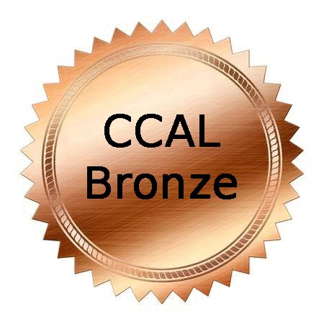 |  | 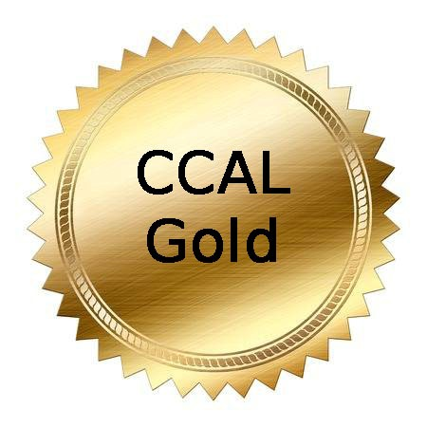 | 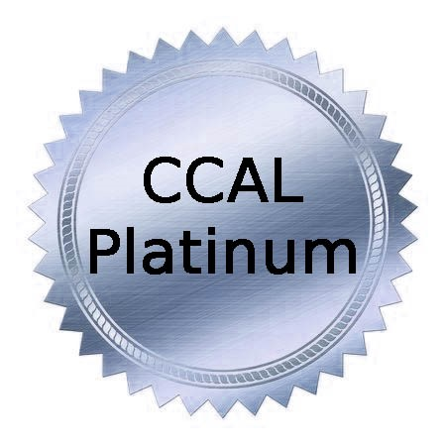
$120/year | $165/year | $200/year | $300/year
COVERS 5 STAFF MEMBERS | COVERS 7 STAFF MEMBERS | COVERS 10 STAFF MEMBERS | COVERS UNLIMITED STAFF

Join or Renew at www.childcarelouisiana.org

SPRING EDUCATION CONFERENCE

FRIDAY, MARCH 13, 2020

GENERAL SESSION – PLANTATION ROOM

WEST BATON ROUGE CONFERENCE CENTER
2750 N Westport Drive, Port Allen, Louisiana

7:30 AM Registration Check-in and Continental Breakfast
Networking and Visit with Sponsors / Vendors
8:55 AM Welcoming Remarks– Olivette Temple, President
9:00 AM KEYNOTE PRESENTATION

10:00 AM Louisiana Department of Education Updates
Lisa Brochard and Jessica Baghian
Child Care Assistance Program - Melinda George
Ancillary Teaching Certificates – Nasha Patel
Licensing/Bulletin 137 – Shelia Campbell
Child Care Criminal Background Checks – Valerie Black
Emmy O’Dwyer – Louisiana Early Leaders Academy and State Purchasing

11 AM – 12:15 PM Early Childhood Education Panel Discussion Moderator – Alan Young

First Lady Donna Edwards
Senator Beth Mizell
Representative Stephanie Hilferty
Representative Royce Duplessis
Representative Rick Edmonds
Representative Gary Carter
Tony Davis, BESE Member

12:30 PM Lunch, Door Prizes and Sponsor Recognition

Friday, March 13, 2020 AFTERNOON BREAKOUT SESSIONS 1:30 – 4:30 PM

SESSION A  Medication  Administration  (Good for 2 years)  Dianna Constant  Agenda for Children | SESSION B  Playing with  Teachable Moments  Suzanne  Millerhebert | SESSION C  The Early Leaders Academy  Emmy O’Dwyer  Louisiana Department of Education | SESSION D  Building the Good Life with Goal Setting: Using a Proven Framework to Find Clarity, Increase Productivity and Achieve Results that Matter Most  Wyatt Graves | SESSION E  Small Business  Financial Strategies  Doyle Fillastre CPA | SESSION F  Creating Quality-Based Afterschool  Programs  Andrew Ganucheau  Louisiana Center for Afterschool Learning

FRIDAY, MARCH 13, 2020 AFTERNOON BREAKOUT SESSIONS 1:30 – 3:30 PM

SESSION A Medication Administration – Dianna Constant, Agenda for Children
This session provides staff training on how to properly administer medication to children in early learning centers. Participants will learn the state’s policies and procedures to follow in order to institute a clear guiding principle for medication administration. After completion, participants will receive a certificate to demonstrate compliance with the Louisiana Department of Health.

SESSION B Playing with Teachable Moments – Suzanne Millerhebert
We should all look for teachable moments throughout our day with children. When teachers are intentional with their planning, learning can be fun. Games and activities can be used to teach concepts and information. Participants will first see how this is done, then create a game to teach an objective.

SESSION C The Louisiana Early Leaders Academy - Emmy O’Dwyer, LDOE
Co-Presenter: Olivette Temple, CCAL President and LELA Fellow
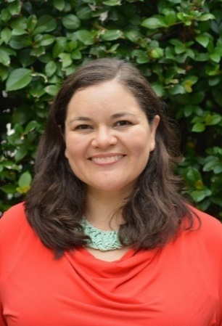
The Louisiana Early Leaders Academy pilot is a selective fellowship for directors of Type III centers who want to build instructional leadership skills. The program offers executive coaching, training, and communities of practice. The second year of applications will open in May. The presentation will provide information about the program, an opportunity to hear from 1 or more fellows, and guidance for the application process.

SESSION D Building the Good Life with Goal Setting: Using a Proven Framework to Find Clarity, Increase Productivity, and Achieve Results that Matter Most - Wyatt Graves

Participants will learn a proven method for setting goals and a framework for day-to-day implementation of activities necessary to achieve the results that matter most. Presenter will walk participants through an examination of ‘success’ and define it for the class. They will learn proven methods for taking control of their lives within the workplace and how to stay the course to WIN. By the end of the class, participants will have hands-on work already started to walk out and take charge of their schedules, adding personal time back to their lives!

SESSION E Small Business Financial Strategies - Doyle Fillastre CPA
Start 2020 off right with a two-hour session from a certified public accountant Doyle Fillastre. Doyle will provide information on budgeting, tax tips, maximizing the School Readiness Tax Credit and more useful tips on how to improve your businesses’ finances for 2020. He owns The Fillastre Group headquartered in Baton Rouge, helping individuals and businesses with tax return preparation and accounting services.

SESSION F Creating Quality-Based Afterschool Programs
Andrew Ganucheau, Louisiana Center for Afterschool Learning
This session will provide early learning centers with the basic tools for establishing and operating an afterschool program in their facility. All participants will receive a copy of the LAPQI tool kit, which provides best practices and observation tools to inform the development of quality afterschool programs.

Saturday, March 14, 2020

7:30 – 8:30 AM Coffee, Networking and Visit Exhibitors
8:30 AM – 10:30 AM Early Morning Breakout Sessions

SESSION G  Stress Management for Childcare Givers  Dr. DeShannon Quiett-Burrell  Co-Presenters:  Sharon McNeely Dominque Byrd | SESSION H  Playing with Teachable Moments  Suzanne  Millerhebert | SESSION I  Administrator Support in CLASS  Niki Da’Jon  Sea Academy | SESSION J  Striving for Excellence Using  CLASS Data  Angela Barnes  Co-Presenter:  Charlene Jenkins  LSU Early Childhood Education  Laboratory Preschool | SESSION K  Ready Set Eat  Qualifies as the  Food Safety  Requirement  Dianna Constant  Agenda for Children | SESSION L  Children Need Play: Their Mental Health Depends Upon It  Desiree Collins  East Baton Rouge Parish School System

SATURDAY, MARCH 14, 2020
Early Morning Breakout Sessions 8:30 AM – 10:30 AM
SESSION G Stress Management for Child Caregivers
Dr. DeShannon Quiett-Burrell
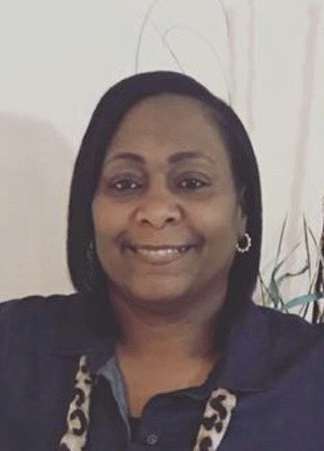
Co-Presenters: Sharon McNeely and Dominque Byrd
Stress Management for Child Caregivers
Caring for young children is rewarding and enjoyable. However, sometimes there are life stressors and career demands that can cause serious health problems.

This session will:
- Help childcare providers fulfill their job role by learning how to care for themselves by managing their stress and restoring balance in life.
- Learn how to develop positive habits and relaxation techniques to help them while simultaneously modeling positive behavior for the children they serve.

SESSION H Playing with Teachable Moments – Suzanne Millerhebert
We should all look for teachable moments throughout our day with children. When teachers are intentional with their planning learning can be fun. Games and activities can be used to teach concepts and information. Participants will first see how this is done, then create a game to teach an objective.

SESSION I Administrator Support in CLASS - Niki Da’Jon, Sea Academy
This training is designed for administrators to help them understand the CLASS tool and CLASS protocols to prepare and inform their teachers on how implement and facilitate highly effective teacher and child interactions. The objective of this training is to build administrator’s confidence and competence of CLASS to help them better support their teaching staff.

SESSION J Striving for Excellence Using CLASS Data
Angela Barnes, LSU Early Education Childhood Laboratory Preschool
Co-Presenter: Charlene Jenkins
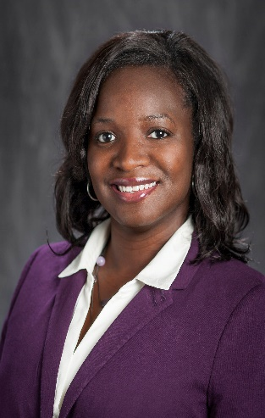
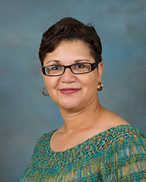
Come learn how to effectively analyze and use data to improve CLASS scores. Participants will practice using self-reflection videos and professional development plans to improve their classroom performance scores. The presenters will review scoring guidelines and indicators of high-quality interactions based on the CLASS manual. Participants are invited to bring their CLASS observation data to the session.

SESSION K Ready Set Eat (Food Safety Class) Dianna Constant, Agenda for Children
Ready, Set Eat is a session on how children grow and develop and fulfills the Board of Health's Food Safety requirement. This is an interactive session that includes children with special needs. Additionally, participants will be able to:
- define the grasping stages
- describe a positive and supportive learning environment for feeding children
- be able to discuss how language and feeding are related. CLASS language is used
This class counts toward the Louisiana Department of Health food safety requirement.

SESSION L
Children Need Play: Their Mental Health Depends Upon It
Desiree Collins, East Baton Rouge Parish School System
Join Desiree Collins for an informative and hands-on session focused on the importance and value of providing children the freedom to make choices about what they want to pay. Desiree will also guide teachers in how to take the children’s focus and make it meaningful and educational.
Saturday, March 14, 2020
Mid-Morning Breakout Sessions 10:30 AM – 12:30 PM

SESSION M  Director’s  Roundtable Discussion:  Part I  Bob Lansing  Central Early Learning Center  Jonathan Pearce  Sugar N’Spice | SESSION N  Ready Set Eat  Qualifies as the Food Safety  Requirement  Dianna Constant  Agenda for Children | SESSION O  Playing with Teachable Moments  Suzanne Millerhebert | SESSION P  Gross Motor Skills in the CLASSroom  Theresa Lawson  Children’s Coalition for Northeast Louisiana | SESSION Q  Administrator Support in CLASS  Niki Da’Jon  Sea Academy | SESSION R  Active Supervision  Dr. DeShannon Quiett-Burrell  Co-Presenters:  Sharon McNeely Dominque Byrd

SESSION M DIRECTOR’S ROUNDTABLE DISCUSSION
Bob Lansing and Jonathan Pearce will facilitate an engaging roundtable discussion on current topics facing owners and directors of early learning centers.
- Criminal Background Checks
- Licensing Inspections
- Video Cameras
- Workers Compensation
- Risk Management
- Staffing
- Budget Cutting Ideas
- Career Path Ladder
Bring your list of topics and be a part of the discussion

SESSION N Ready Set Eat (Food Safety Class) - Dianna Constant, Agenda for Children
This class counts toward the Louisiana Department of Health food safety requirement.
Ready, Set Eat is a session on how children grow and develop and fulfills the Board of Health's Food Safety requirement. This is an interactive session that includes children with special needs. Additionally, participants will be able to:
- define the grasping stages
- describe a positive and supportive learning environment for feeding children
- be able to discuss how language and feeding are related. CLASS language is used.

SESSION O Playing with Teachable Moments - Suzanne Millerhebert
We should all look for teachable moments throughout our day with children. When teachers are intentional with their planning learning can be fun. Games and activities can be used to teach concepts and information. Participants will first see how this is done, then create a game to teach an objective.

SESSION P Gross Motor Skills in the CLASSroom - Theresa Lawson
Gross motor skills are the abilities required to control the large muscles of the body for walking, jumping, skipping, and more. We will discuss the importance of giving children the opportunity to help a child gain strength and confidence in his/her body safely while inside your classroom. Gross motor activities aren’t just for rainy days or outside play time because intentional activities can align with the CLASS observation tool and maybe even improve your score.

SESSION Q Administrator Support in CLASS - Niki Da’Jon, Sea Academy
This training is designed for administrators to help them understand the CLASS tool and CLASS protocols to prepare and inform their teachers on how implement and facilitate highly effective teacher and child interactions. The objective of this training is to build administrator’s confidence and competence of CLASS to help them better support their teaching staff.

SESSION R Active Supervision - Dr. DeShannon Quiett-Burrell
Everyone has a responsibility to keep children safe. Children learn best when they are in safe, well-supervised environments. Staff can reduce the possibility of a child getting hurt when they closely observe children and respond when needed. When programs think systematically about child supervision, they create safe, positive learning environments for all children. In this training you will learn
- To discover the importance of looking, listening, and engaging
- the six strategies to keep children safe
- See how active supervision benefits the children and the staff
Co-Presenters: Sharon McNeely and Dominque Byrd

Saturday March 14
Afternoon Breakout Sessions 1:45 PM – 3:45 PM
SESSION S  Playing with Teachable Moments  Suzanne  Millerhebert | SESSION T  Gross Motor Skills in the CLASSroom  Theresa Lawson  Children’s Coalition for Northeast Louisiana | SESSION U  Director’s Roundtable Discussion:  Part II  Jonathan Pearce  Sugar N’Spice  Bob Lansing  Central Early Learning Center | SESSION V  Stress Management for Child Caregivers  Dr. DeShannon Quiett-Burrell  Co-Presenters:  Sharon McNeely and Dominque Byrd | SESSION W  The Relationship between Teacher Beliefs, Adult Attachment and Classroom Climate  Jeanette Bankston  Graduate Assistant  Cynthia DiCarlo  LSU Early Childhood Education Laboratory Preschool | SESSION X  Children Need Play: Their Mental Health Depends Upon It  Desiree Collins  East Baton Rouge Parish School System

SESSION T Playing with Teachable Moments
Suzanne Millerhebert
We should all look for teachable moments throughout our day with children. When teachers are intentional with their planning learning can be fun. Games and activities can be used to teach concepts and information. Participants will first see how this is done, then create a game to teach an objective.

SESSION U Gross Motor Skills in the CLASSroom - Theresa Lawson
Gross motor skills are the abilities required to control the large muscles of the body for walking, jumping, skipping, and more. We will discuss the importance of giving children the opportunity to help a child gain strength and confidence in his/her body safely while inside your classroom. Gross motor activities aren’t just for rainy days or outside play time because intentional activities can align with the CLASS observation tool and maybe even improve your score!

SESSION V DIRECTOR’S ROUNDTABLE DISCUSSION
Bob Lansing and Jonathan Pearce will facilitate an engaging roundtable discussion on current topics facing owners and directors of early learning centers.
- Criminal Background Checks
- Licensing Inspections
- Video Cameras
- Workers Compensation
- Risk Management
- Staffing
- Budget Cutting Ideas
- Career Ladders
Bring your list of topics and be a part of the discussion

SESSION W Stress Management for Child Caregivers
Dr. DeShannon Quiett-Burrell
Co-Presenters: Sharon McNeely and Dominque Byrd
Stress Management for Child Caregivers – Caring for young children is rewarding and enjoyable. However, sometimes there are life stressors and career demands that can cause serious health problems. This session will:
- Help childcare providers fulfill their job role by learning how to care for themselves by managing their stress and restoring balance in life.
- Learn how to develop positive habits and relaxation techniques to help them while simultaneously modeling positive behavior for the children they serve.

SESSION X
The Relationship between Teacher Beliefs, Adult Attachment and Classroom Climate
Jeanette Bankston, Graduate Assistant, Early Childhood Education, LSU School of Education -Cynthia DiCarlo, LSU Early Childhood Education Laboratory Preschool
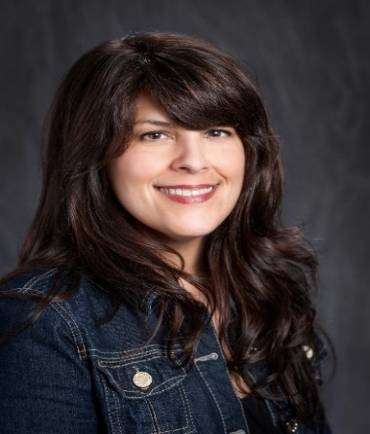
The purpose of this presentation to is discus the relationship between adult attachment style, teacher beliefs about toddler care and education and classroom climate. Seminal research indicates that adult attachment style affects caregiving behaviors (Havan & Shaver, 1987) and is a function of early childhood experiences. Adults tend to behave the same way their parents behaved (Fraley 2002). Research indicates that teacher beliefs impact the teacher’s behavior (Ajzen, 2011). Teacher-child interactions (Malaguzzi, 1994), child interest (Upadyaya & Eccles, 2014) and the behavior of others toward children and children’s achievement (Majus & Reynolds, 2015.)
SESSION Y
Children Need Play: Their Mental Health Depends Upon It
Desiree Collins, East Baton Rouge Parish School System
Join Desiree Collins for an informative and hands-on session focused on the importance and value of providing children the freedom to make choices about what they want to pay. Desiree will also guide teachers in how to take the children’s focus and make it meaningful and educational.

CHILDCARE ASSOCIATION OF LOUISIANA

2020 SPRING EDUCATION CONFERENCE

If your childcare center is a CCAL member, all of your employees are entitled to register at the Early Bird Discount Rate. This conference is offered to CCAL Member. We LOVE new members. It is easy and affordable to join CCAL at www.childcarelouisiana.org/join

CONFERENCE REGISTRATION FEES

Early Bird Registration Rates apply to Spring Conference Registrations that are fully completed and paid by or before February 15, 2020

Two Day Conference Registration Rate Friday and Saturday $150 per person
Friday Only Conference Registration Rate $90 per person
Saturday Only Conference Registration Rate $80 per person
Spring Conference Registrations fully completed and paid on or after February 16, 2020

Two Day Conference Registration Rate Friday and Saturday $160 per person
Friday Only Conference Registration Rate $100 per person
Saturday Only Conference Registration Rate $85 per person

Fast and Convenient Registration Online

www.childcarelouisiana.org/events

BOOK YOUR HOTEL ROOM TODAY

CCAL has reserved a small block of hotel rooms at the Hampton Suites Hotel and at the LaQuinta Suites in Port Allen for Thursday, March 12, 2020 and Friday, March 13, 2020
The room rate includes a hot breakfast for each occupant.

Mention the “CCAL” Room Block to obtain this special rate of $89 per night

Hampton Inn and Suites LA Quinta Inn & Suites
2755 Commercial Drive 2720 N Westport Drive
Port Allen, Louisiana Port Allen, Louisiana
(225) 389-6655 (225) 960-7787

Fast and Convenient Registration Online www.childcarelouisiana.org

