2021 Fall Education Conference

Friday, October 15, 2021

Saturday, October 16, 2021

West Baton Rouge Convention Center
2750 North Westport Drive
Port Allen, Louisiana

For more information text or call Cindy Bishop (225) 933-5435

Early Bird Discount Rates for CCAL Members

Select from one of our four Lagniappe Membership Bundles for early learning centers. We also have a membership category for Family Day Homes and Corporate Sponsors.
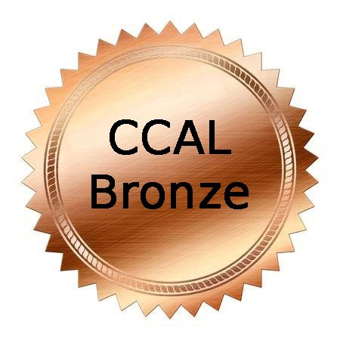 | 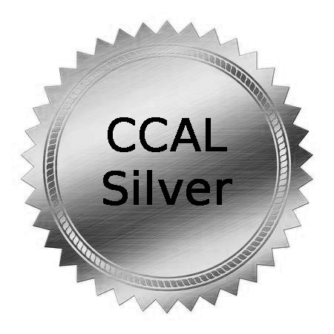 |  | 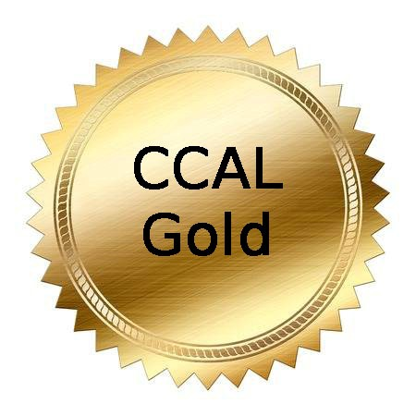 |  | 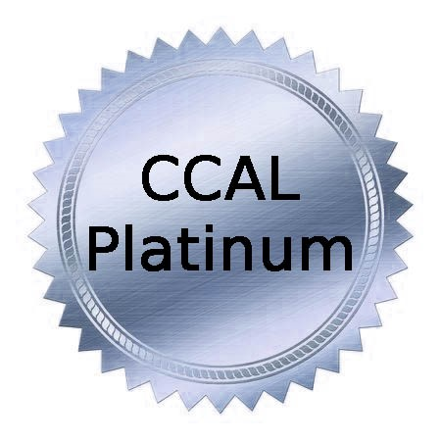
$120/year |  | $165/year |  | $200/year | $300/year
COVERS  5 STAFF MEMBERS |  | COVERS  7 STAFF MEMBERS |  | COVERS  10 STAFF MEMBERS | COVERS  UNLIMITED STAFF

Renew at www.childcarelouisiana.org

Join at www.childcarelouisiana.org/join-us

2021 FALL EDUCATION CONFERENCE
IN PERSON AND VIRTUAL OPTIONS

FRIDAY, OCTOBER 15, 2021

GENERAL SESSION – PLANTATION ROOM
West Baton Rouge Parish Conference Center
2750 N Westport Drive
Port Allen, Louisiana

7:45 AM Registration Check-in
9:00 AM Welcoming Remarks – Olivette Temple, President

Keynote Speaker - Charlie Zeanah, M.D.
Building Healthy Brains
Dr. Zeanah is Mary Peters Sellars-Polchow Chair in Psychiatry, Professor of Psychiatry and Pediatrics, and Vice-Chair for Child and Adolescent Psychiatry in the Department of Psychiatry and Behavioral Sciences at the Tulane University School of Medicine in New Orleans.
He also directs the Institute of Infant and Early Childhood Mental Health at Tulane. Throughout his career, he has studied the effects of adverse early experiences on development, including trauma, abuse and neglect. He also has studied interventions designed to enhance recovery following exposure to adverse experience.

10:00 AM Louisiana Department of Education Updates
Introductory Remarks - Jenna Chiasson and Lisa Brochard
Early Childhood Data Systems – Daisy Grotsma
Child Care Assistance Program - Melinda George
Performance Profiles/ Supply and Access / Workforce
Licensing Updates (Bulletin 137)– Shelia Campbell
Child Care Criminal Background Checks - Hayden Melancon

12 PM – 1:00 PM Lunch and Door Prize Giveaways
Champion for Children and Legislator of the Year Awards Presentation

Friday, October 15, 2021 Afternoon Breakout Sessions
SESSION A  Preparing Families and Children for Disasters  Nikki Honore’  Louisiana Department of Health, Nurse Program Consultant,  Emergency Preparedness & Response | SESSION B  Director’s Roundtable Discussion  Jonathan Pearce  Olivette Temple | SESSION C  Medication Administration  Dianna Constant  Agenda for Children  Available in Person  And Virtual | SESSION D  Active Supervision  Dr. DeShannon  Burrell | SESSION E  Embrace and Accept: Looking at Cultural Diversity through a New Lens  Rori Brooks | SESSION AA  Virtual Only  The Importance of Play  Mary Mills  Center for Development and Learning

Session A Preparing Children and Families for Disasters Nikki Honore’
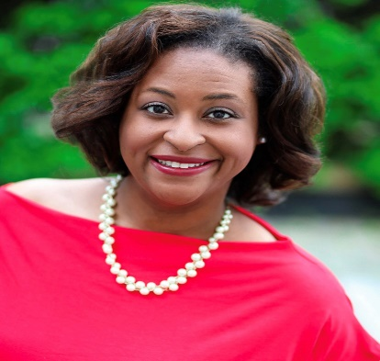
After completing this training, attendees will be able to assist Families in Using the American Academy of Pediatrics’ Family Readiness Guide through:
- Creating Family Disaster Kits
- Developing Family Plans
- Learning how to stay Informed
- Identifying Ways to for Families to Get Involved with Community Preparedness Efforts
- Understanding Children’s Response to Disasters
- Ensuring that your Center’s Disaster plans are up to date

Dr. Nikki Christy Honore’ is the Statewide Nurse Consultant for Emergency Preparedness at the Louisiana Department of Health - Office of Public Health Bureau of Community Preparedness. She is a Board-Certified Family Nurse Practitioner with over 13 years of experience as clinical practitioner, educator, consultant, and nurse leader. In her current role, Dr. Honore’ provides programmatic supervision and training for healthcare professionals across the state of Louisiana who deliver medical support for multiple state-run medical operations. In addition, she develops strategies and identifies training opportunities to build capacity and resiliency in Louisiana communities during disasters. Dr. Honore’ also works as a pediatric clinical adjunct instructor at the Southern University School of Nursing. In this role, Dr. Honore’ is able to give back to future nurses through providing innovative clinical experiences that integrate didactic instruction and clinical practice. Dr. Honore’ is a proud two-time alumna of Southern University earning a Bachelor of Science in Nursing and Master of Science in Nursing. Dr. Honore’ holds a Doctorate of Nursing Practice degree with a focus in Executive Leadership from Louisiana State University Health Sciences Center in New Orleans, LA. She has been recognized as a 2019 New Leaders Council Fellow, 2019 Barton Leadership Fellow, and 2019 Great 100 Nurse Honoree. Dr. Honore’ is an active member of Delta Sigma Theta Sorority, Inc. Baton Rouge Delta Alumnae Chapter, Junior League of Baton Rouge, and the Top Ladies of Distinction, Inc. Nonpareil Chapter. She a native of Lafayette, LA. Dr. Honore’ currently resides in Baton Rouge, Louisiana with her husband Ian Honore’ and daughter Addison Honore’.

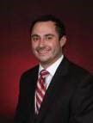
Session B Owners and Director’s Roundtable Discussion
Jonathan Pearce, Owner, Sugar N’Spice Preschools, CCAL Legislative Committee Chairman
Olivette Temple, President, Child Care Association of Louisiana (CCAL)
Owner, Temple’s Preschool Education Foundation and Temple’s Preschool North STEAM Early Learning Center
Jonathan Pearce and Olivette Temple will facilitate an engaging roundtable discussion on topics facing owners and directors of early learning centers. Roundtable Discussion topics include but are not limited to the following:
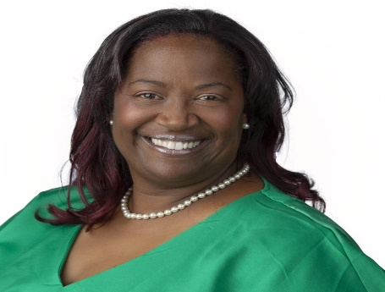
- COVID-19 concerns
- Risk management
- criminal background checks
- cost saving measures
- licensing inspections
- employment compensation
- best practices

Session C Medication Administration Dianna Constant, Agenda for Children
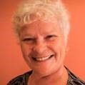
This training session provides staff training on how to properly administer medication to children in early learning centers. Participants will learn the state’s policies and procedures to follow in order to implement a clear guiding principle for medical administration. Upon completion of this training session, participants will receive a certificate to demonstrate compliance with the Louisiana Department of Health.

Session D Active Supervision Dr. DeShannon Burrell
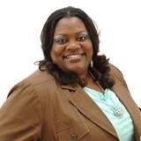
Everyone has a responsibility to keep children safe. Children learn best when they are in safe, well-supervised environments. Staff can reduce the possibility of a child getting hurt when they closely observe children and respond when needed. When programs think systematically about child supervision, they create safe, positive learning environments for all children. In this training session, participants will learn
- how to discover the importance of looking, listening, and engaging
- how to learn six strategies to keep children safe
- See how active supervision benefits the children and the staff
Dr. DeShannon Burrell is a native of Baton Rouge, Louisiana. She holds a master’s degree in Psychology and her Doctorate in Naturopathic Health. She has over twenty-five years of experience in the childcare field. Within this field, she has worked as childcare staff, director, administrator and trainer. She has a love for training, equipping and propelling childcare staff, children and families into their divine destiny. She is owner of Elite Caregiver Training Institute and executive director of Louisiana Human Care Connection, Inc. She is also a state trainer for Northwestern State University Louisiana Pathways Career Development System helping to improve quality childcare in Louisiana.

Session E Embrace and Accept: Looking at Cultural Diversity through a New Lens
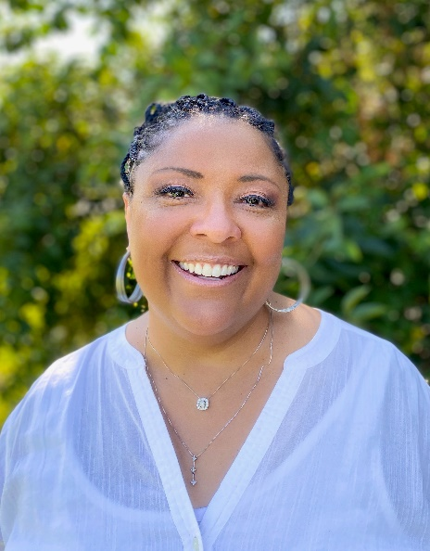
Rori Brooks, More Taught Than Caught
This presentation will provide ways that early childhood teachers can create learning opportunities for children to discuss sensitive topics like cultural diversity. Participants will also explore ways to retrain their thinking to see others through the lens of a child. Participants will examine ways to help children focus more on similarities than differences.
Ms. Brooks is a graduate of the University of South Louisiana where she earned a Bachelor of Art degree in Speech Pathology and Audiology. She has worked with children in many capacities over the past thirty years, including owning and operating a childcare center for 18 years. It is her mission to help the younger generation to embrace difference through acceptance and love. She is the author of two children’s books “What Color is Love” and “What Makes Me Different is What Makes Me Me”. She is a Pathways certified trainer, a CPR trainer and is certified in Health and Safety. She is also a Toddler CLASS Trainer as well as an Infant, Toddler and Pre-K CLASS observer. She has her NAC certification and an active member of the RSN Early Childhood Advisory Council.

SESSION AA VIRTUAL SESSION ONLY Friday October 15, 2021 1:00 - 4:00 PM

The Importance of Play

Mary Mills, Center for Development and Learning

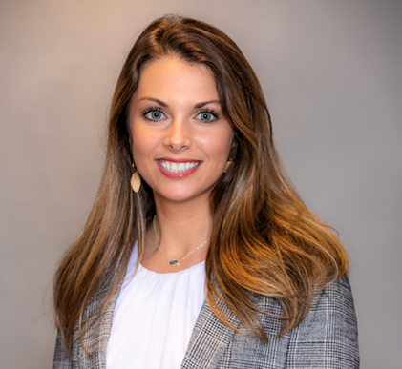
Play in early childhood is essential for young children’s growth and development. Play is strongly associated with children’s cognitive and social-emotional development, preparing children for academic achievement and overall success. Play enables young children to explore and make sense of the world around them, as well as to use and develop their imagination and creativity. This session will provide helpful strategies for early childhood educators to know how to meet the learning needs and goals of young children though high-quality play-based experiences. We will discuss how to use CLASS strategies to promote play in the classroom. Mary Mills, M.S., is the Director of Early Childhood Cornerstones Program at the Center for Development and Learning where she enjoys supporting early childhood professionals to promote positive outcomes for young children. Mary is passionate about the field of early childhood education with a specific focus on working to ensure growth and development for all children. Mary received both, bachelor’s and master’s degree in Human Development and Family Science with an emphasis in Child Development from Mississippi State University. Mary is an endorsed Louisiana Pathways trainer, and approved Child Development Associate (CDA) Professional Development Specialist, and an Infant, Toddler, and Pre-K CLASS Reliable observer. Mary’s comprehensive academic and professional experience in the field of early childhood education enables her to support early childhood professionals in providing high-quality care and experiences for every child.

Saturday, October 16, 2021

8 – 9:00 AM Pre-Registration Check-In
9 AM – 12 Noon Breakout Sessions

SESSION F  Ready Set Eat  Qualifies as the  Food Safety  Requirement  Dianna Constant  Agenda for Children  Available in Person  And Virtual | SESSION G  Owners and Director’s Roundtable Discussion  Jonathan Pearce  Sugar N’Spice Preschool  Olivette Temple  Temple’s Preschool Education Foundation and Temples Preschool North STEAM Early Learning Center | SESSION H  Positive Discipline in the Classroom  Dr. DeShannon  Burrell | SESSION I  Embrace and Accept: Looking at Cultural Diversity through a New Lens  Rori Brooks | SESSION J  Risk Management: A Primer for Owners and Directors  Bob Lansing  Jenn Kelsay

Saturday, October 16, 2021 Breakout Sessions 9 – 12 Noon
Session F: Ready Set Eat Food Safety Class - Dianna Constant, Agenda for Children
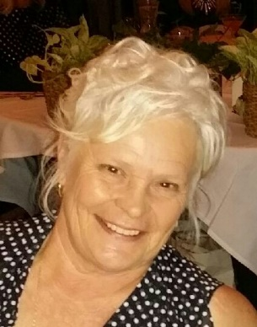
Ready Set Eat is a session on how children grown and develop. This is an interactive session that includes information on handling children with special needs. Participants will be able to :
- Define the grasping status
- Describe a positive and supportive learning environment for feeding children
- Be able to discuss how language and feeding are related. CLASS language is used.
Ready Set Eat counts as the Louisiana Department of Health food safety requirement. All participants who successfully complete this training session will receive a certificate of completion.

Session G
Owners and Directors Roundtable Discussion – Jonathan Pearce and Olivette Temple
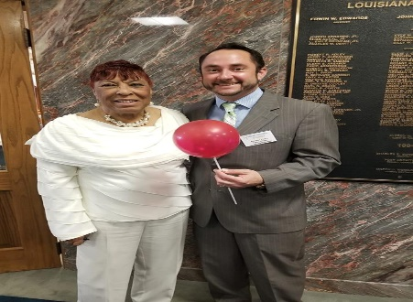
Jonathan Pearce, Owner, Sugar N’Spice Preschools, CCAL Legislative Committee Chairman
Olivette Temple, President, Child Care Association of Louisiana (CCAL) and Owner of Preschool Education Foundation and Temple’s Preschool North STEAM Early Learning Center
Jonathan Pearce and Olivette Temple will facilitate an engaging roundtable discussion on topics facing owners and directors of early learning centers. Roundtable Discussion topics include but are not limited to the following:
- COVID-19 concerns
- Risk management
- criminal background checks
- cost saving measures
- licensing inspections
- employment compensation
- best practices

Session H Positive Discipline Dr. DeShannon Burrell
Discipline is an often-misused word. This session will encourage childcare providers to see discipline as the practice of teaching or training children to obey rules or codes of behavior to attain short- or long-term goals. Childcare providers will learn that discipline is meant to develop children’s behavior while teaching them self-control, confidence, to take initiative, responsibility, and respect for themselves and others.

Dr. DeShannon L. Burrell is a native of Baton Rouge, Louisiana. She holds a master’s degree in Psychology and her Doctorate in Naturopathic Health. She has over twenty-five years of experience in the childcare field. Within this field, she has worked as childcare staff, director, administrator and trainer. She has a love for training, equipping and propelling childcare staff, children and families into their divine destiny. She is owner of Elite Caregiver Training Institute and executive director of Louisiana Human Care Connection, Inc. She is also a state trainer for Northwestern State University Louisiana Pathways Career Development System helping to improve quality childcare in Louisiana

Session I Embrace and Accept: Looking at Cultural Diversity through a New Lens
Rori Brooks, More Taught Than Caught
This presentation will provide ways that early childhood teachers can create learning opportunities for children to discuss sensitive topics like cultural diversity. Participants will also explore ways to retrain their thinking to see others through the lens of a child. Participants will examine ways to help children focus more on similarities than differences.

Ms. Brooks is a graduate of the University of South Louisiana where she earned a Bachelor of Art degree in Speech Pathology and Audiology. She has worked with children in many capacities over the past thirty years, including owning and operating a childcare center for 18 years. It is her mission to help the younger generation to embrace difference through acceptance and love. She is the author of two children’s books “What Color is Love” and “What Makes Me Different is What Makes Me Me”. She is a Pathways certified trainer, a CPR trainer and is certified in Health and Safety. She is also a Toddler CLASS Trainer as well as an Infant, Toddler and Pre-K CLASS observer. She has her NAC certification and an active member of the RSN Early Childhood Advisory Council.
Session J
Risk Management: A Primer for Owners and Directors

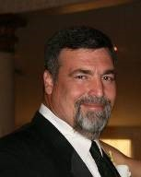
Bob Lansing and Jennifer Kelsay will present a three-hour workshop on managing risks associated with operating an early learning center.

CCAL HOTEL ROOM BLOCKS
CCAL has made arrangements with the Hampton Inn and Suites in Port Allen for discount hotel rooms at the rate of $89/night for Thursday, October 14th and Friday, October 15th. To book a room, call the hotel directly at 225 389-6655 Mention the CCAL Room Block to get the discounted rate. Includes breakfast.

CCAL has also made arrangements with the LaQuinta Inn and Suites in Port Allen for discount hotel room at the rate of $94/night for Thursday, October 14th and October 15th. To book a room, call the hotel directly at 225 831 3523
Mention the CCAL Room Block to get the discounted rate. Includes breakfast.

