2023 Spring Education Conference

Friday, March 31, 2023 - Six Clock Hours
Saturday, April 1, 2023 – Three Clock Hours

West Baton Rouge Convention Center
2750 North Westport Drive
Port Allen, Louisiana

For Registration Assistance, Call or Text Cindy Bishop (225) 933-5435

Register at www.childcarelouisiana.org/events

Select from one of our four Lagniappe Membership Bundles for early learning centers. We also have a membership category for Family Day Homes and Corporate Sponsors.
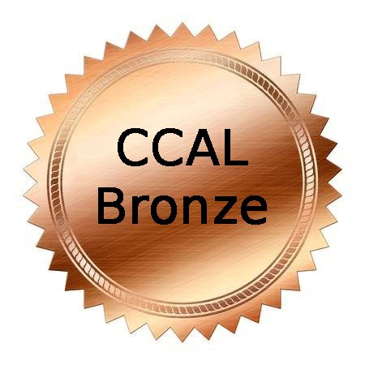 |  |  | 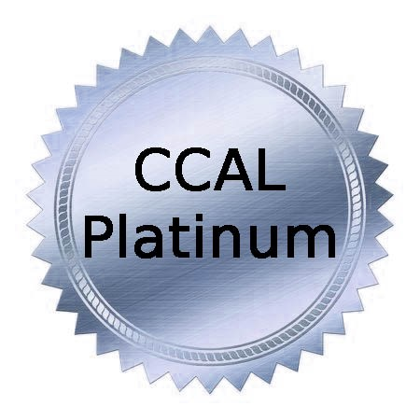
$160/year  Includes CCAL Membership for up to eight (8) staff members. Each bundle member will receive the CCAL newsletters and a CCAL membership card. | $200/year  Includes CCAL Membership for up to ten (10) staff members. Each bundle member will receive the CCAL newsletters and a CCAL membership card. | $280/year  Includes CCAL Membership for up to fourteen (14) staff members. Each bundle member will receive the CCAL newsletters and a CCAL membership card. | $400/year  Includes CCAL Membership for an unlimited number of staff members. Each bundle member will receive the CCAL newsletters and a CCAL membership card.

Register at www.childcarelouisiana/org/events
Renew at www.childcarelouisiana.org
Join at www.childcarelouisiana.org/join-us

General Session
Friday, March 31, 2023

7:40 AM Registration Check-in for Onsite Participants
8:55 AM Welcoming Remarks – Tafta Miller, President
9:00 AM Keynote Speaker: Julie Bartkus!
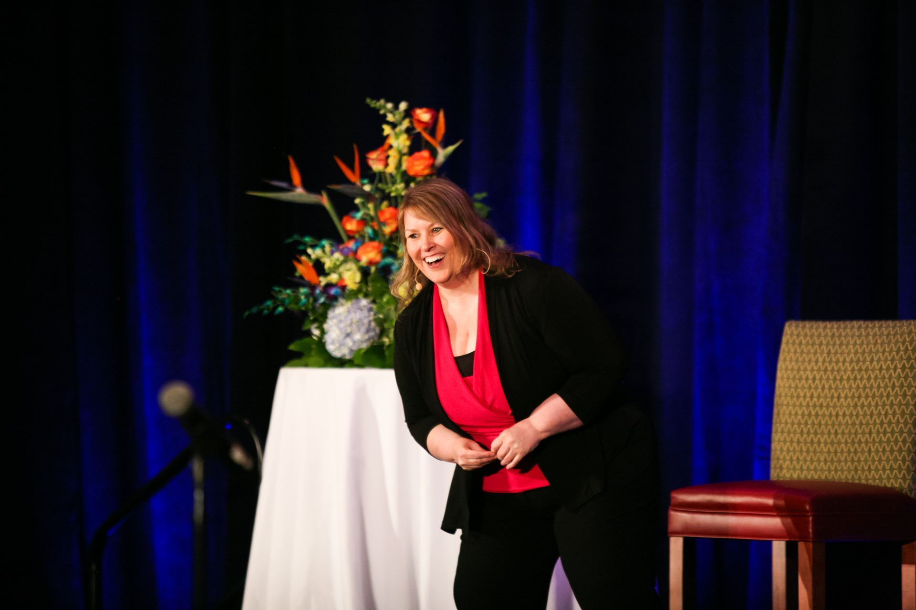
Motivate The Motivator!
Every day, you have the opportunity to impact many lives in many ways. The lives of the children, the families, and your co-workers are just a few of the people who are positively impacted by you. You are The Motivator. So the big question is: who motivates you? During this keynote, you'll discover immediately applicable strategies for creating an enduring source of motivation for yourself so you can thrive and feel alive as you achieve greater levels of success in your life. If you sometimes feel that things are hard (and perhaps at times, really hard) and your motivation is faltering, don't fret. You will leave feeling motivated with tools and strategies that you can implement daily to regain hope as you strive to bring your big, bold dreamy vision to life! Are you ready to Motivate the Motivator?
10:00 – 10:30 AM Break (Visit Exhibitors, Network)

Friday, March 31, 2023 Concurrent Session 10:30 AM – 12 Noon
For Owners and Directors and  Assistant Directors | For Teachers and  Support Staff
Louisiana Department of Education Updates  Introductory Remarks - Karen Powell, Deputy Assistant Superintendent, Early Childhood Strategy  - Moderator: Shelia Campbell  - EdLink Update – Daisy Grotsma, Director of Early Childhood Data Systems, LA Department of Education  - Child Care Assistance Program – Tamara Patrick  - Licensing Updates (Bulletin 137) –Andrea Burl  - Criminal Background Checks – Kayla Batiste | Teachers Roundtable Discussion  Moderators: Pamela Marshall, Owner, Shiloh Garden Academy and Jennifer Stevenson, Owner, The Garden of Knowledge  Topics include:  - Choosing early care and education as a career  - Improving Classroom Settings for Children with Special Needs  - Classroom Structure Ideas  - Helping Children with Behavorial Issues  - Dealing with Burnout in the Classroom  - Getting Support from Management

Pamela Marshall is the proud owner and Executive Director of Shiloh Gardens Academy located in Central City New Orleans. She holds a Bachelor of Arts Degree in Organizational Management with a concentration in Early Childhood Education and minor in Psychology. She has over 20 years of experience in the childcare profession as a FCC Director working with diverse families. Additionally, she is a CLASS Observer. Pamela serves on the Board of Directors of the Child Care Association of Louisiana representing Orleans Parish. She is a strong advocate for early childhood education and has a strong passion for educating young children, empowering others to tap into their full potential, and using her platform to bring about change in the childcare profession. Pamela is a native New Orleanian.
Jennifer Stevenson has over a decade's worth of experience in early childhood education, starting as a teacher and working her way up. She is the owner of The Garden of Knowledge, a new premiere preschool located in Bogalusa, LA. "Ms. Jen", as she is affectionately known, carries on a family legacy in education. She is a graduate of West Jefferson Hish School and holds a CDYC (Care and Development of Young Children) Degree from Delgado Community College. Ms. Jen is also a graduate of the prestigious Louisiana Early Learners Academy, a program backed by Harvard University's Saul Zentz Early Education Initiative and the Louisiana Department of Education and has been recognized by the same as one of the 2022 Inaugural Top 5 Leaders of the Year in Louisiana Early Childhood Education.

12:00 PM – 1:00 PM
- Lunch and Corporate Sponsor Recognition - Cindy Bishop
- Door Prize Giveaways – Tara Emery and Tafta Miller

Friday, March 31, 2023 Afternoon Breakout Sessions 1:00 – 4:00 PM

Plantation Room  The Workplace Happiness Formula  Julie Bartkus  Onsite and Virtual  Target  Audience:  Owners and Directors  Assistant Directors | Allendale Room  Medication Administration  Dianna Constant  Agenda for Children  Onsite and Virtual  Counts as a Health and Safety Class as Required by the Louisiana Department of Health  Target Audience:  Teachers, Directors | Cinclaire Room  How to Get Your  EdLink On  Daisy Grotsma  Louisiana Department of Education  Onsite Only  Target Audience:  Owners, Directors | Choctaw Room  A Framework for Fidelity  Dr. DeShannon Burrell  Elite Caregiver Training Institute  Co-Presenters:  Sharon McNeely  Dominque Byrd  Onsite Only  Target Audience:  Owners and Directors | Poplar Grove  KidKare Class  Good Nutrition Pays: The Benefits of Participating in the Child and Adult Care Food Program  Cindy Viann  Jordan Berkstresser  Target Audience: Center Owners/Directors

Friday, March 31, 2023 Afternoon Breakout Sessions 1:00 – 4:00 PM

The Workplace Happiness Formula presented by Julie Bartkus
What does it take to create a motivated, happy team? During this session, you'll discover a formula that you can put into place immediately to help you ATTRACT and RETAIN the team of your dreams. If you're struggling with absenteeism, tardiness, turnover, gossip, complaining, and blaming and you're ready to detox your workplace so everyone (including you) comes to work feeling happy - you'll want to grab a front-row seat and discover The Workplace Happiness Formula. For over 20 years Julie Bartkus has been confidentially surveying every level of staff in child care programs across the globe. During this session, she is pulling back the curtain and revealing the results to you. You'll gain an understanding of what really motivates your staff, what attracts new staff members, and why child care professionals check out and quit. Target Audience: Center Owners, Directors, and Assistant Directors

Medication Administration presented by Dianna Constant, Agenda for Children
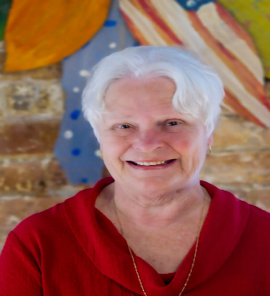
This three-hour breakout session provides staff training on how to properly administer medication to children in early learning centers. Participants will learn the state’s policies and procedures to follow to implement a clear guiding principle for medical administration. Upon completion of this training session, participants will receive a certificate to demonstrate compliance with the Louisiana Department of Health. Dianna Constant has been part of Agenda for Children’s team since 1990. She has over forty years of experience in early childhood education. She spent twenty years directing and operating her own childcare center and has more than two decades of experience as a trainer and technical assistance advisor for early childhood programs. She serves on the board of United Way of St. Charles and is actively involved with the Parish Networks in New Orleans and Houma supporting interaction improvements in Early Child Care Center and has served on the Child Care Health Care Consultant board since 2000. Dianna holds a bachelor’s degree in Sociology/Youth and Family Services from Nichols State University. Certifications include Certified Reliable CLASS Observer (Infant, Toddler, Pre-K), CLASS Affiliate Trainer (Pre K), Inter-Rater Reliable in GOLD by Teaching Strategies, Child Care Health Consultant, Louisiana Pathways Trainer Level II. Dianna is a lifelong resident of Thibodaux, Louisiana.

Get Your EdLink On! Presented by Daisy Grotsma, Louisiana Department of Education
Target Audience: Center Owners and Directors
Bring your laptop computers and get ready for an interactive session on how to navigate the LDOE’s new EdLink system. Daisy Grotsma, the chief architect of the Department of Education’s new data management system, will walk participants through the process of completing their license renewal through EdLink. She will be joined by a few early learning center directors who have successfully completed their license renewals on EdLink who will share their personal insights and experiences.

The Framework of a Center with Fidelity presented by Dr. DeShannon Burrell
Co-Presenters: Sharon McNeely and Dominque Byrd
Target Audience: Educators, Owners and Directors
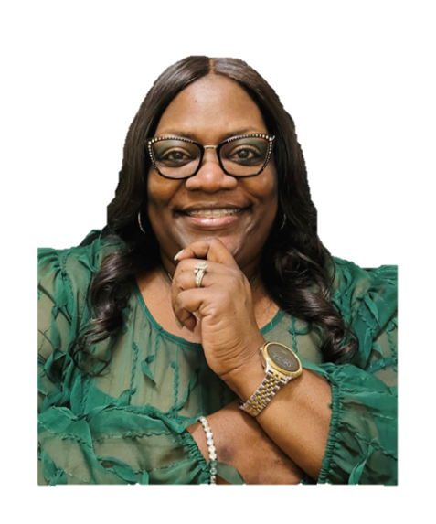
This course will identify a framework for operating a center with fidelity. Fidelity looks at how close policies and procedures along with curriculum are followed. Fidelity fits into the framework of everyday practice within a childcare center. Center owners and directors who implement fidelity within their daily practices administratively will engage in proficient and strong staff. Childcare teachers who implement curriculum with fidelity will assess if the curriculum is working for children and support children in their growth and development. This course will help staff and students with daily interactions and activities, resulting in positive goals and outcomes for the children and the center as a whole. Dr. DeShannon Burrell is a native of Baton Rouge, Louisiana. She holds a master’s degree in Psychology and a Doctorate in Naturopathic Health. She has over twenty-five years of experience in the childcare field. She has worked as childcare staff, director, administrator, and trainer. She has a love for training, equipping and propelling childcare staff, children and families into their divine destiny. She is the owner of Elite Caregiver Training Institute and the Executive Director of Louisiana Human Care Connection, Inc. She is also a state trainer for Northwestern State University Louisiana Pathways Career Development System helping to improve quality childcare in Louisiana.

Good Nutrition Pays: The Benefits of Participating in the Child and Adult Care Food Program
Target Audience: Center Owners/Directors

This breakout session is designed for childcare providers and others interested in learning more about the Child and Adult Care Food Program (CACFP) and the benefits of participating in the program. Industry experts encourage the essential childcare industry to leverage all subsidy programs during this staffing shortage. So now is the time. The CACFP is a federal program that provides funding to improve the quality and accessibility of nutritious food for children and adults in care settings. In this workshop, participants will learn about the CACFP and how it can help to promote good nutrition and healthy eating habits in care settings. Participants will gain an understanding of the nutritional guidelines established by the program and the requirements for participating. This breakout session will also cover the financial benefits of participating in the program, including the reimbursement provided to care providers for the meals they serve. Participants will learn about the potential for increased enrollment and improved health outcomes associated with providing healthy and balanced meals. In addition to discussing the benefits of participating in the CACFP, the workshop will provide participants with practical guidance on how to enroll in the program and navigate the requirements. And when the paperwork seems too much, you’ll get to see how other providers are utilizing KidKare to manage this program with ease. Join us for this informative workshop to learn how good nutrition pays, not just for the well-being of the individuals in care, but also for care providers and the broader community.
Cindy Vian is a seasoned professional in child care, currently serving as KidKares VP of Customer Acquisition. With experience in family child care and running for-profit centers, she spent 10 years managing a non-profit organization sponsoring child care providers in the food program, which grew to serve over 1500+ providers in 13 counties of California. Cindy's exceptional knowledge of federal regulations and state policies as well as passion for assisting childcare providers have enabled her to become the most effective advocate for state program operational improvements.

Jordan Berkstresser is a skilled professional with 18 years of experience in hospitality, food service, and business management. As KidKare's Project Manager for Louisiana, she ensures successful project initiatives that align with the state's requirements. Jordan's passion for quality childcare and feeding people stems from her background. In addition to her work at KidKare, Jordan is also the President of a non-profit that provides Christmas for children, operates a large food pantry, and helps homeless families find stable homes. Her management experience and passion for community service make her an invaluable asset to KidKare and the childcare profession.

Saturday April 1, 2023 Morning Breakout Sessions 9 AM - 12 Noon

Attract Staff Fast and Keep Them Long  Julie Bartkus  Target Audience:  Owners and Directors  Assistant Directors  Onsite or Virtual Registration Available | Ready Set Eat Food Safety  Dianna Constant  Agenda for Children  Meets the Food Safety Requirements Set forth by the Louisiana Department of Health  Target Audience:  Teachers, Owners, Directors  Onsite or Virtual Registration Available | Managing the Madness:  Conflict Resolution  Dr. DeShannon Burrell  Elite Caregiver Training Institute  Co-Presenters:  Sharon McNeely  Dominque Byrd  Target Audience:  Teachers, Owners, Directors and Assistant Directors  Onsite Only | Musical, Mathematical and Language Development of Infants: Transferring Knowledge to Practice in Louisiana Early Childhood Environments  Kamile Geist, Ph.D., MT-BC Associate Professor and Board-Certified Music Therapist  LSU School of Music  Eugene Geist, Ph.D Associate Professor, Payne School of Education at LSU  Emily Marcinowski, Ph.D. Assistant Professor  LSU Department of Kinesiology  Target Audience: Teachers  Onsite Only

Saturday, April 1, 2023 Morning Breakout Session: 9:00 AM – 12 Noon
Attract Staff Fast and Keep Them Long by Julie Bartkus
Can you attract people to you? Can you attract staff to work for you? If you believe you can, but you’re just not sure how to make it happen, this session is for you! We’re deep diving into staff attraction strategies that will move you from hearing crickets after you place a Help Wanted Ad to attracting 9, 23 or even 50 job applicants in just a matter of days. You’ll discover the secret to attracting staff fast (really great staff) and engaging them for the long run. Bring your Help Wanted Ad and get ready to transform it into your ultimate staff attraction magnet. You’ll leave other leaders in your community wondering how you’re attracting the most amazing staff ever when everyone else is struggling. This is a do-not-miss opportunity for child care leaders who need staff to grow. Target Audience: Owners and Directors, Assistant Directors

Managing the Madness: Conflict Resolution by Dr. DeShannon Burrell
Elite Caregiver Training Institute
Co-Presenters: Sharon McNeely and Dominique Byrd
Target Audience: Staff, Owners, Directors

This three-hour breakout session will identify the types of conflict and the reason why we deal with certain challenges within center life. Our daily work involves dealing with difficult people and difficult situations. Participants will be challenged with resolving conflict and reconciling
relationships if possible. Strategies in dealing with difficult people - supervisor, staff,students, and parents will be given. Managing the Madness begins with you.

Ready Set Eat Food Safety Presented by Dianne Constant, Agenda for Children
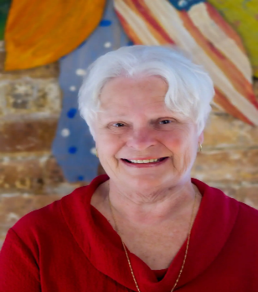
Ready Set Eat Food Safety is a session on how children grown and develop. This is an interactive session that includes information on handling children with special needs. After completion of this three-hour training class, participants will be able to:
- Define the grasping status
- Describe a positive and supportive learning environment for feeding children
- Be able to discuss how language and feeding are related.
- CLASS language is used. This CLASS meets the food safety requirement of the Louisiana Department of Health

Musical, Mathematical and Language Development of Infants:
Transferring Knowledge to Practice in Louisiana Early Childhood Environments
Experts in early childhood research and practice from LSU will share their recent findings of how infants naturally use music interactions to self-regulate and attach to caregivers, how they use mathematics to construct their world, and how they shape early language through motor development. You don’t want to miss this one! It’s going to be fun with lots of hands-on ideas and music that can be applied to all three areas of development. You will leave with many tools to take back to your classrooms and centers.
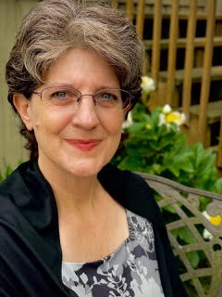
Kamile Geist, Ph.D., MT-BC is an Associate Professor and Board-Certified Music Therapist in the School of Music at LSU. With a generous gift from Ava and Cordell Haymon, Dr. Geist recently joined LSU’s faculty to develop the first Music Therapy program at a state university in Louisiana. Her research is focused on how young children (birth to 5) incorporate music elements (e.g. steady beat, rhythm, melody, dynamics) to self-regulate, decrease stress, and mutually attune and gain social-emotional competence with their teachers and caregivers.
Eugene Geist, Ph.D is an Associate Professor in the Payne School of Education at LSU. His major research focus is how young children (birth to 3rd grade) learn and think mathematically and how integrated curriculum and child centered approaches can be used to foster cognitive growth and understanding in children from birth through age 8 and beyond. Dr. Geist’s research on mathematics and learning is grounded in the theoretical framework of Piaget’s Constructivism. Much of his scholarly work has been devoted mainly to understanding how children develop mathematical knowledge from birth through early elementary school and how mathematics can be integrated into other aspects of the developing child’s such as the arts and music.
Emily Marcinowski, Ph.D. is an Assistant Professor in the Department of Kinesiology at LSU. She holds a doctorate in Developmental Psychology and completed a postdoctoral fellowship at Virginia Commonwealth University in Physical Therapy. Dr. Marcinowski’s research interests primarily center on how motor skills and asymmetries affect the development of play, language, and cognition in early childhood, particularly in children younger than 2 years. Specific projects include the impact of emerging independent sitting and locomotion on manipulative play, hand preferences on the development of object construction and language, and how parents support motor development in their infants. Dr. Marcinowski is the director of the Understanding Play Lab at Louisiana State University in Baton Rouge.
Spring Conference Social Event
Friday, March 31, 2023
6:30 - 9:30 PM
"CCAL Has Talent Show" Dancing, Buffet, and Fun
Cocktail Attire Recommended but Not Required
Register separately for the Social Event
http://childcarelouisiana.org/events
Only $53 per person!

CCAL Spring Education Conference

Early Bird Discount Registration Open Now

West Baton Rouge Conference Center
2750 N Westport Drive
Port Allen, Louisiana

Our Clock Hours are accepted by Louisiana Pathways

REGISTRATION RATES:
Register at www.childcarelouisiana.org/events
Regular Registration for CCAL Members Friday Only $125 March 2 – 31st
Regular Registration for CCAL Members Friday and Saturday $175 March 2 – 31st
Regular Registration for CCAL Members Saturday Only $ 75 March 2 – 31st
Corporate Sponsors $275 March 2 – 31st

For non-members, call or text Cindy Bishop at 225 933 5435 for special promotion rates
Include your name, center or affiliation and email address please
For registration assistance, call Cindy Bishop at 225 933 5435 or email cindy.bishop@checkmate-strategies.com and David.roberson@checkmate-strategies.com

CCAL HOTEL ROOM BLOCK

CCAL has made arrangements with the Hampton Inn and Suites in Port Allen for discount hotel rooms at the rate of $92/night for Thursday, March 30, 2023.
To book a room, call the hotel directly at 225 389-6655 and ask for a reservation under the CCAL Room Block to get the discounted hotel room rate. The hotel rate includes breakfast.
CCAL has made arrangements with the LaQuinta is $96/night Thursday, March 30th or Friday, March 31st

