2020 Fall Education Conference

Friday, October 23, 2020

Saturday, October 24, 2020

West Baton Rouge Conference Center
2750 North Westport Drive
Port Allen, Louisiana

PRE-REGISTRATION PACKET
Due to social distancing requirements,
registration for our Fall Education Conference is limited as follows
Maximum of 50 registrants, speakers and staff on-site for Friday October 23, 2020
Maximum of 50 registrants, speakers and staff on-site for Saturday, October 24, 2020

Virtual Registration will be available soon!
Questions about registration? Email cindy.bishop@checkmate-strategies.com

(225) 933-5435 Text or Call

Early Bird Discount Rates for CCAL Members!

Select from one of our four Lagniappe Membership Bundles
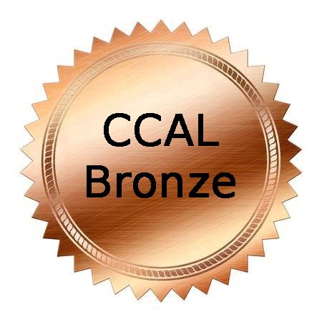 | 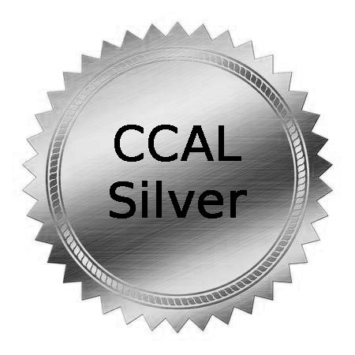 | 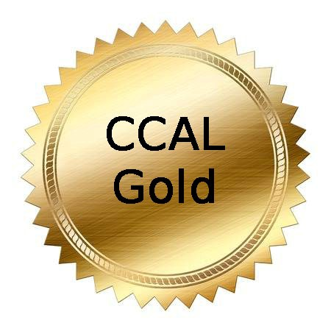 | 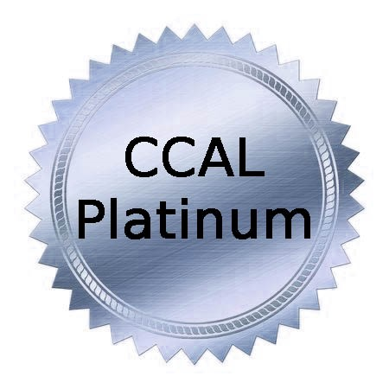
$100/year  Special Promotion | $145/year  Special Promotion | $175/year  Special Promotion | $275/year  Special Promotion
COVERS 5 STAFF MEMBERS | COVERS 7 STAFF MEMBERS | COVERS 10 STAFF MEMBERS | COVERS UNLIMITED STAFF

Renew at www.childcarelouisiana.org

Join at www.childcarelouisiana.org/Join

FALL EDUCATION CONFERENCE

FRIDAY, OCTOBER 23, 2020

GENERAL SESSION – PLANTATION ROOM
West Baton Rouge Parish Conference Center
2750 N Westport Drive
Port Allen, Louisiana

7:45 AM Registration Check-in
8:55 AM Welcoming Remarks – Olivette Temple, President
9:00 AM Keynote Speaker
Dr. Cade Brumley, Superintendent
Board of Elementary and Secondary Education

10:00 AM Louisiana Department of Education Updates
Introductory Remarks - Jenna Chiasson and Lisa Brochard
Child Care Assistance Program - Melinda George
Performance Profiles – Taylor Dunn
Licensing/Bulletin 137 – Shelia Campbell
Child Care Criminal Background Checks – Valerie Black
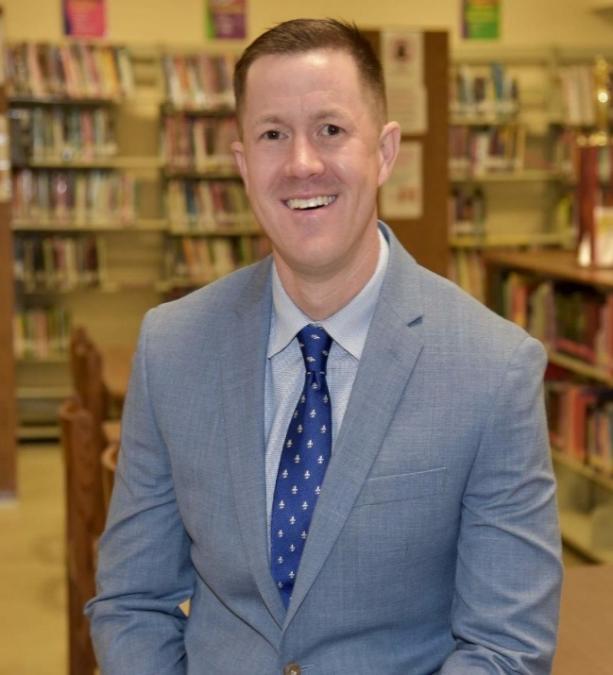
Keynote Speaker
Dr. Cade Brumley, Superintendent
Board of Elementary and Secondary Education

Dr. Cade Brumley began his tenure as the Louisiana State Superintendent of Education in June 2020. Dr. Brumley is a product of public education who has invested his entire professional career into improving the lives of Louisiana children. He has served students as a teacher, coach, assistant principal, principal, district leader, and superintendent.
Prior to joining the Louisiana Department of Education, Dr. Brumley served as Superintendent of Jefferson Parish Schools, the largest school system in the state with more than 51,000 students. Under his steady leadership, the school system earned its first increase in four years on its 2019 state report card; led the state in Advanced Placement growth; outpaced the state’s gains on the number of students earning Mastery on state assessments; provided local educators with their first raise in over a decade; adopted standardized district-wide curriculum; and created a Transformation Network to provide extra support and resources to high-need schools.
Before that, Dr. Brumley served six years as DeSoto Parish Schools Superintendent in Northwest Louisiana. During his time in DeSoto, results greatly improved, and the system now ranks as one of Louisiana's top ten districts for student academic achievement, an increase from 49.
In addition, Dr. Brumley served as the President of the Louisiana Association of School Superintendents, representing the interests of all Louisiana school systems at the state level.
Dr. Brumley holds a Bachelors of Science in Education from Northwestern State University in Natchitoches, a Masters of Education in School Administration from Louisiana State University - Shreveport, and a Doctorate of Education in School Leadership from Stephen F. Austin State University in Nacogdoches, Texas. He has served as adjunct instructor at multiple universities and has supported numerous non-profit organizations in the areas of organizational leadership. He has completed several post-doctorate fellowships centered around urban education in America.
An avid marathoner, Dr. Brumley has raised in excess of $25,000 through running for organizations such as St. Jude's, Wounded Warrior Project, and the ALS Association. In his spare time, he enjoys spending time in outdoor pursuits, visiting with friends, spending time at church, and going to movies.
Follow Dr. Brumley on Twitter at @cadebrumley

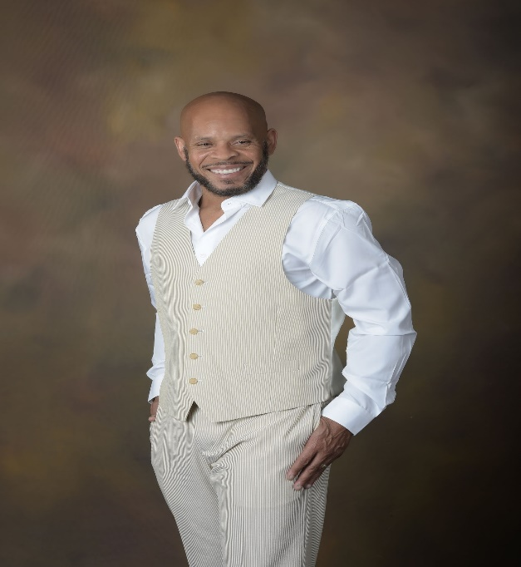
11 AM – 12 Noon
COVEY Today and Beyond COVID-19
Danna Andrus, D.D., LMFT, BCPC
A practice from the PAST can be the solution for TODAY and BEYOND as we move through the challenges of COVID-19. Stephen Covey’s 7 Habits of Highly Successful Professionals is an effective teaching and learning tool from yesterday (1989) that can be revisited and embraced today. Covey’s 7 Habits can stand today as a reliable tool for driven and determined professionals who dare to create a new day and a new way of living, learning and lasting! Dr. Andrus, with the spirit of the late Stephen Covey revisits the Seven Habits of the late 80’s and now they become relevant for a challenging today and a promising tomorrow.
12 PM – 1:00 PM Lunch will be served

Friday, October 23, 2020

Afternoon Breakout Sessions

1 – 4 PM

SESSION A  Medication  Administration  Dianna Constant  Agenda for Children  Good for 2 years  VIRTUAL SESSION | SESSION B  Director’s Roundtable Discussion  Jonathan Pearce  Sugar N’Spice Preschool  Tara Emery  London Bridge Early Learning Center | SESSION C  How to Make Everyone Happy  Suzanne Millerhebert | SESSION D  Professionalism in the Workplace  Dr. DeShannon Quiett-Burrell  Sharon McNeeley  Dominque Byrd  Elite Caregiver Training Institute | SESSION E  Small Business  Financial Strategies  Doyle Fillastre CPA

SESSION F Louisiana Pathways 101

Jenny Cowan, Louisiana Pathways
Register for Session F if you would like to meet with Ms. Cowan one-on-one

FRIDAY, OCTOBER 23, 2020 AFTERNOON BREAKOUT SESSIONS

1:00 – 4:00 PM

SESSION A

Medication Administration

Dianna Constant, Agenda for Children

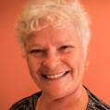
Virtual Session – Limited to 25 participants
This session provides staff training on how to properly administer medication to children in early learning centers. Participants will learn the state’s policies and procedures to follow in order to institute a clear guiding principle for medication administration. After completion, participants will receive a certificate to demonstrate compliance with the Louisiana Department of Health. Counts for three clock hours

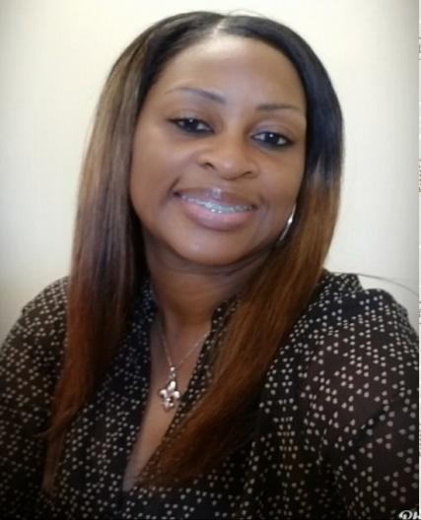
SESSION B
Director’s Roundtable Discussion
Tara Emery, London Bridge Early Learning Center
Jonathan Pearce, Sugar N’Spice Preschool Tara Emery and Jonathan Pearce will facilitate an engaging roundtable discussion on topics facing owners and directors of early learning centers. Bring your list of topics and be ready to engage in a lively discussion. Counts for three clock hours

- COVID-19 Concerns
- Criminal Background Checks
- Licensing Inspections
- Unemployment Compensation
- Career Ladders
- Workers Compensation
- Risk Management
- Staffing
- Cost Saving Ideas

SESSION C:

How to Make Everyone Happy – Suzanne Millerhebert
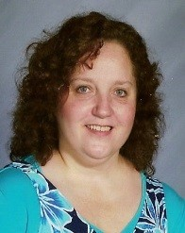
Participants will create a list of ideas to make the work environment more
pleasant and satisfying. In this workshop, participants will learn how to make the workplace a positive experience.

Everyone wants to be happy at work and enjoy what they do. We will explore what can be done to make people remember why they chose this profession.
Counts for three clock hours

SESSION D: Professionalism in the Workplace
Dr. DeShannon Quiett-Burrell
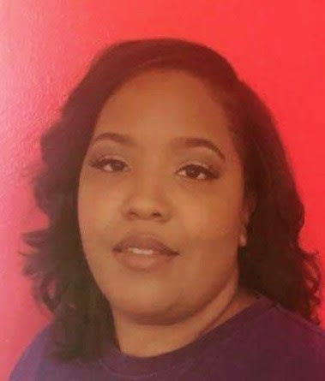
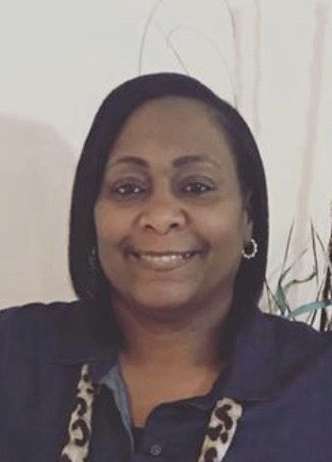
Co-Presenters: Sharon McNeely and Dominque Byrd
To understand the importance of professionalism in the workplace. This session will provide valuable information on strategies for getting cooperation and collaboration to improve relationships within the center. Counts for three clock hours

In this three-hour workshop, you will learn:
  - The Importance of YOU as a Professional
  - The Benefits of a Center that Operates Professionally
  - General Principles of Professionalism in the Workplace
  - Professionalism in the Child Care Setting
  - Strategies to diffuse competition in the Workplace
  - Strategies on improving Cooperation and Collaboration in the Workplace

SESSION E: Small Business Financial Strategies - Doyle Fillastre CPA
Doyle Fillastre, a certified public accountant, will provide information on budgeting, tax tips, maximizing the School Readiness Tax Credit and more useful tips on how to improve your business finances. Doyle is the President and CEO of The Fillastre Group headquartered in Baton Rouge. On a daily basis, he helps individuals and businesses with tax return preparation and accounting services. Counts for three clock hours

SESSION F: Louisiana Pathways 101

Jenny Cowan, Program Coordinator
Louisiana Pathways
NSU Child and Family Network

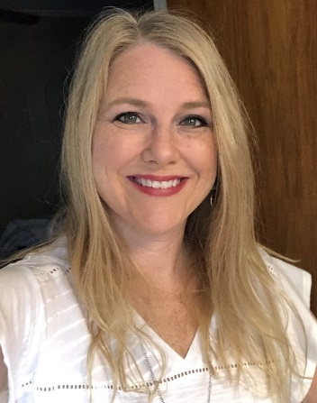
Register for this Session if you would like to spend one-on-one time with conference attendees who need assistance with Louisiana Pathways. But also select another session to receive your three clock hours.

- Registering with Louisiana Pathways
- Career Ladder
- Career Ladder Leveling
- Scholarships
- School Readiness Tax Credits.

We will schedule time in 15-minute increments with Ms. Cowan.

2020 Fall Education Conference

Saturday, October 24, 2020

7:45 – 9:00 AM Pre-Registration Check-In
9 AM – 12 Noon Breakout Sessions
SESSION G  Ready Set Eat  Qualifies as the  Food Safety  Requirement  Dianna Constant  Agenda for Children  Virtual Session  Limited to 25  Participants | SESSION H  Professionalism in the Workplace  Dr. DeShannon Quiett-Burrell  Sharon McNeely  Dominque Byrd | SESSION I  Director’s Roundtable Discussion  Tara Emery  London Bridge  Early Learning Center  Jonathan Pearce  Sugar N’Spice Preschool | SESSION J  How to Make Everyone Happy  Suzanne Millerhebert | SESSION K  Why It Is Important to Stay Active in Your Profession:  Your Neighbor is Not Your Competitor  Olivette Temple  Temple’s STEM Preschool  Jennifer Kelsay  Honeycomb Preschool

SESSION L Pathways 101 Jenny Cowan, Louisiana Pathways
Register for Session L if you would like to meet with Ms. Cowan one-on-one
But select another session to receive your three clock hours

SATURDAY, OCTOBER 24, 2020
Breakout Sessions 9 – 12 Noon
SESSION G: Ready Set Eat (Food Safety Class)
Dianna Constant, Agenda for Children Limited to 25 Participants – Virtual Session
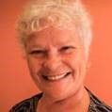
Ready, Set Eat is a session on how children grow and develop and fulfills the Board of Health's Food Safety requirement. This is an interactive session that includes children with special needs. Additionally, participants will be able to:
- define the grasping stages
- describe a positive and supportive learning environment for feeding children
- be able to discuss how language and feeding are related.
- CLASS language is used
- Counts for three clock hours

Ready Set Eat counts as the Louisiana Department of Health food safety requirement.
This session will be streamed live through Zoom Platform.

SESSION H Professionalism in the Workplace Dr. DeShannon Quiett-Burrell Co-Presenters Sharon McNeely and Dominque Byrd
To understand the importance of professionalism in the workplace. This workshop will provide participants valuable information on strategies for getting cooperation and collaboration to improve relationships within the center. In this training you will learn
  - The Importance of YOU as a Professional
  - The Benefits of a Center that Operates Professionally
  - General Principles of Professionalism in the Workplace
  - Professionalism in the Child Care Setting
  - Strategies to diffuse competition in the Workplace
  - Strategies on improving Cooperation and Collaboration in the Workplace
Counts for three clock hours

SESSION I – Director’s Roundtable Discussion
Tara Emery – London Bridge Early Learning Center
Jonathan Pearce – Sugar N’Spice Preschool
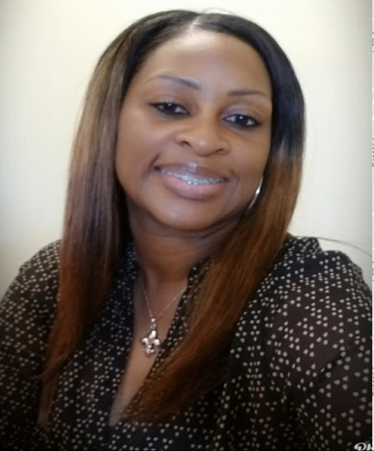
Tara Emery and Jonathan Pearce will facilitate an engaging roundtable discussion on topics facing owners and directors of early learning centers. Bring your list of topics for this interactive discussion. Counts for three clock hours
- COVID-19 Concerns
- Criminal Background Checks
- Licensing Inspections
- Unemployment Compensation
- Career Ladders
- Workers Compensation
- Risk Management
- Staffing
- Cost Saving Ideas

SESSION J: How to Make Everyone Happy – Suzanne Millerhebert

Participants will create a list of ideas to make their work environment more
pleasant and satisfying. In this workshop, participants will learn how to make the workplace a positive experience.

Everyone wants to be happy at work and enjoy what they do. We will explore what can be done to make people remember why they chose this profession.
Counts for three clock hours

SESSION K: Why It Is Important to Stay Active in your Profession: Your Neighbor is Not Your Competitor
Olivette Temple, Temple’s STEAM Preschool and Jennifer Kelsay, Honeycomb Preschool
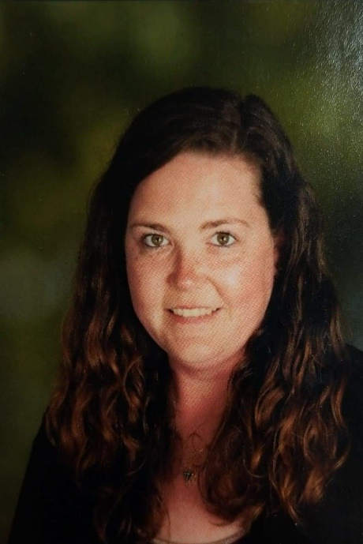
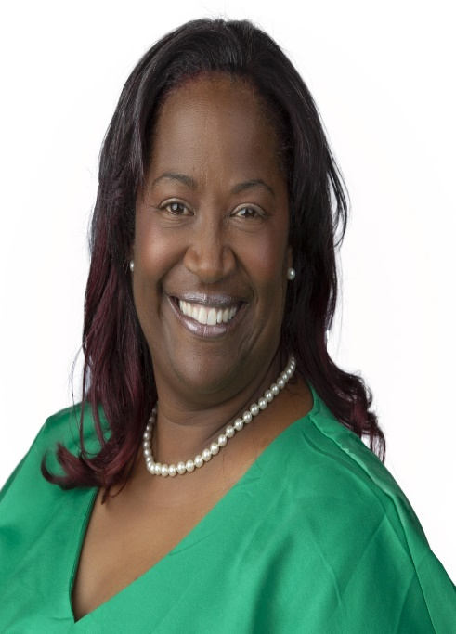
Olivette Temple and Jennifer Kelsay will highlight the importance of being active in the early childhood education profession. Owners and directors will have a better understanding of how to form relationships with neighboring childcare centers and how to use those relationships to their benefit. Owners and directors will walk away from this workshop feeling empowered and connected with a new network of like-minded individuals rather than feeling like they are in competition with the early learning centers in their area
Counts for three clock hours

SESSION L
Louisiana Pathways 101

Jenny Cowan, Program Coordinator
Louisiana Pathways
NSU Child and Family Network
Register for this Session if you would like to spend one-on-one time with conference attendees who need assistance with Louisiana Pathways.
We will schedule time in 15-minute increments with Ms. Cowan
But also select another session to receive your three clock hours.

- Registering with Louisiana Pathways
- Career Ladder
- Career Ladder Leveling
- Scholarships
- School Readiness Tax Credits

.

2020 Fall Education Conference

If your childcare center is a member of CCAL, all your employees are entitled to register at the Early Bird Discount Rate. This conference is offered to CCAL Members only. We LOVE new members. It is easy and affordable to join CCAL at www.childcarelouisiana.org/join

CONFERENCE REGISTRATION FEES

Early Bird Registration Rates apply to Fall Conference Registrations that are fully completed and paid by or before October 1st

Two Day Conference Registration Rate (Friday and Saturday) $125 per person
Friday Only Conference Registration Rate $100 per person
Saturday Only Conference Registration Rate $ 60 per person

Fast and Convenient Registration Online

www.childcarelouisiana.org/events

BOOK YOUR HOTEL ROOM TODAY

CCAL has reserved a small block of hotel rooms at the Hampton Suites Hotel and at the LaQuinta Suites in Port Allen for Thursday, October 22nd and Friday, October 23rd.
The room rate includes a hot breakfast for each occupant.

Ask for the “CCAL” Group Room Block to obtain this special rate of $89 per night

Hampton Inn and Suites LA Quinta Inn & Suites
2755 Commercial Drive 2720 N Westport Drive
Port Allen, Louisiana Port Allen, Louisiana
(225) 389-6655 (225) 960-7787

Fast and Convenient Registration Online
www.childcarelouisiana.org
If you need assistance with registration, please call 225 933-5435
or email cindy.bishop@checkmate-strategies.com

