2020 Virtual Education Conference

Friday, October 23, 2020 - Six Clock Hours

Saturday, October 24, 2020 – Three Clock Hours

Virtual Registration is Now available!
Register Early to Take Advantage of our Early Bird Discounts!

Exclusively for CCAL Members

For more information, contact Cindy Bishop, Executive Director
cindy.bishop@checkmate-strategies.com

(225) 933-5435 Phone or Text

You can Join CCAL at

www.childcarelouisiana.org/join

Select from one of our four Lagniappe Membership Bundles

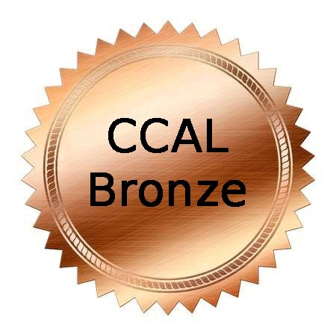 | 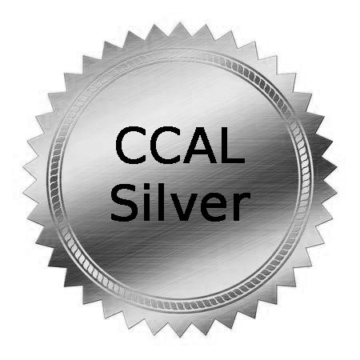 | 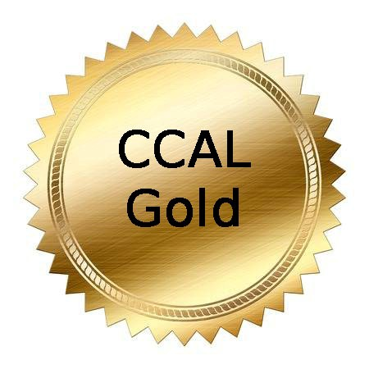 | 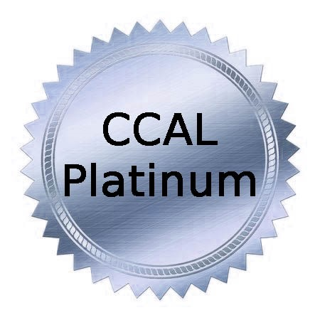
$120/year | $165/year | $200/year | $300/year
COVERS 5 STAFF MEMBERS | COVERS 7 STAFF MEMBERS | COVERS 10 STAFF MEMBERS | COVERS UNLIMITED STAFF

VIRTUAL EDUCATION CONFERENCE

FRIDAY, OCTOBER 23, 2020

GENERAL SESSION

9:00 AM Welcoming Remarks – Olivette Temple, President
9:00 AM Dr. Cade Brumley, Superintendent
Board of Elementary and Secondary Education

10:00 AM Louisiana Department of Education Updates
Jenna Chiasson and Lisa Brochard – Introductions
Child Care Assistance Program - Melinda George
Performance Profiles – Taylor Dunn
Licensing/Bulletin 137 – Shelia Campbell
Child Care Criminal Background Checks – Valerie Black

11 AM – 12 Noon COVEY Today and Beyond COVID – Danna Andrus, D.D., LMFT, BCPC
A practice from the PAST can be the solution for TODAY and BEYOND as we move through the challenges of COVID-19. Stephen Covey’s 7 Habits of Highly Successful Professionals is an effective teaching and learning tool from yesterday (1989) that can be revisited and embraced today. Covey’s 7 Habits can stand today as a reliable tool for driven and determined professionals who dare to create a new day and a new way of living, learning and lasting! Dr. Andrus, with the spirit of the late Stephen Covey revisits the Seven Habits of the late 80’s and now they become relevant for a challenging today and a promising tomorrow.

Friday, October 23, 2020

AFTERNOON VIRTUAL SESSION

1:00 – 4:00 PM

Owners’ and Directors’ Roundtable Discussion
Tara Emery, London Bridge Early Learning Center
Jonathan Pearce, Sugar N’Spice
Tara Emery and Jonathan Pearce will facilitate an engaging roundtable discussion on topics facing owners and directors of early learning centers. Tara is the owner of London Bridge Early Learning Center. Jonathan Pearce is the owner of Sugar N’Spice with four locations in the Acadiana region.
Topics include COVID-19 Issues, Criminal Background Checks, Licensing Inspections, Risk Management, Staffing and Cost Saving Measures

Option 2 for Friday Afternoon Virtual Session

Limited to 40 participants

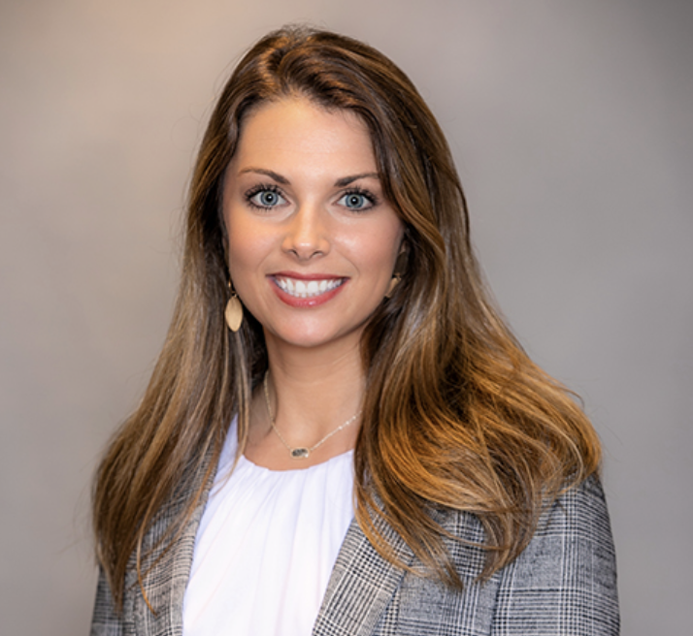
Building Resilience: Fostering Social and Emotional Well-Being
Mary Mills, Director of Early Childhood Cornerstones Program
Center for Development and Learning
Resilience is the ability to cope and thrive in the face of negative events, challenges or adversity. COVID-19 can have a negative affect on young children’s development and well-being; however, it is essential that early childhood educators take the steps to help build their resilience. This session will provide early childhood educators with strategies that teachers can take to enhance resilience and promote the personal and social capabilities of their young children. These strategies include promotion of high - quality teacher – children interactions, promotion of positive student – peer relationships, creating a positive learning environment through effective classroom management and teaching methods, and promotion of explicit social and emotional skills.

Saturday, October 24, 2020

MORNING VIRTUAL SESSION
Register for Session A

9 AM – 12 PM

Why It Is Important to Stay Active in your Profession: Your Neighbor is Not Your Competitor
Olivette Temple, Temple’s STEAM Preschool
Jennifer Kelsay, Honeycomb School

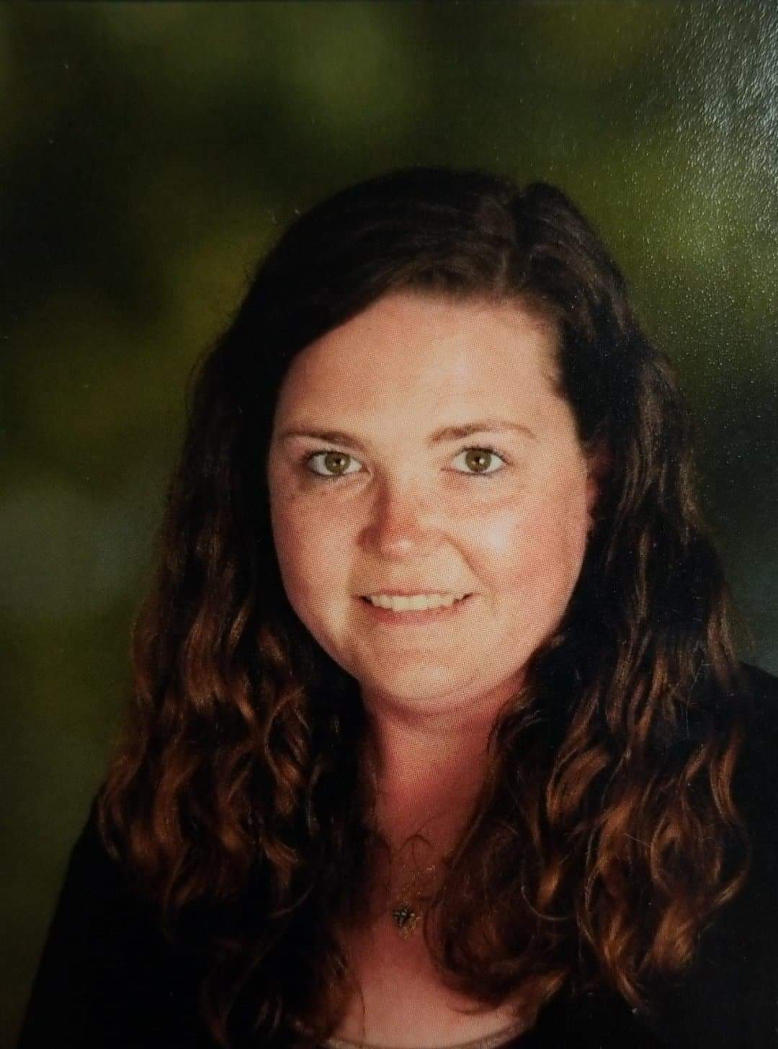

Olivette Temple and Jennifer Kelsay will highlight the importance of being active in the early childhood education profession. Owners and directors will have a better understanding of how to form relationships with neighboring childcare centers and how to use those relationships to their benefit. After this workshop, owners and directors will have a feeling of empowerment and connection with a new network of like-minded individuals, rather than feeling like they are in competition with the early learning centers in their area. Olivette Temple is the owner and director of Temple’s Preschool in New Orleans and Temple’s STEAM Early Learning Center in Slidell. Jennifer Kelsay is the Director of the Honeycomb School in Slidell.

Ready Set Eat Food Safety Class - Dianna Constant, Agenda for Children
Session B
Ready, Set Eat is a session on how children grow and develop and fulfills the Board of Health's Food Safety requirement. This is an interactive session that includes children with special needs. Additionally, participants will be able to:
- define the grasping stages
- describe a positive and supportive learning environment for feeding children
- be able to discuss how language and feeding are related. CLASS language is used

This class counts toward the Louisiana Department of Health food safety require

2020 Fall Education Conference

Virtual Registration Fees

Friday and Saturday Virtual Sessions $ 80 per person
Friday October 23, 2020 Virtual Session $ 50 per person
Saturday October 24, 2020 Virtual Session $ 40 per person

Fast and Convenient Registration Online

www.childcarelouisiana.org/events

