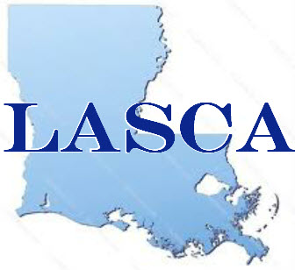
Louisiana Ambulatory Surgery Centers Association
Greater Baton Rouge Region
Key Contact Information
NAME:_____________________________________________
PHONE NUMBER:____________________________________
EMAIL:_____________________________________________
Please circle each legislator(s) you would be willing to contact regarding legislative issues:
Sen. Eddie Lambert Sen. Regina barrow Sen. Dan Claitor
Sen. Yvonne Dorsey-Colomb Sen. Dale Erdey Sen. Rick Ward III
Sen. Mack “Bodi” White Jr Rep. Edmond Jordan Rep. Steve Carter
Rep. Franklin Foil Rep. “Rick” Edmonds Rep. Barbara West Carpenter
Rep. Denise Marcelle Rep. Tony Bacala Rep. Kenny Harvard
Rep. Paula Davis Rep. Rogers Pope Rep. Ted James
Rep. John Berthelot Rep. Patricia Haynes Smith Rep. Chad Brown
Rep. Major Thibaut Rep. Valarie Hodges Rep. Ken Brass
Rep. Clay Schexnayder Rep. Barry Ivey Rep. Sherman Mack
Please list any other elected officials you may have a connection to who you would contact for legislative purposes: 1)__________________________2)__________________________ Please fax to (225) 208-1932 or email information to Cindy Bishop at cindy.bishop@checkmate-strategies.com

