Last Chance Education Conference
In Person and Virtual Conference

Friday, December 4, 2020

Saturday, December 5, 2020

West Baton Rouge Convention Center
2750 North Westport Drive
Port Allen, Louisiana

Due to social distancing requirements, on-site attendance for this one-day
Conference is limited to a total of fifty (50) registrants

Early Bird Discount Rates for CCAL Members!

Select from one of our four Lagniappe Membership Bundles
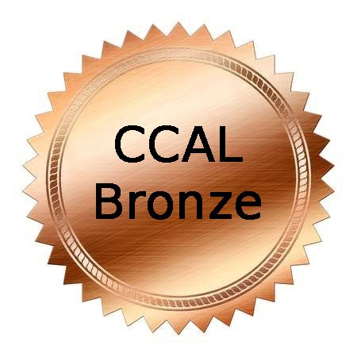 |  |  | 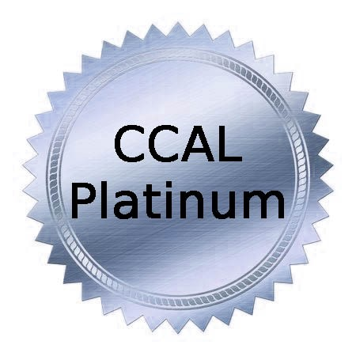
$100/year  New Member Promotion | $145/year  New Member Promotion | $175/year  New Member Promotion | $275/year  New Member Promotion
COVERS 5 STAFF MEMBERS | COVERS 7 STAFFMEMBERS | COVERS 10 STAFF MEMBERS | COVERS UNLIMITED STAFF

Renew at www.childcarelouisiana.org

Join at www.childcarelouisiana.org/Join

LAST CHANCE EDUCATION CONFERENCE – IN PERSON

Friday December 4, 2020
West Baton Rouge Parish Convention Center
2750 N Westport Drive
Port Allen, Louisiana

8:00 AM Registration Check-in
9:00 AM Welcoming Remarks – Olivette Temple, President
Keynote Speaker – Collis Temple, III

10:00 AM Louisiana Department of Education Updates
Introductory Remarks - Jenna Chiasson, PhD and Lisa Brochard
Child Care Assistance Program - Melinda George
Performance Profiles – Taylor Dunn
Licensing/Bulletin 137 – Shelia Campbell
Child Care Criminal Background Checks – Valerie Black, JD

11:00 AM Tax Strategies for Year-End Tax Planning – Doyle Fillastre, CPA
The Fillastre Group

12 PM – 1 PM Lunch and Door Prize Giveaways!

Keynote Speaker
Collis Temple, III
Collis Temple III & Associate

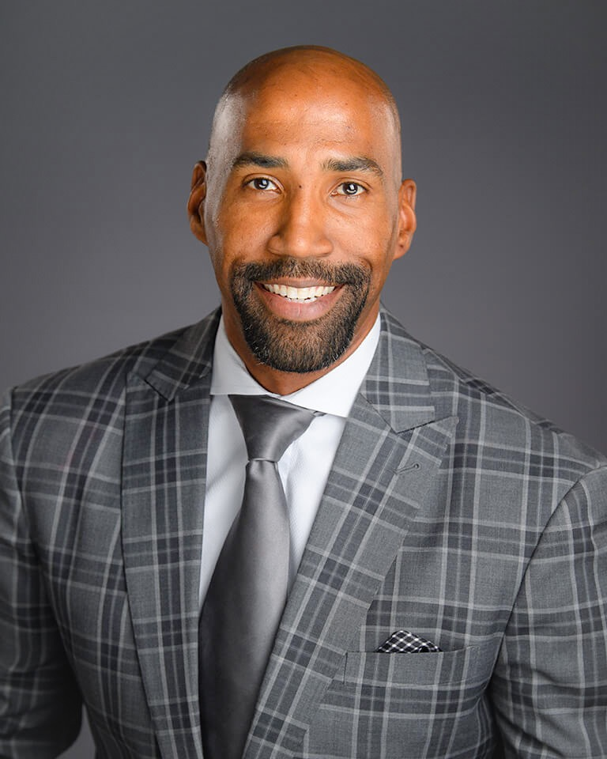
Collis owns and operates Collis Temple III & Associates, a training center of Primerica with over 550 licensed agents. Primerica is an international financial services marketing organization listed on the NYSE. The firm locates, trains, and mentors people interested in owning their own financial brokerage business offering investments, insurance, and most importantly, financial literacy training geared primarily towards helping families become properly protected, debt free, and financially independent. Collis helps individuals build a financial business from the ground up with no capital requirement that may generate a six figure income for individuals who are self-starters and looking for a legitimately significant opportunity, while providing a flexible schedule, therefore enhancing their overall quality of life.
Collis’ mantra in business has been that FINANCIAL LITERACY = ECONOMIC EMPOWERMENT = REAL CHANGE in OUR COMMUNITIES! Collis and his wife Britney sincerely and completely focus on making sure that their clients understand why the financial programs are set up the way they are, how they work; and makes sure that they are totally customized to the desires of that particular client
In January 2015, Collis was appointed by the Governor John Bel Edwards to serve on the Louisiana Board of Regents, the highest decision-making board of Higher Education in the State of Louisiana. In January 2019, Collis was elected Vice-Chairman of the Board of Regents. Collis also serves the Greater Baton Rouge community by being an active member of the Board of Directors of the Knock Knock Children’s Museum. He also serves on the Board of Directors of 100 Black Men of Metro Baton Rouge.
In January 2016, Collis published with his first book, Work Like a Slave, Think Like a Master. It has received great reviews.
Collis is the husband of Britney Temple and father to four amazing children - Monet (9), Eden (7), Collis IV (5), and Briton (5 months). At age 24, Collis was named a "Top 40 Under 40" by the Baton Rouge Business Report.
Collis played for the LSU Tigers from 2000-2003, becoming one of less than forty players in LSU history to amass over 1000 points, playing on two NCAA Tournament teams and an NIT team. Temple earned several awards while at LSU, including being named a member of the ten-member roster for LSU's All-Decade Team of the 2000s highlighting the best players at LSU from 2000-2010. Upon completing his eligibility was asked to compete during the 2003 NBA Summer League with the Detroit Pistons. After Summer League and prior to training camp Collis re-injured his surgically repaired right ankle and made the tough decision to walk away from basketball. At age 24 ( 2003) Collis decided to retire from basketball due to and injury and pursue his business interests with Primerica. Prior to joining Primerica and pursuing his own dreams of business ownership in November 2003, Collis was a student-athlete playing basketball at LSU.
While at LSU, Collis earned an undergraduate degree in general business in three years, then completed a Masters in Sports Management, before beginning the pursuit of his Doctorate in Educational Leadership. According to LSU's Sports Information Department, Collis is believed to be the first Division I student athlete to complete an undergraduate degree, Master's degree and began the pursuit of a Doctorate while still eligible to play athletics.
Collis played for the LSU Tigers from 2000-2003, becoming one of less than forty players in LSU history to amass over 1000 points, playing on two NCAA Tournament teams and an NIT team. Temple earned several awards while at LSU, including being named a member of the ten-member roster for LSU's All-Decade Team of the 2000s highlighting the best players at LSU from 2000-2010. Upon completing his eligibility was asked to compete during the 2003 NBA Summer League with the Detroit Pistons. After Summer League and prior to training camp Collis re-injured his surgically repaired right ankle and made the tough decision to walk away from basketball

Friday, December 4, 2020 1:00 – 4:00 PM
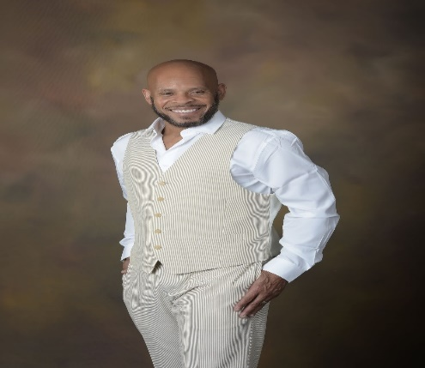
COVEY Today and Beyond COVID – Danna Andrus, D.D., LMFT, BCPC
A practice from the PAST can be the solution for TODAY and BEYOND as we move through the challenges of COVID-19. Stephen Covey’s 7 Habits of Highly Successful Professionals is an effective teaching and learning tool from yesterday (1989) that can be revisited and embraced today. Covey’s 7 Habits can stand today as a reliable tool for driven and determined professionals who dare to create a new day and a new way of living, learning and lasting!
Dr. Andrus, with the spirit of the late Stephen Covey revisits the Seven Habits of the late 80’s and now they become relevant for a challenging today and a promising tomorrow.

Louisiana Pathways 101 VIRTUAL

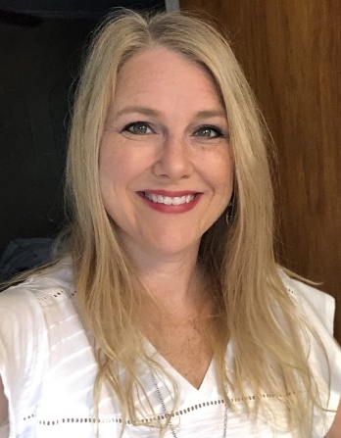
Jenny Cowan
Louisiana Pathways NSU Child and Family Network

Jenny Cowan is scheduling 15-minute virtual appointments with conference attendees who need assistance with Louisiana Pathways.

When registering, check the box to schedule an appointment with Ms. Cowan.

- Register with Louisiana Pathways
- Career Ladder
- Career Ladder Leveling
- Scholarships
- School Readiness Tax Credits

EARLY BIRD REGISTRATION FEES

CCAL Member IN PERSON Friday December 4, 2020
$100 per person for CCAL members
Includes Lunch

CCAL Member VIRTUAL Friday, December 4, 2020
Saturday, December 5, 2020
$60 per person for CCAL members
Six Clock Hours on Friday
Three Clock Hours on Saturday
Total Clock Hours: 9

CCAL Member Virtual Friday Only – December 4, 2020
$50 per person for CCAL members
Six Clock Hours on Friday

CCAL Member VIRTUAL ONLY Saturday Only – December 5, 2020
$30 per person for CCAL Members
Three Clock Hours

www.childcarelouisiana.org/events

CCAL HOTEL ROOM BLOCK

The Hampton Inn and Suites is offering CCAL members a group rate of $89/night for a single or double room. Reservations can be made by contacting the hotel directly at 225 389-6655

The La Quinta Inn and Suites is offering CCAL members a group rate of $89/night for a single or a double hotel room. Reservations can be made by contacting the hotel directly at 225 960-7787

