Last Chance VIRTUAL
Education Conference

Friday, December 4, 2020

Saturday, December 4, 2020

Early Bird Discount Rates for CCAL Members!
Register at www.childcarelouisiana.org/events
Select Virtual Registration Link

Select from one of our four Lagniappe Membership Bundles
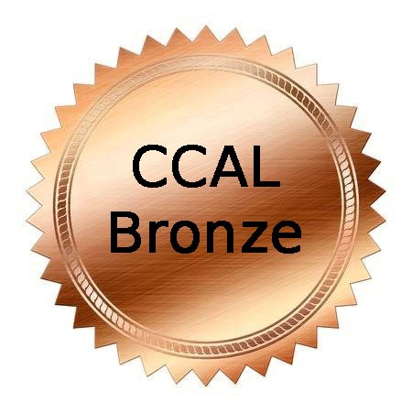 |  |  | 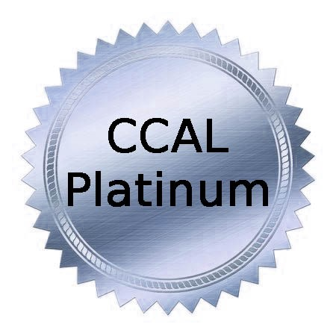
$100/year  Special Promotion  FOR NEW MEMBERS | $145/year  Special Promotion  FOR NEW MEMBERS | $175/year  Special Promotion  FOR NEW MEMBERS | $275/year  Special Promotion  FOR NEW MEMBERS
COVERS 5 STAFF MEMBERS | COVERS 7 STAFF MEMBERS | COVERS 10 STAFF MEMBERS | COVERS UNLIMITED STAFF

Renew your CCAL membership at www.childcarelouisiana.org

Join CCAL at www.childcarelouisiana.org/Join
To obtain the Special Promotion Rates, text 225 933-5435
Include your name and your email address
VIRTUAL LAST CHANCE EDUCATION CONFERENCE
FRIDAY, DECEMBER 4, 2020
General Session

7:45 AM Registration Check-in
9:00 AM Welcoming Remarks – Olivette Temple, President
Keynote Speaker – Collis Temple, III, Collis Temple III and Associates

10:00 AM Louisiana Department of Education Updates
Introductory Remarks - Jenna Chiasson, PhD and Lisa Brochard
Child Care Assistance Program - Melinda George
Performance Profiles – Taylor Dunn
Licensing/Bulletin 137 – Shelia Campbell
Child Care Criminal Background Checks – Valerie Black, JD

11:00 AM Tax Strategies for Year–End Tax Planning – Doyle Fillastre, CPA
The Fillastre Group

12 Noon – 1 PM Lunch and Door Prize Giveaways
Keynote Speaker
Collis Temple, III
Collis Temple & Associates
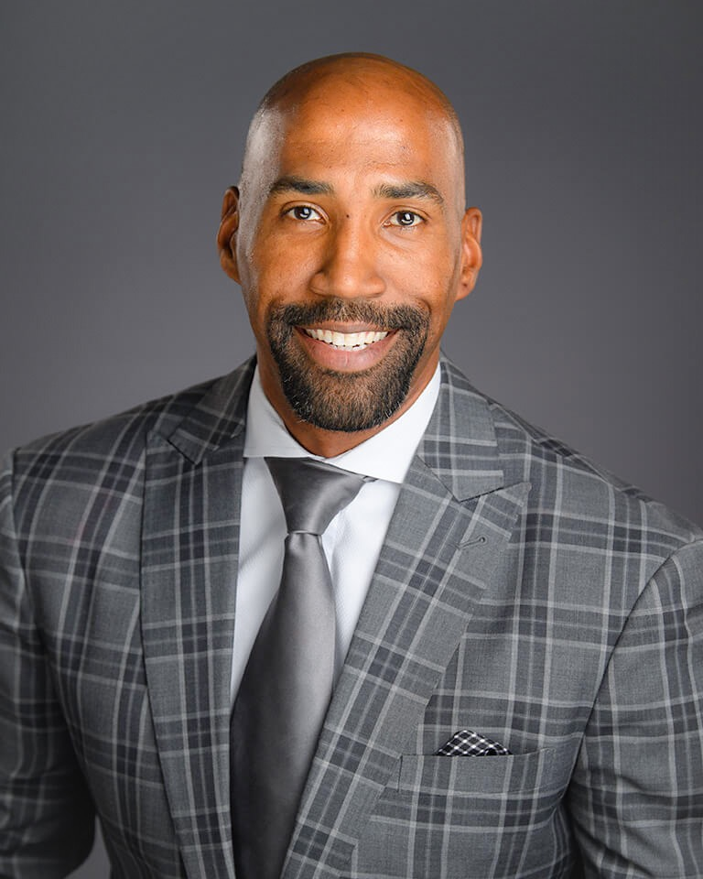
Collis owns and operates Collis Temple III & Associates, a training center of Primerica with over 550 licensed agents. Primerica is an international financial services marketing organization listed on the NYSE. The firm locates, trains, and mentors people interested in owning their own financial brokerage business offering investments, insurance, and most importantly, financial literacy training geared primarily towards helping families become properly protected, debt free, and financially independent. Collis helps individuals build a financial business from the ground up with no capital requirement that may generate a six figure income for individuals who are self-starters and looking for a legitimately significant opportunity, while providing a flexible schedule, therefore enhancing their overall quality of life.
Collis’ mantra in business has been that FINANCIAL LITERACY = ECONOMIC EMPOWERMENT = REAL CHANGE IN OUR COMMUNITIES! Collis and his wife Britney sincerely and completely focus on making sure that their clients understand why the financial programs are set up the way they are, how they work; and makes sure that they are totally customized to the desires of that particular client
In January 2015, Collis was appointed by the Governor John Bel Edwards to serve on the Louisiana Board of Regents, the highest decision-making board of Higher Education in the State of Louisiana. In January 2019, Collis was elected Vice-Chairman of the Board of Regents.
Collis also serves the Greater Baton Rouge community by being an active member of the Board of Directors of the Knock Knock Children’s Museum. He also serves on the Board of Directors of 100 Black Men of Metro Baton Rouge.
In January 2016, Collis published with his first book, Work Like a Slave, Think Like a Master. It has received great reviews. Collis is the husband of Britney Temple and father to four amazing children - Monet (9), Eden (7), Collis IV (5), and Briton (5 months). At age 24, Collis was named a "Top 40 Under 40" by the Baton Rouge Business Report.
Collis played for the LSU Tigers from 2000-2003, becoming one of less than forty players in LSU history to amass over 1000 points, playing on two NCAA Tournament teams and an NIT team. Temple earned several awards while at LSU, including being named a member of the ten-member roster for LSU's All-Decade Team of the 2000s highlighting the best players at LSU from 2000-2010. Upon completing his eligibility was asked to compete during the 2003 NBA Summer League with the Detroit Pistons. After Summer League and prior to training camp Collis re-injured his surgically repaired right ankle and made the tough decision to walk away from basketball. At age 24 ( 2003) Collis decided to retire from basketball due to and injury and pursue his business interests with Primerica. Prior to joining Primerica and pursuing his own dreams of business ownership in November 2003, Collis was a student-athlete playing basketball at LSU.
While at LSU, Collis earned an undergraduate degree in general business in three years, then completed a Masters in Sports Management, before beginning the pursuit of his Doctorate in Educational Leadership. According to LSU's Sports Information Department, Collis is believed to be the first Division I student athlete to complete an undergraduate degree, Master's degree and began the pursuit of a Doctorate while still eligible to play athletics. Collis played for the LSU Tigers from 2000-2003, becoming one of less than forty players in LSU history to amass over 1000 points, playing on two NCAA Tournament teams and an NIT team. Temple earned several awards while at LSU, including being named a member of the ten-member roster for LSU's All-Decade Team of the 2000s highlighting the best players at LSU from 2000-2010.
Friday, December 4, 2020 1 – 4 PM IN PERSON AND VIRTUAL
COVEY Today and Beyond COVID – Danna Andrus, D.D., LMFT, BCPC
A practice from the PAST can be the solution for TODAY and BEYOND as we move through the challenges of COVID-19. Stephen Covey’s 7 Habits of Highly Successful Professionals is an effective teaching and learning tool from yesterday (1989) that can be revisited and embraced today. Covey’s 7 Habits can stand today as a reliable tool for driven and determined professionals who dare to create a new day and a new way of living, learning and lasting!
Dr. Andrus, with the spirit of the late Stephen Covey revisits the Seven Habits of the late 80’s and now they become relevant for a challenging today and a promising tomorrow.
Saturday, December 5, 2020 9 AM – 12 NOON VIRTUAL OPTION ONLY
SESSION A Why It Is Important to Stay Active in your Profession: Your Neighbor is Not Your Competitor
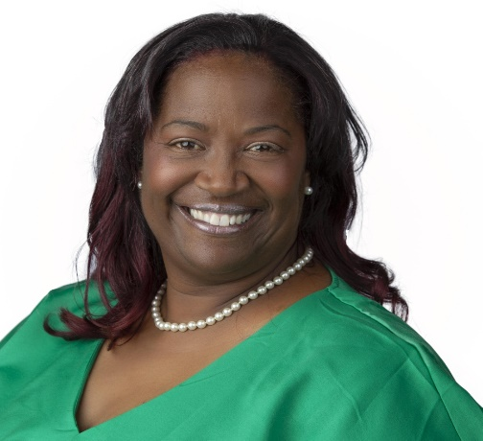
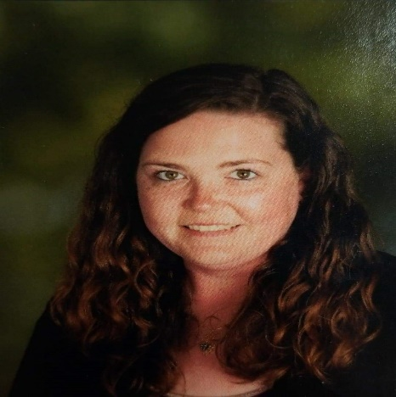
Olivette Temple and Jennifer Kelsay will highlight the importance of being active in the early childhood education profession. Owners and directors will have a better understanding of how to form relationships with neighboring childcare centers and how to use those relationships to their benefit. Owners and directors will walk away from this workshop feeling empowered and connected with a new network of like-minded individuals rather than feeling like they are in competition with the early learning centers in their geographic areas.

Saturday December 5, 2020
SESSION B
Ready Set Eat Food Safety Class - Dianna Constant, Agenda for Children
12:30 PM – 3:30 PM

Ready, Set Eat is a session on how children grow and develop and fulfills the Board of Health's Food Safety requirement. This is an interactive session that includes children with special needs. Additionally, participants will be able to:
- define the grasping stages
- describe a positive and supportive learning environment for feeding children
- be able to discuss how language and feeding are related. CLASS language is used

This class meets the health and safety class mandated by the Louisiana Department of Health.

Early Bird Registration Rates

CCAL Member: Friday Only 50.00 December 4, 2020
CCAL Member: Saturday Only 30.00 December 5, 2020
CCAL Member: Friday and Saturday 60.00 December 4-5, 2020

Register online at www.childcarelouisiana.org/events

Scroll down to VIRTUAL CCAL Last Chance Conference

For assistance with registration, call or text Cindy Bishop @ 225 933-5435

CCAL Lagniappe Membership Bundles
$100/year  New Member Promotion | $145/year  New Member Promotion | $175/year  New Member Promotion | $275/year  New Member Promotion
COVERS 5 STAFF MEMBERS | COVERS 7 STAFF MEMBERS | COVERS 10 STAFF MEMBERS | COVERS UNLIMITED STAFF
Renew your CCAL membership at www.childcarelouisiana.org
Join CCAL at www.childcarelouisiana.org/Join
To obtain the Special Promotion Rates, text 225 933-5435
Include your name and your email address

